Baby Driver (Paul Simon, 1970) (C)

C  My daddy was the family bassman  My mamma was an engineer  And I was born - One dark grey morn  F C  With music coming in my ears, in my ears.  Chorus:  F  They call me Baby Driver  And once upon a pair of wheels  C  Hit-the-road-and-I'm gone ah . . . . . .  C B Bb A  What's my num - ber? *  Dm  I wonder how your engine feels  (Ba-ba ba ba ba)  C  Scoot down the road -  C B Bb A  What's my num - ber?  Dm C  I wonder how your engine feels.  C7  Bada da da dadada - Bada da dadada  Bada da dadada - Bada da dadada  F C  Da da - Bada da da dada  * Or:  C5 B5 Bb5 A5  What's my num - ber? |  |  |  | C  My daddy was a prominent frogman  My mamma's in the Naval reserve  When I was young - I carried a gun  F  But I never got the chance to serve  C  I did not serve. Chorus  C  My daddy got a big promotion  My mamma got a raise in pay  There's no-one home, we're all alone  F  Oh, come into my room and play  C  Yes we can play.  F  I'm not talking about your pigtails  But I'm talking 'bout your sex appeal  C  Hit-the-road-and-I'm gone ah. . . . .  C B Bb A  What's my num - ber?  Dm  I wonder how your engine feels  (Ba-ba ba ba ba)  C B Bb A  Scoot down the road What's my num - ber?  Dm C - C7  I wonder how your engine feels?  C7 to fade
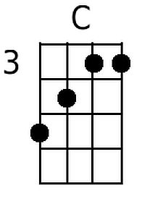 | 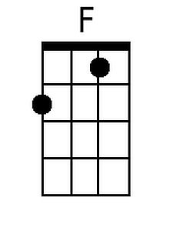 | 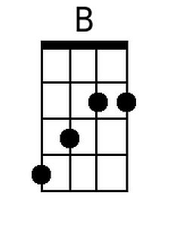 | 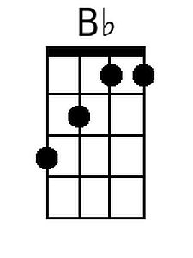 | 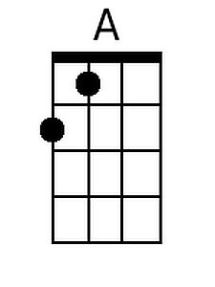 | 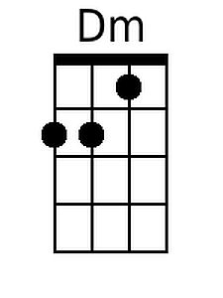 | 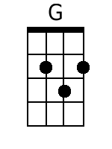 | 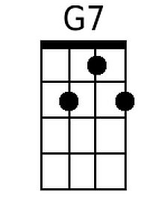
Baritone
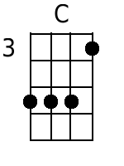 | 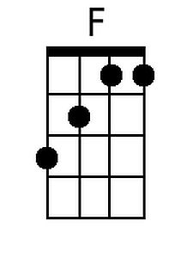 | 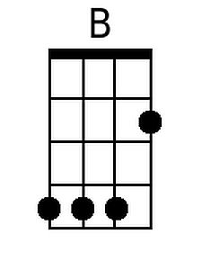 | 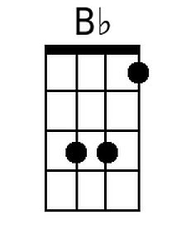 | 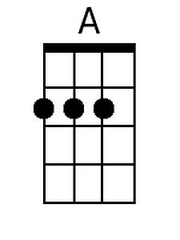 | 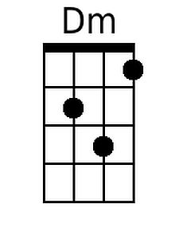 | 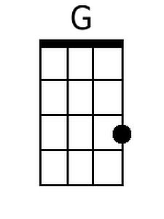 | 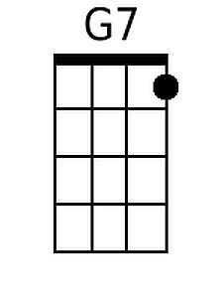

Baby Driver (Paul Simon, 1970) (G)

G  My daddy was the family bassman  My mamma was an engineer  And I was born - One dark grey morn  C G  With music coming in my ears, in my ears.  Chorus:  C  They call me Baby Driver  And once upon a pair of wheels  G  Hit-the-road-and-I'm gone ah . . . . . .  G F# F E  What's my num - ber? *  Am  I wonder how your engine feels  (Ba-baba ba ba)  G  Scoot down the road -  G F# F E  What's my num - ber?  Am G  I wonder how your engine feels.  G7  Badada da dadada - Badada dadada  Badada dadada - Badada dadada  C G  Ba da - Badada da dada  * Or:  G5 F#5 F5 E5  What's my num - ber? |  |  |  | G  My daddy was a prominent frogman  My mamma's in the Naval reserve  When I was young - I carried a gun  C  But I never got the chance to serve  G  I did not serve. Chorus  G  My daddy got a big promotion  My mamma got a raise in pay  There's no-one home, we're all alone  C  Oh, come into my room and play  G  Yes we can play.  C  I'm not talking about your pigtails  But I'm talking 'bout your sex appeal  G  Hit-the-road-and-I'm gone ah. . . . .  G F# F E  What's my num - ber?  Am  I wonder how your engine feels  (Ba-baba ba ba)  G F# F E  Scoot down the road What's my num - ber?  Am G - G7  I wonder how your engine feels?  G7 to fade
 | 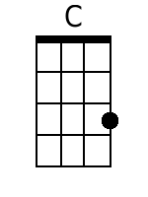 | 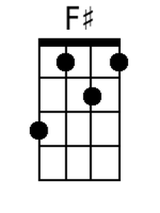 |  | 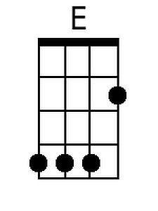 | 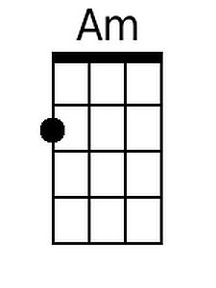 | 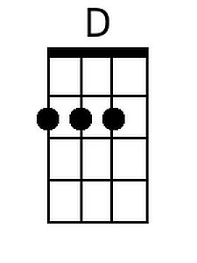 | 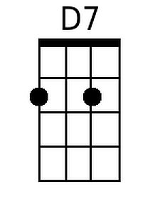
Baritone
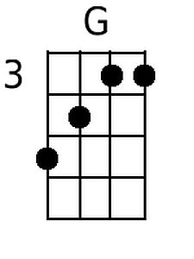 | 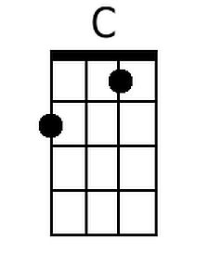 | 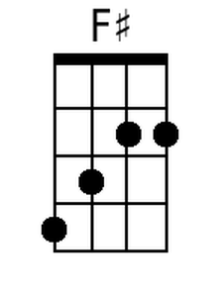 |  | 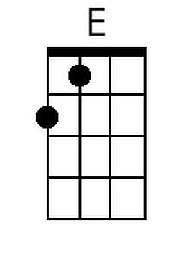 | 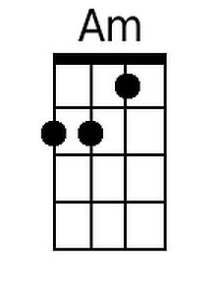 | 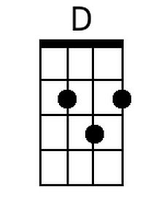 | 