**Baby Driver (Paul Simon)**

**C**

My daddy was the family bassman

My mamma was an engineer

And I was born - One dark grey morn

**F**

With music coming in my ears

**C**

In my ears

**Chorus:**

**F**

They call me Baby Driver

And once upon a pair of wheels

**C**

Hit-the-road-and-I'm gone ah............

**C B Bb A**

What's my num-ber?

**D**

I wonder how your engine feels (Ba-ba ba ba ba)

**C B Bb A**

Scoot down the road - What's my num-ber

**D G C**

I wonder how your engine feels

**C7**

Bada da da dadada - Bada da dadada

Bada da dadada - Bada da dadada

**F C**



Bb

Da da - Bada da da dada

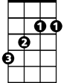

B

**C**

My daddy was a prominent frogman

My mamma's in the Naval reserve

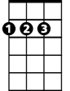

D

When I was young - I carried a gun



A

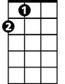

A

**F**

But I never got the chance to serve

**C**

I did not serve

**(Chorus)**

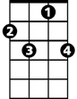

C7



G

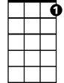

C7



G

**C7**

Bada da da dadada - Bada da dadada

Bada da dadada - Bada da dadada

**F C**

Da da - Bada da da dada

**C**

My daddy got a big promotion

My mamma got a raise in pay

There's no-one home, we're all alone

**F**

Oh, come into my room and play

**C**

Yes we can play

**F**

I'm not talking about your pigtails

But I'm talking 'bout your sex appeal

**C**

Hit-the-road-and-I'm gone ah............

**C B Bb A**

What's my num-ber?

**D**

I wonder how your engine feels (Ba-ba ba ba ba)

**C B Bb A**

Scoot down the road What's my num-ber

**D G C C7 to fade**

I wonder how your engine feels

F



C

C



F

**BARITONE**



D

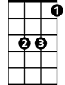

Bb

B

