**Baby I'm Yours (Van McCoy)**

**Intro: C A7 Dm G**

**tacet C A7**

Baby I'm yours (baby I’m yours)

**Dm**

And I'll be yours

**G C A7**

Until the stars fall from the sky-y-y

**Dm G F**

Yours until the rivers all run dry

**Em Dm G**

In other words, until I die

**C A7**

Baby I'm yours (baby I’m yours)

**Dm**

And I'll be yours

**G C A7**

Until the sun no longer shi-i-ines

**Dm G F**

Yours until the poets run out of rhyme

**Em Dm G**

In other words, until the end of time

**F Dm F Dm**

I'm gonna stay right here by your side

**Em C**

**BARITONE**

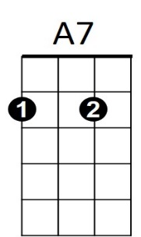Do my best to keep you satisfied

C

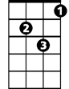

Dm

**F Dm**

Nothing in the world can drive me away

**G Em G**

Cause every day you'll hear me say

**C A7**



F

Baby I'm yours (baby I’m yours)

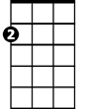

Em



G

**Dm G C A7**

And I'll be yours until two and two is three-ee

**Dm G F**

Yours until the mountain crumbles to the sea

**Em Dm G C A7**

In other words, until eternity - baby I'm yours

**Repeat to fade:**

**Dm F G C A7**

Till the stars fall from the sky - baby I'm yours

**Dm F G C A7**

Till the rivers all run dry - Baby I'm yours

**Dm F**

Till the poets run out of rhyme -

**G C A7**

Baby I'm yours

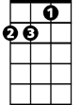

Dm



A7



C

F



Em

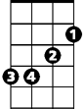

G