**Baby the Rain Must Fall (Elmer Bernstein / Ernie Sheldon) Key C**

**Intro: C Dm Em / Dm G C Am Dm G C (Chords for last two lines of chorus)**

**C F C**



G

Em

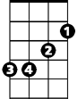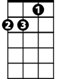

Dm



C

Some men climb a mountain

**C F G**

Some men swim the sea,

**C F**

Some men fly above the sky:

**C Bb G**

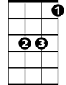

Eb



Bb

F

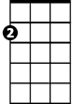

Am

They are what they must be.

**Chorus:**

**C Bb C**

But, baby the rain must fall,

**F Eb F**

Baby, the wind must blow,

**C Dm Em**

Wherever my heart leads me

**Dm G C Am Dm G C**

Baby, I must go, baby I must go.

**C F C**

I do not love for silver,

**C F G**

I do not love for gold,

**C F**

My heart is mine to give away,

**C Bb G**

It never will be sold.



G



Em

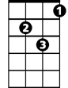

Dm

C



**BARITONE**

**(Chorus)**

**C F C**

I am not rich or famous:

**C F G**



Bb

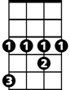

Eb



F



Am

But who can ever tell?

**C F**

I don't know now what waits for me

**C Bb G**

Maybe heaven, maybe hell.

**(Chorus) 2x (extend last line)**

**Baby the Rain Must Fall (Elmer Bernstein / Ernie Sheldon) Key G**

**Intro: G Am Bm / Am D G Em Am D G (Chords for last two lines of chorus)**

**G C G**

Some men climb a mountain

**G C D**

Some men swim the sea,

**G C**

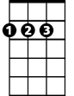

D

Some men fly above the sky:



Am

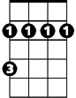

Bm



G

**G F D**

They are what they must be.

**Chorus:**

**G F G**

F



Bb



C

Em



But, baby the rain must fall,

**C Bb C**

Baby, the wind must blow,

**G Am Bm**

Wherever my heart leads me

**Am D G Em Am D G**

Baby, I must go, baby I must go.

**G C G**

I do not love for silver,

**G C D**

I do not love for gold,

**G C**

My heart is mine to give away,

**G F D**

It never will be sold.

**BARITONE**

Bm



D



Am



G

**(Chorus)**

**G C G**

I am not rich or famous:

**G C D**

But who can ever tell?



Em

C



F



Bb

**G C**

I don't know now what waits for me

**G F D**

Maybe heaven, maybe hell.

**(Chorus) 2x**