**Back Home Again (John Denver, 1974) Key A**

**Intro (Two Measures): A A**

**A A7**

There’s a storm across the valley,

**D**

clouds are rollin’ in

**E7 A**

the afternoon is heavy on your shoulders.

**A7**

There’s a truck out on the four lane,

**D**

a mile or more away

**E7 A**

the whinin’ of his wheels just makes it colder.

**A A7**

He’s an hour away from ridin’

**D**

on your prayers up in the sky

**E7 A**

and ten days on the road are barely gone.

**A7**

There’s a fire softly burning;

**D**

supper’s on the stove

**E7 A A7**

but it’s the light in your eyes that makes him warm

**Chorus**

**D E7 A A7**

Hey, it’s good to be back home a-gain.

**D E7**

Sometimes this old farm

**A D**

feels like a long lost friend.

**E7 A**

Yes, ‘n, hey it’s good to be back home a-gain.

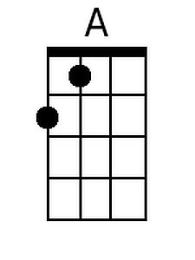

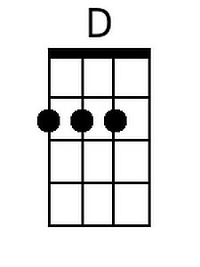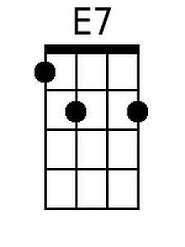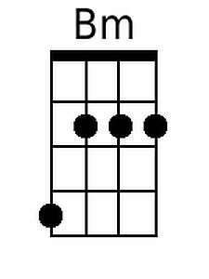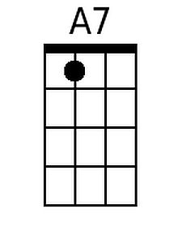

**B**

**A A7**

After all the news to tell him:

**D**

how you spent your time;

**E7 A**

and what’s the latest thing the neighbors say;

**A A7**

and your mother called last Friday;

**D**

“Sunshine” made her cry;

**E7 A A7**

and you felt the baby move just yester-day.

**(Chorus)**

**D E7 A**

And oh, the time that I can lay this tired

**D**

old body down

**Bm E7 A A7**

and feel your fingers feather soft u-pon me;

**D E7**

the kisses that I live for;

**A D**

the love that lights my way;

**Bm D E7**

the happiness that livin’ with you brings me.

**A A7**

It’s the sweetest thing I know of,

**D**

just spending time with you

**E7 A**

It’s the little things that make a house a home.

**A A7 D**

Like a fire softly burning and supper on the stove.

**E7 A A7**

And the light in your eyes that makes me warm.

**(Chorus) 2x**

**E7 D A**

I said, hey it’s good to be back home a-gain.

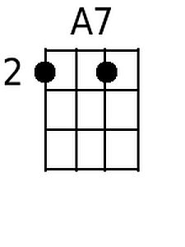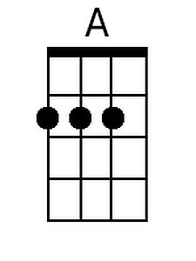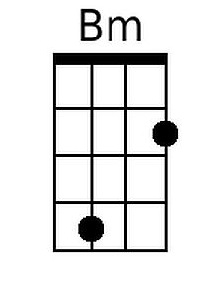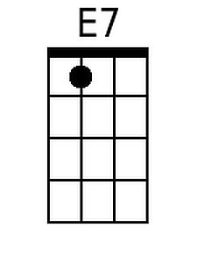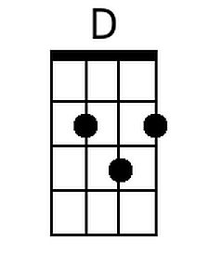

BARITONE

**Back Home Again (John Denver, 1974) Key C**

**Intro (Two Measures): C C**

**C C7**

There’s a storm across the valley,

**F**

clouds are rollin’ in

**G7 C**

the afternoon is heavy on your shoulders.

**C7**

There’s a truck out on the four lane,

**F**

a mile or more away

**G7 C**

the whinin’ of his wheels just makes it colder.

**C C7**

He’s an hour away from ridin’

**F**

on your prayers up in the sky

**G7 C**

and ten days on the road are barely gone.

**C7**

There’s a fire softly burning;

**F**

supper’s on the stove

**G7 C C7**

but it’s the light in your eyes that makes him warm

**Chorus**

**F G7 C C7**

Hey, it’s good to be back home a-gain.

**F G7**

Sometimes this old farm

**C F**

feels like a long lost friend.

**G7 C**

Yes, ‘n, hey it’s good to be back home a-gain.

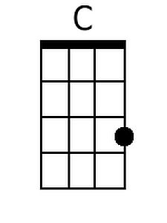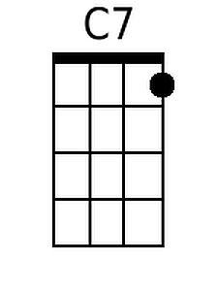

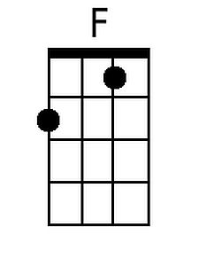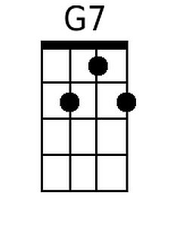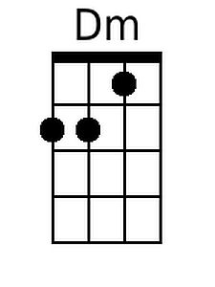

BARITONE

**C C7**

After all the news to tell him:

**F**

how you spent your time;

**G7 C**

and what’s the latest thing the neighbors say;

**C C7**

and your mother called last Friday;

**F**

“Sunshine” made her cry;

**G7 C C7**

and you felt the baby move just yester-day.

**(Chorus)**

**F G7 C**

And oh, the time that I can lay this tired

**F**

old body down

**Dm G7 C C7**

and feel your fingers feather soft u-pon me;

**F G7**

the kisses that I live for;

**C F**

the love that lights my way;

**Dm F G7**

the happiness that livin’ with you brings me.

**C C7**

It’s the sweetest thing I know of,

**F**

just spending time with you

**G7 C**

It’s the little things that make a house a home.

**C C7 F**

Like a fire softly burning and supper on the stove.

**G7 C C7**

And the light in your eyes that makes me warm.

**(Chorus) 2x**

**G7 F C**

I said, hey it’s good to be back home a-gain.

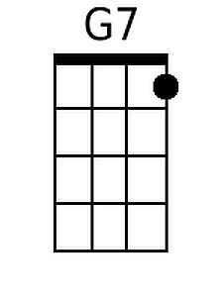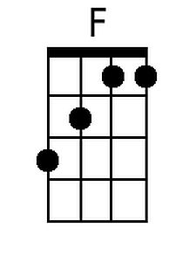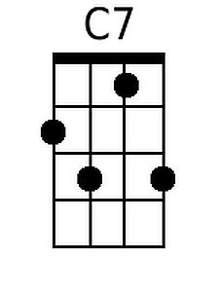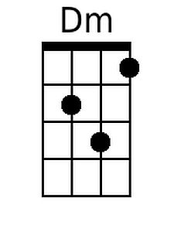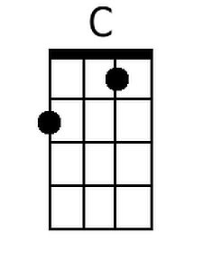

**Back Home Again (John Denver, 1974) Key G**

**Intro (Two Measures): G G**

**G G7**

There’s a storm across the valley,

**C**

clouds are rollin’ in

**D7 G**

the afternoon is heavy on your shoulders.

**G7**

There’s a truck out on the four lane,

**C**

a mile or more away

**D7 G**

the whinin’ of his wheels just makes it colder.

**G G7**

He’s an hour away from ridin’

**C**

on your prayers up in the sky

**D7 G**

and ten days on the road are barely gone.

**G7**

There’s a fire softly burning;

**C**

supper’s on the stove

**D7 G G7**

but it’s the light in your eyes that makes him warm

**Chorus**

**C D7 G G7**

Hey, it’s good to be back home a-gain.

**C D7**

Sometimes this old farm

**G C**

feels like a long lost friend.

**D7 G**

Yes, ‘n, hey it’s good to be back home a-gain.

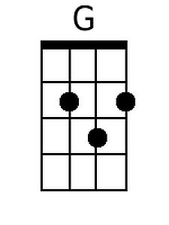



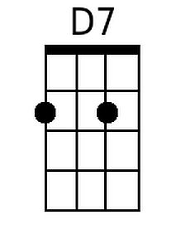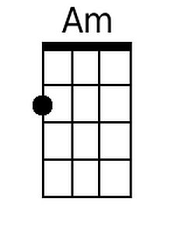

BARITONE

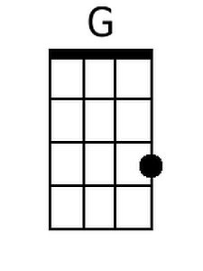

**G G7**

After all the news to tell him:

**C**

how you spent your time;

**D7 G**

and what’s the latest thing the neighbors say;

**G G7**

and your mother called last Friday;

**C**

“Sunshine” made her cry;

**D7 G G7**

and you felt the baby move just yester-day.

**(Chorus)**

**C D7 G**

And oh, the time that I can lay this tired

**C**

old body down

**Am D7 G G7**

and feel your fingers feather soft u-pon me;

**C D7**

the kisses that I live for;

**G C**

the love that lights my way;

**Am C D7**

the happiness that livin’ with you brings me.

**G G7**

It’s the sweetest thing I know of,

**C**

just spending time with you

**D7 G**

It’s the little things that make a house a home.

**G G7 C**

Like a fire softly burning and supper on the stove.

**D7 G G7**

And the light in your eyes that makes me warm.

**(Chorus) 2x**

**D7 C G**

I said, hey it’s good to be back home a-gain.

******