Back Home Again (John Denver, 1974)
Key of A – 4/4 Time – Back Home Again by John Denver (In E)

Intro (Two Measures): A A  A A7 D  There’s a storm across the valley, clouds are rollin’ in  E7 A  the afternoon is heavy on your shoulders.  A A7 D  There’s a truck out on the four lane, a mile or more away  E7 A  the whinin’ of his wheels just makes it colder.  A A7 D  He’s an hour away from ridin’ on your prayers up in the sky  E7 A  and ten days on the road are barely gone.  A A7 D  There’s a fire softly burning; supper’s on the stove  E7 A A7  but it’s the light in your eyes that makes him warm.  Chorus  D E7 A A7  Hey, it’s good to be back home a-gain.  D E7 A D  Sometimes this old farm feels like a long lost friend.  E7 A  Yes, ‘n, hey it’s good to be back home a-gain.  (A7 Transition To Bridge After 2nd Verse)  A A7 D  After all the news to tell him: how you spent your time;  E7 A  and what’s the latest thing the neighbors say;  A A7 D  and your mother called last Friday; “Sunshine” made her cry;  E7 A A7  and you felt the baby move just yester-day. Chorus |  |  |  |  |  |  | 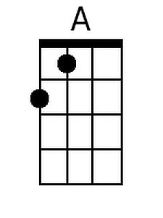
 |  |  |  |  |  |  | 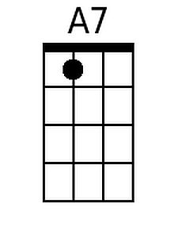
 |  |  |  |  |  |  | 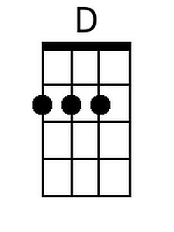
 |  |  |  |  |  |  | 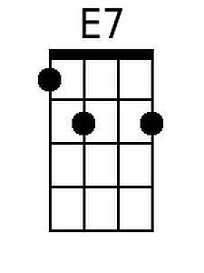
 |  |  |  |  |  |  | 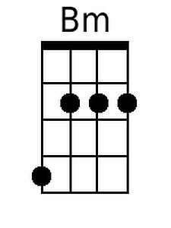
Bari
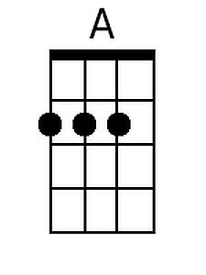 | 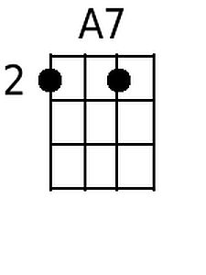 | 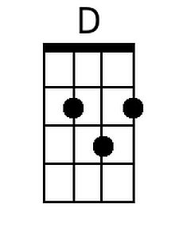 | 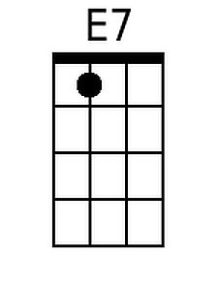 | 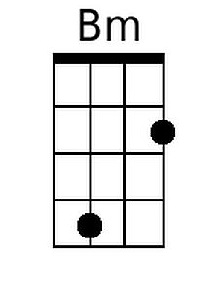

Back Home Again (A) - Page 2
Bridge
D E7 A D
And oh, the time that I can lay this tired old body down
Bm E7 A A7
and feel your fingers feather soft u-pon me;
D E7 A D
the kisses that I live for; the love that lights my way;
Bm D E7
the happiness that livin’ with you brings me.

A A7 D
It’s the sweetest thing I know of, just spending time with you
E7 A
It’s the little things that make a house a home.
A A7 D
Like a fire softly burning and supper on the stove.
E7 A A7
And the light in your eyes that makes me warm.

D E7 A A7
Hey, it’s good to be back home a-gain.
D E7 A D
Sometimes this old farm feels like a long lost friend.
E7 A
Yes, ‘n, hey it’s good to be back home a-gain.
E7 D A
Yes, ‘n, hey it’s good to be back home a-gain.

Back Home Again (John Denver, 1974)
Key of C – 4/4 Time – Back Home Again by John Denver (In E)

Intro (Two Measures): C C  C C7 F  There’s a storm across the valley, clouds are rollin’ in  G7 C  the afternoon is heavy on your shoulders.  C C7 F  There’s a truck out on the four lane, a mile or more away  G7 C  the whinin’ of his wheels just makes it colder.  C C7 F  He’s an hour away from ridin’ on your prayers up in the sky  G7 C  and ten days on the road are barely gone.  C C7 F  There’s a fire softly burning; supper’s on the stove  G7 C C7  but it’s the light in your eyes that makes him warm.  Chorus  F G7 C C7  Hey, it’s good to be back home a-gain.  F G7 C F  Sometimes this old farm feels like a long lost friend.  G7 C  Yes, ‘n, hey it’s good to be back home a-gain.  (C7 Transition To Bridge After 2nd Verse)  C C7 F  After all the news to tell him: how you spent your time;  G7 C  and what’s the latest thing the neighbors say;  C C7 F  and your mother called last Friday; “Sunshine” made her cry;  G7 C C7  and you felt the baby move just yester-day. Chorus |  |  |  |  |  |  | 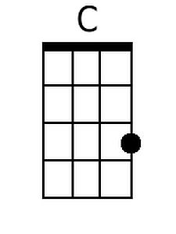
 |  |  |  |  |  |  | 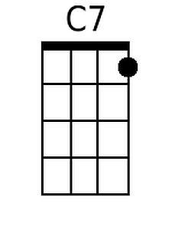
 |  |  |  |  |  |  | 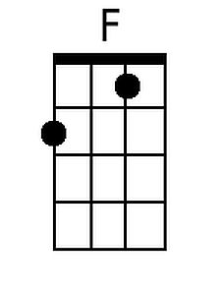
 |  |  |  |  |  |  | 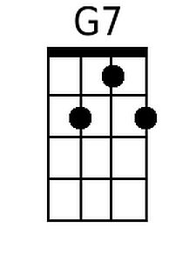
 |  |  |  |  |  |  | 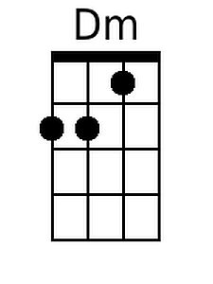
Bari:
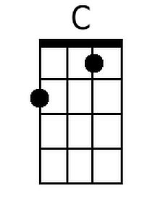 | 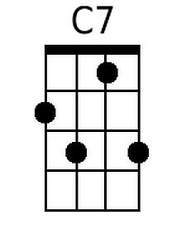 | 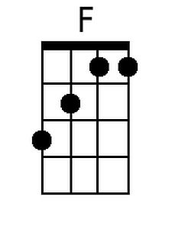 | 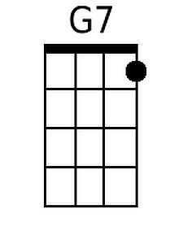 | 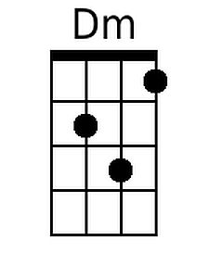

Back Home Again (C) - Page 2
Bridge
F G7 C F
And oh, the time that I can lay this tired old body down
Dm G7 C C7
and feel your fingers feather soft u-pon me;
F G7 C F
the kisses that I live for; the love that lights my way;
Dm F G7
the happiness that livin’ with you brings me.

C C7 F
It’s the sweetest thing I know of, just spending time with you
G7 C
It’s the little things that make a house a home.
C C7 F
Like a fire softly burning and supper on the stove.
G7 C C7
And the light in your eyes that makes me warm.

F G7 C C7
Hey, it’s good to be back home a-gain.
F G7 C F
Sometimes this old farm feels like a long lost friend.
G7 C
Yes, ‘n, hey it’s good to be back home a-gain.
G7 F C
Yes, ‘n, hey it’s good to be back home a-gain.

Back Home Again (John Denver, 1974)
Key of G – 4/4 Time – Back Home Again by John Denver (In E)

Intro (Two Measures): G G  G G7 C  There’s a storm across the valley, clouds are rollin’ in  D7 G  the afternoon is heavy on your shoulders.  G G7 C  There’s a truck out on the four lane, a mile or more away  D7 G  the whinin’ of his wheels just makes it colder.  G G7 C  He’s an hour away from ridin’ on your prayers up in the sky  D7 G  and ten days on the road are barely gone.  G G7 C  There’s a fire softly burning; supper’s on the stove  D7 G G7  but it’s the light in your eyes that makes him warm.  Chorus  C D7 G G7  Hey, it’s good to be back home a-gain.  C D7 G C  Sometimes this old farm feels like a long lost friend.  D7 G  Yes, ‘n, hey it’s good to be back home a-gain.  (G7 Transition to Bridge After 2nd Verse)  G G7 C  After all the news to tell him: how you spent your time;  D7 G  and what’s the latest thing the neighbors say;  G G7 C  and your mother called last Friday; “Sunshine” made her cry;  D7 G G7  and you felt the baby move just yester-day. Chorus |  |  |  |  |  |  | 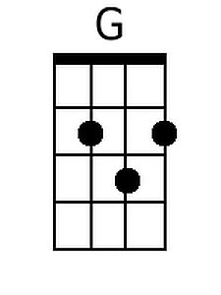
 |  |  |  |  |  |  | 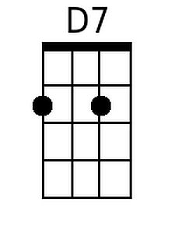
 |  |  |  |  |  |  | 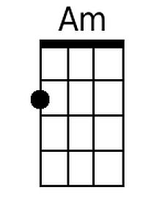
Bari:
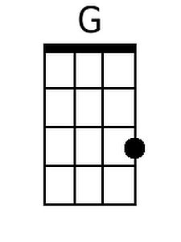 |  |  | 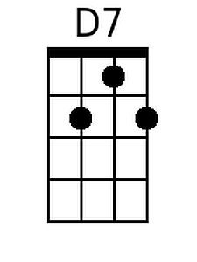 | 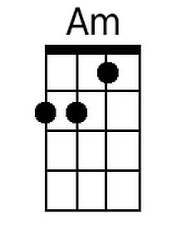

Back Home Again (G) - Page 2
Bridge
C D7 G C
And oh, the time that I can lay this tired old body down
Am D7 G G7
and feel your fingers feather soft u-pon me;
C D7 G C
the kisses that I live for; the love that lights my way;
Am C D7
the happiness that livin’ with you brings me.

G G7 C
It’s the sweetest thing I know of, just spending time with you
D7 G
It’s the little things that make a house a home.
G G7 C
Like a fire softly burning and supper on the stove.
D7 G G7
And the light in your eyes that makes me warm.

C D7 G G7
Hey, it’s good to be back home a-gain.
C D7 G C
Sometimes this old farm feels like a long lost friend.
D7 G
Yes, ‘n, hey it’s good to be back home a-gain.
D7 C G
Yes, ‘n, hey it’s good to be back home a-gain.

