Bad Bad Leroy Brown (Jim Croce) (C)
Bad Bad Leroy Brown by Jim Croce (in G)

Intro C G7  C D7  Well the South side of Chicago, is the baddest part of town  E7 F  And if you go down there, you better just beware  G7 C  Of a man named Leroy Brown  C D7  Now Leroy more than trouble, you see he stand 'bout six foot four  E7 F  All the downtown ladies call him "Treetop Lover"  G7 C  All the men just call him "Sir"  Chorus  C  And he's bad, bad Leroy Brown  D7  The baddest man in the whole damned town  E7 F  Badder than old King Kong  G7 C  And meaner than a junkyard dog.  C D7  Now Leroy, he a gambler, and he like his fancy clothes  E7 F G7 C  And he like to wave his diamond rings in front of everybody's nose  C D7  He got a custom Continental, he got an Eldorado too  E7 F  He got a 32 gun in his pocket for fun  G7 C  He got a razor in his shoe. Chorus |  |  |  |  |  |  | 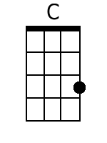
 |  |  |  |  |  |  | 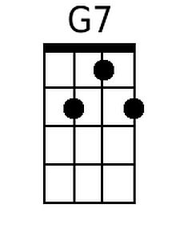
 |  |  |  |  |  |  | 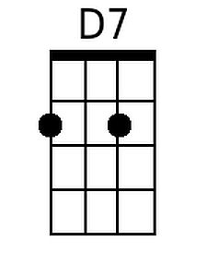
 |  |  |  |  |  |  | 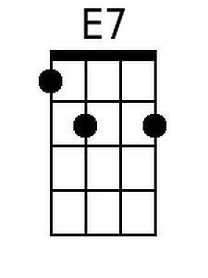
 |  |  |  |  |  |  | 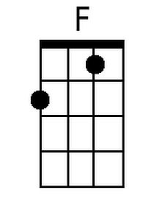
Baritone
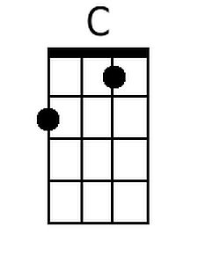 | 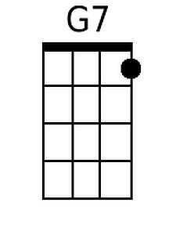 | 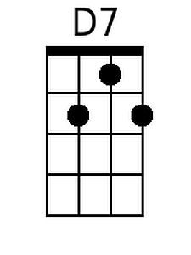 | 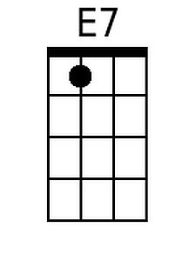 | 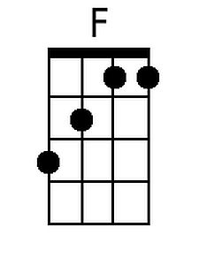

Bad, Bad Leroy Brown (C) – Page 2

C D7
Well Friday 'bout a week ago, Leroy shootin' dice
E7 F
And at the edge of the bar sat a girl named Doris and
G7 C C
oo that girl looked nice
C D7
Well he cast his eyes upon her, and the trouble soon began
E7 F
Cause Leroy Brown learned a lesson 'bout messin'
G7 C
With the wife of a jealous man. Chorus

C
Well the two men took to fighting
D7
And when they pulled them from the floor
E7 F
Leroy looked like a jigsaw puzzle
G7 C
With a couple of pieces gone. Chorus

Outro:
E7 F
Yeah, you were badder than old King Kong,
G7 F C
and meaner than a junkyard dog.

Bad Bad Leroy Brown (Jim Croce) (G)
Bad Bad Leroy Brown by Jim Croce (in G)

Intro G D7  G A7  Well the South side of Chicago, is the baddest part of town  B7 C  And if you go down there, you better just beware  D7 G  Of a man named Leroy Brown  G A7  Now Leroy more than trouble, you see he stand 'bout six foot four  B7 C  All the downtown ladies call him "Treetop Lover"  D7 G  All the men just call him "Sir"  Chorus  G  And he's bad, bad Leroy Brown  A7  The baddest man in the whole damned town  B7 C  Badder than old King Kong  D7 G  And meaner than a junkyard dog.  G A7  Now Leroy, he a gambler, and he like his fancy clothes  B7 C D7 G  And he like to wave his diamond rings in front of everybody's nose  G A7  He got a custom Continental, he got an Eldorado too  B7 C  He got a 32 gun in his pocket for fun  D7 G  He got a razor in his shoe. Chorus |  |  |  |  |  |  | 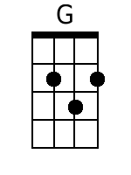
 |  |  |  |  |  |  | 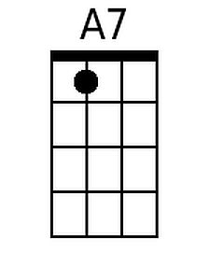
 |  |  |  |  |  |  | 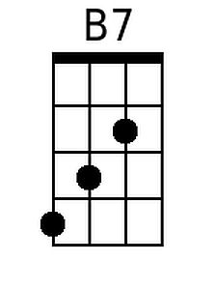
Baritone
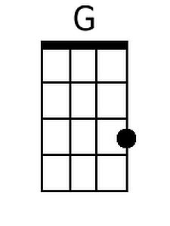 |  | 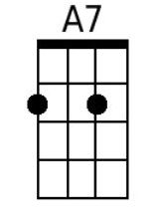 | 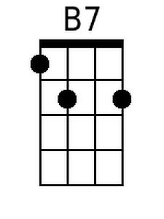

Bad, Bad Leroy Brown (G) – Page 2

G A7
Well Friday 'bout a week ago, Leroy shootin' dice
B7 C
And at the edge of the bar sat a girl named Doris and
D7 G G
oo that girl looked nice
G A7
Well he cast his eyes upon her, and the trouble soon began
B7 C
Cause Leroy Brown learned a lesson 'bout messin'
D7 G
With the wife of a jealous man. Chorus

G
Well the two men took to fighting
A7
And when they pulled them from the floor
B7 C
Leroy looked like a jigsaw puzzle
D7 G
With a couple of pieces gone. Chorus

Outro:
B7 C
Yeah, you were badder than old King Kong,
D7 C G
and meaner than a junkyard dog.

