Bad Bad Leroy Brown (Jim Croce, 1972) (C)
Bad Bad Leroy Brown by Jim Croce (1972) (G)
4/4 Time; Tempo = 148
Intro | C F C F | C F C F | C F C F | C F C7 F |  | C F C F | C F C F | C F C F | C CC CC CC  C D7  Well the South side of Chicago, is the baddest part of town,  E7 F G7 C  And if you go down there you better just beware of a man named Leroy Brown.  C D7  Now Leroy – more than trouble – you see he stand ‘bout six foot four.  E7 F G7 C  All the downtown ladies call him “treetop lover,” all the men just call him “Sir.”  Chorus  C D7  And he bad, bad Leroy Brown, the baddest man in the whole damned town;  E7 F G C  Badder than old King Kong, and meaner than a junkyard dog.  C D7  Now Leroy, he a gambler and he like his fancy clothes,  E7 F G7 C  And he like to wave his diamond rings in front of ev’ry-body's nose.  C D7  He got a custom Continental, he got an Eldorado, too,  E7 F G7 C  He got a 32 gun in his pocket for fun, he got a razor in his shoe. Chorus  C D7  Well, Friday 'bout a week ago, Leroy shootin' dice  E7 F G7 C  And at the edge of the bar sat a girl name of Doris, and, oo, that girl looked nice.  C D7  Well, he cast his eyes upon her, and the trouble soon began,  E7 F G7 C  And Leroy Brown learned a lesson 'bout messin' with the wife of a jealous man.  Chorus  C D7  Well the two men took to fighting, and when they pulled them from the floor  E7 F G7 C  Leroy looked like a jigsaw puzzle with a couple of pieces gone. Chorus (2x)  Repeat last line twice; second time: “Yes, you were badder...” |  |  |  |  |  |  |  | 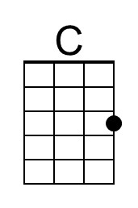
 |  |  |  |  |  |  |  | 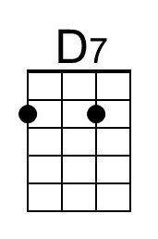
 |  |  |  |  |  |  |  | 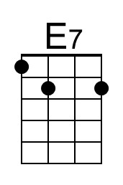
 |  |  |  |  |  |  |  | 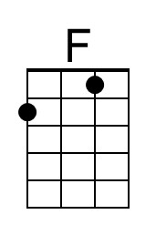
 |  |  |  |  |  |  |  | 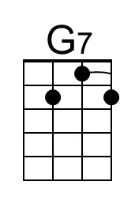
 |  |  |  |  |  |  |  | 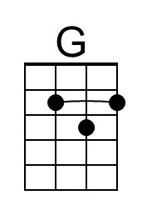
Bari | 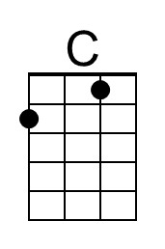 | 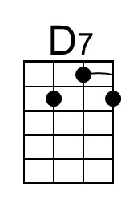 | 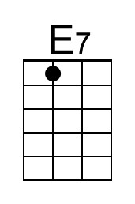 | 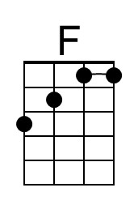 | 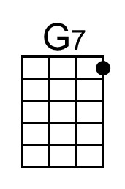 | 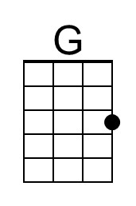

Bad Bad Leroy Brown (Jim Croce, 1972) (G)
Bad Bad Leroy Brown by Jim Croce (1972) (G)
4/4 Time; Tempo = 148
Intro | G C G C | G C G C | G C G C | G C G7 C |
| G C G C | G C G C | G C G C | G GG GG GG

G A7
Well the South side of Chicago, is the baddest part of town,
B7 C D7 G
And if you go down there you better just beware of a man named Leroy Brown.
G A7
Now Leroy – more than trouble – you see he stand ‘bout six foot four.
B7 C D7 G
All the downtown ladies call him “treetop lover,” all the men just call him “Sir.”

Chorus
G A7
And he bad, bad Leroy Brown, the baddest man in the whole damned town;
B7 C D G
Badder than old King Kong, and meaner than a junkyard dog.

G A7
Now Leroy, he a gambler and he like his fancy clothes,
B7 C D7 G
And he like to wave his diamond rings in front of ev’ry-body's nose.
G A7
He got a custom Continental, he got an Eldorado, too,
B7 C D7 G
He got a 32 gun in his pocket for fun, he got a razor in his shoe. Chorus

G A7
Well, Friday 'bout a week ago, Leroy shootin' dice
B7 C D7 G
And at the edge of the bar sat a girl name of Doris, and, oo, that girl looked nice.
G A7
Well, he cast his eyes upon her, and the trouble soon began,
B7 C D7 G
And Leroy Brown learned a lesson 'bout messin' with the wife of a jealous man.
Chorus
G A7
Well the two men took to fighting, and when they pulled them from the floor
B7 C D7 G
Leroy looked like a jigsaw puzzle with a couple of pieces gone. Chorus (2x)
Repeat last line twice; second time: “Yes, you were badder...”

 |  |  |  |  |  |  |  | 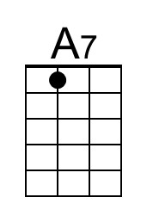
 |  |  |  |  |  |  |  | 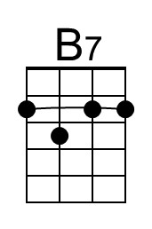
 |  |  |  |  |  |  |  | 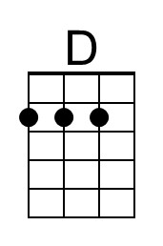
Bari |  | 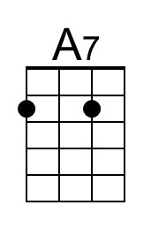 | 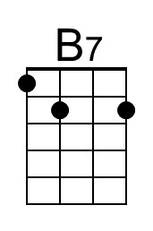 |  |  | 