**The Ballad of Paladin (Sam Rolfe / Richard Boone / Johnny Western)**

**G C G**

Paladin, Paladin, where do you roam

**C G**



G



C

Paladin, Paladin, far, far from home

**G D7 G**

Have gun will travel reads the card of a man

**D7 G**

A knight without armor in a savage land

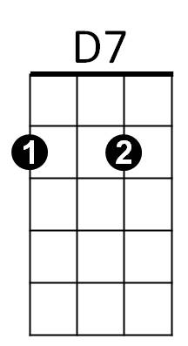 **Em C G**

Em

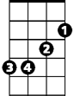

His fast gun hire heeds the calling wind

**C G**

A soldier of fortune is a man called Paladin

**G C G**

Paladin, Paladin, where do you roam

**C G**

Paladin, Paladin, far, far from home

**G D7 G**

He travels on to where ever he must

**D7 G**

A chess knight of silver is his badge of trust

**Em C G**

There are campfire legends that the plainsmen sing

**C G**

Of the man with the gun of the man called Paladin

**BARITONE**



G

C



**G C G**

Paladin, Paladin, where do you roam

**C G**

Paladin, Paladin, far, far from home

**C G C G**

Far, far, from home – far, far, from home

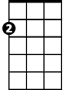

Em

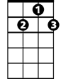

D7