Banana Boat Song
Jamaican Folk Song
Banana Boat Song (Jamaican Folk Song) (C)

Intro A capella Day-oh, Day-day-ay-ay-oh  Daylight come an' me wan' go home  Day, me say day, me say day, me say day-oh  Daylight come an' me wan' go home  C  Work all night on a drink a' rum,  G7 C  Daylight come an' me wan' go home  C  Stack banana til the mornin' come,  G7 C  Daylight come an' me wan' go home  Verse 2  C G7  Come, mister tally man, tally me banana,  C G7 C  Daylight come an' me wan' go home  C G7  Come mister tally man tally me banana,  C G7 C  Daylight come an' me wan' go home  Chorus  C  Lift six foot, seven foot, eight foot bunch!  G7 C  Daylight come an' me wan' go home  C  Six foot, seven foot, eight foot bunch!  G7 C  Daylight come an' me wan' go home  C G7 C  Day, me say day-ay-ay-oh,  G7 C  Daylight come an' me wan' go home  G7 F  Day, me say day, me say day,  C  me say day-oh  G7 C  Daylight come an' me wan' go home. | C  A beautiful bunch of ripe bananas  G7 C  Daylight come an' me wan' go home  C  Hide de deadly black tarantula  G7 C  Daylight come an' me wan' go home.  Chorus  Repeat Verse 2  C G7 C  Day, me say day-ay-ay-oh,  G7 C  Daylight come an' me wan' go home  G7 F  Day, me say day, me say day,  C  me say day-oh (slowly)  G7 C  Daylight come an' me wan' go home.
 | 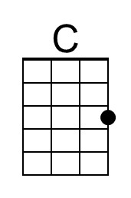 | 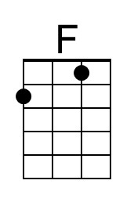 | 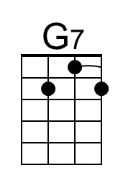
 | Bari | 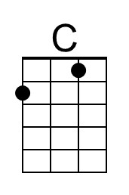 | 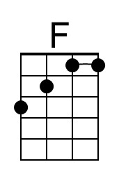 | 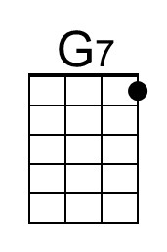

Banana Boat Song (Jamaican Folk Song) (G)

Intro A capella Day-oh, Day-day-ay-ay-oh  Daylight come an' me wan' go home  Day, me say day, me say day, me say day-oh  Daylight come an' me wan' go home  G  Work all night on a drink a' rum,  D7 G  Daylight come an' me wan' go home  G  Stack banana til the mornin' come,  D7 G  Daylight come an' me wan' go home  Verse 2  G D7  Come, mister tally man, tally me banana,  G D7 G  Daylight come an' me wan' go home  G D7  Come mister tally man tally me banana,  G D7 G  Daylight come an' me wan' go home  Chorus  G  Lift six foot, seven foot, eight foot bunch!  D7 G  Daylight come an' me wan' go home  G  Six foot, seven foot, eight foot bunch!  D7 G  Daylight come an' me wan' go home  G D7 G  Day, me say day-ay-ay-oh,  D7 G  Daylight come an' me wan' go home  D7 C  Day, me say day, me say day,  G  me say day-oh  D7 G  Daylight come an' me wan' go home. | G  A beautiful bunch of ripe bananas  D7 G  Daylight come an' me wan' go home  G  Hide de deadly black tarantula  D7 G  Daylight come an' me wan' go home.  Chorus  Repeat Verse 2.  G D7 G  Day, me say day-ay-ay-oh,  D7 G  Daylight come an' me wan' go home  D7 C  Day, me say day, me say day,  G  me say day-oh (slowly)  D7 G  Daylight come an' me wan' go home.
 | 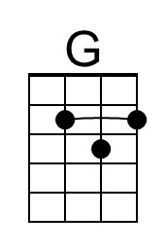 |  | 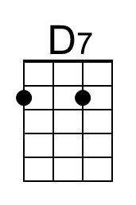
 | Bari | 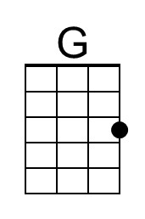 |  | 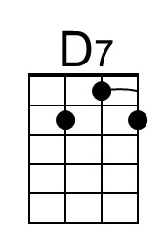

Banana Boat Song (Jamaican Folk Song) (F)

Intro A capella Day-oh, Day-day-ay-ay-oh  Daylight come an' me wan' go home  Day, me say day, me say day, me say day-oh  Daylight come an' me wan' go home  F  Work all night on a drink a' rum,  C7 F  Daylight come an' me wan' go home  F  Stack banana til the mornin' come,  C7 F  Daylight come an' me wan' go home  Verse 2  F C7  Come, mister tally man, tally me banana,  F C7 F  Daylight come an' me wan' go home  F C7  Come mister tally man tally me banana,  F C7 F  Daylight come an' me wan' go home  Chorus  F  Lift six foot, seven foot, eight foot bunch!  C7 F  Daylight come an' me wan' go home  F  Six foot, seven foot, eight foot bunch!  C7 F  Daylight come an' me wan' go home  F C7 F  Day, me say day-ay-ay-oh,  C7 F  Daylight come an' me wan' go home  C7 Bb  Day, me say day, me say day,  F  me say day-oh  C7 F  Daylight come an' me wan' go home. | F  A beautiful bunch of ripe bananas  C7 F  Daylight come an' me wan' go home  F  Hide de deadly black tarantula  C7 F  Daylight come an' me wan' go home.  Chorus  Repeat Verse 2  F C7 F  Day, me say day-ay-ay-oh,  C7 F  Daylight come an' me wan' go home  C7 Bb  Day, me say day, me say day,  F  me say day-oh (slowly)  C7 F  Daylight come an' me wan' go home.
 |  | 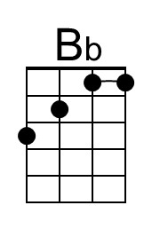 | 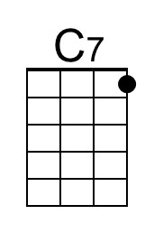
 | Bari |  | 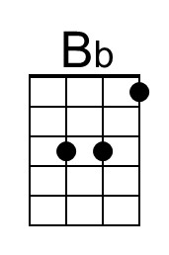 | 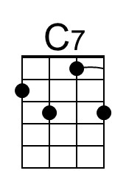

Banana Boat Song (Jamaican Folk Song) (C)

Intro A capella Day-oh, Day-day-ay-ay-oh  Daylight come an' me wan' go home  Day, me say day, me say day, me say day-oh  Daylight come an' me wan' go home  C  Work all night on a drink a' rum,  G7 C  Daylight come an' me wan' go home  C  Stack banana til the mornin' come,  G7 C  Daylight come an' me wan' go home  Verse 2  C G7  Come, mister tally man, tally me banana,  C G7 C  Daylight come an' me wan' go home  C G7  Come mister tally man tally me banana,  C G7 C  Daylight come an' me wan' go home  Chorus  C  Lift six foot, seven foot, eight foot bunch!  G7 C  Daylight come an' me wan' go home  C  Six foot, seven foot, eight foot bunch!  G7 C  Daylight come an' me wan' go home  C G7 C  Day, me say day-ay-ay-oh,  G7 C  Daylight come an' me wan' go home  G7 F  Day, me say day, me say day,  C  me say day-oh  G7 C  Daylight come an' me wan' go home. | C  A beautiful bunch of ripe bananas  G7 C  Daylight come an' me wan' go home  C  Hide de deadly black tarantula  G7 C  Daylight come an' me wan' go home.  Chorus  Repeat Verse 2  C G7 C  Day, me say day-ay-ay-oh,  G7 C  Daylight come an' me wan' go home  G7 F  Day, me say day, me say day,  C  me say day-oh (slowly)  G7 C  Daylight come an' me wan' go home.
 | Bari

This page is intentionally blank.

