**Barbara Allen (Traditional / Jim Moray) Key C**

**C G7 C**

Twas in the merry month of May

**F C**

When green buds all were swelling,

**F C Am F**

Sweet William on his death bed lay

**C G7 C**

For love of Barbara Allen.

**C G7 C**

He sent his servant to the town

**F C**

To the place where she was dwelling,

**F C Am F**

Saying you must come, to my master dear

**C G7 C**

If your name be Barbara Allen.

**C G7 C**

So slowly, slowly she got up

**F C**

And slowly she drew nigh him,

**F C Am F**

And the only word s to him did say

**C G7 C**

Young man I think you're dying.

**C G7 C**

He turned his face unto the wall

**F C**

And death was in him welling,

**F C Am F**

Good-bye, good-bye, to my friends all

**C G7 C**

Be good to Barbara Allen.



C

**C G7 C**

When he was dead and laid in grave

**F C**

She heard the death bells knelling

**F C Am F**

And every stroke to her did say

**C G7 C**

**BARITONE**

Hard hearted Barbara Allen.

C



**C G7 C**

Oh mother, oh mother go dig my grave

**F C**

Make it both long and narrow,

**F C Am F**

Sweet William died of love for me

**C G7 C**

And I will die of sorrow.

**C G7 C**

And father, oh father, go dig my grave

**F C**

Make it both long and narrow,

**F C Am F**

Sweet William died on yesterday

**C G7 C**

And I will die tomorrow.

**C G7 C**

Barbara Allen was buried in the old churchyard

**F C**

Sweet William was buried beside her,

**F C Am F**

Out of sweet William's heart, there grew a rose

**C G7 C**

Out of Barbara Allen's a briar.

**C G7 C**

They grew and grew in the old churchyard

**F C**

Till they could grow no higher

**F C Am F**

At the end they formed, a true lover's knot

**C G7 C**

And the rose grew round the briar.

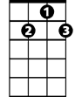

G7

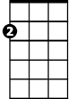

Am

F

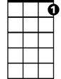

G7



F

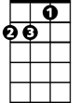

Am

**Barbara Allen (Traditional / Jim Moray) Key G**

**G D7 G**

Twas in the merry month of May

**C G**

When green buds all were swelling,

**C G Em C**

Sweet William on his death bed lay

**G D7 G**

For love of Barbara Allen.

**G D7 G**

He sent his servant to the town

**C G**

To the place where she was dwelling,

**C G Em C**

Saying you must come, to my master dear

**G D7 G**

If your name be Barbara Allen.

**G D7 G**

So slowly, slowly she got up

**C G**

And slowly she drew nigh him,

**C G Em C**

And the only words to him did say

**G D7 G**

Young man I think you're dying.

**G D7 G**

He turned his face unto the wall

**C G**

And death was in him welling,

**C G Em C**

Good-bye, good-bye, to my friends all

**G D7 G**

Be good to Barbara Allen.



G

**G D7 G**

When he was dead and laid in grave

**C G**

She heard the death bells knelling

**C G Em C**

And every stroke to her did say

**G D7 G**

**BARITONE**

Hard hearted Barbara Allen.



G

**G D7 G**

Oh mother, oh mother go dig my grave

**C G**

Make it both long and narrow,

**C G Em C**

Sweet William died of love for me

**G D7 G**

And I will die of sorrow.

**G D7 G**

And father, oh father, go dig my grave

**C G**

Make it both long and narrow,

**C G Em C**

Sweet William died on yesterday

**G D7 G**

And I will die tomorrow.

**G D7 G**

Barbara Allen was buried in the old churchyard

**C G**

Sweet William was buried beside her,

**C G Em C**

Out of sweet William's heart, there grew a rose

**G D7 G**

Out of Barbara Allen's a briar.

**G D7 G**

They grew and grew in the old churchyard

**C G**

Till they could grow no higher

**C G Em C**

At the end they formed, a true lover's knot

**G D7 G**

And the rose grew round the briar.

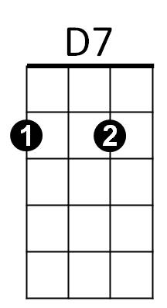

Em

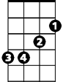

C



Em

C



D7