Batman TV Show Theme Song
(Word and Music by Neal Hefti) – Key of C

Batman Theme, YouTube; Batman Theme, Wikipedia.

Intro | C5 | C5 | C5
C5 | C5 | C5 | C5
Verse
C5  Batman! | C5 | C5  Batman! | C5
C5  Batman! | C5 | C5  Batman! | C5
F5  Batman! | F5 | C5  Batman! | C5
G5  Batman! | F5  Batman! | C5  Batman! | C5
G5  Batman! | F5  Batman! | C5  Batman! | C5
Outro | C5 | C5 | Cm7 ↓ §  Bat-man!!

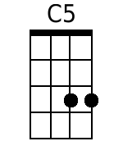 | 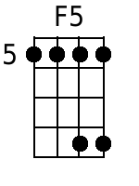 | 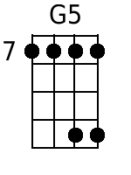 | 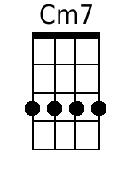 | Baritone | 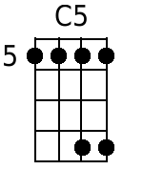 | 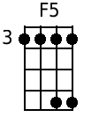 | 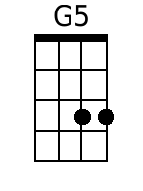 | 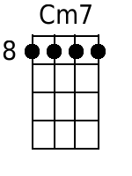
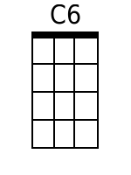 | 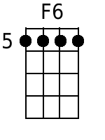 | 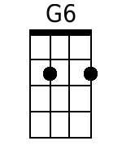 |  |  | 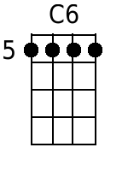 | 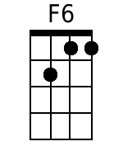 | 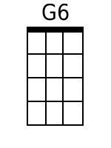

Batman TV Show Theme Song
(Word and Music by Neal Hefti) – Key of G

Batman Theme, YouTube; Batman Theme, Wikipedia.

Intro | G5 | G5 | G5
G5 | G5 | G5 | G5
Verse
G5  Batman! | G5 | G5  Batman! | G5
G5  Batman! | G5 | G5  Batman! | G5
C5  Batman! | C5 | G5  Batman! | G5
D5  Batman! | C5  Batman! | G5  Batman! | G5
D5  Batman! | C5  Batman! | G5  Batman! | G5
Outro | G5 | G5 | Gm7 ↓ §  Bat-man!!

 |  | 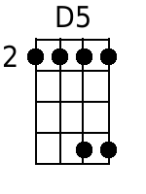 | 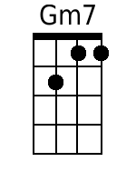 | Baritone |  |  | 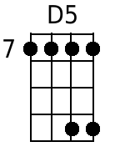 | 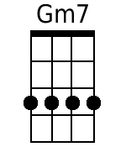
 |  | 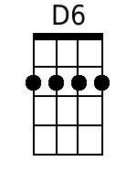 |  |  |  |  | 