Batman Theme
(Word and Music by Neal Hefti)

Batman Theme, YouTube; Batman Theme, Wikipedia.
Intro G#5 (7x)

| G#5 | | G#5 | | G#5 | | G#5 | |
Batman! |  | Batman!
| G#5 | | G#5 | | G#5 | | G#5 | |
Batman! |  | Batman!
| C#5 | | C#5 | | G#5 | | G#5 | |
Batman! |  | Batman!
| D#5 | | C#5 | | G#5 | | G#5 | |
Batman! | Batman! | Batman!
| D#5 | | C#5 | | G#5 | | G#5 | |
Batman! | Batman! | Batman!
Outro
| G#5 | | G#5 | | G#m7 | |
 |  | Bat-man!

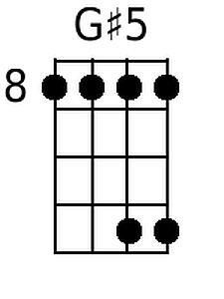 | 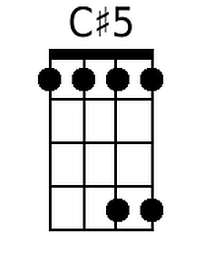 | 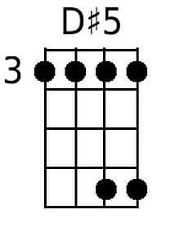 | 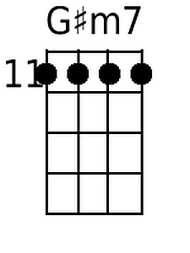 | Baritone | 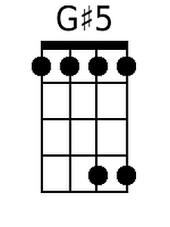 | 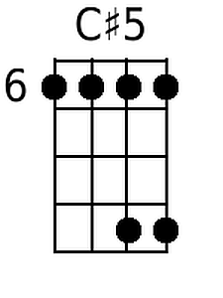 | 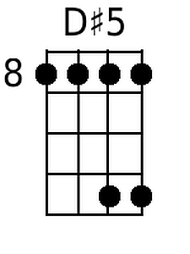 | 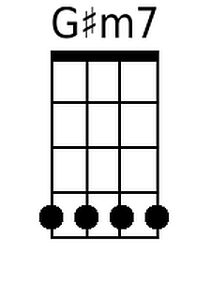
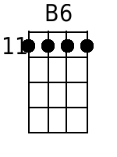 | 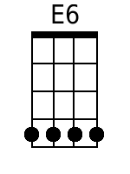 | 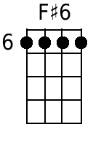 |  |  | 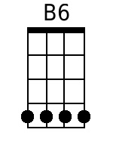 | 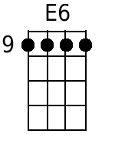 | 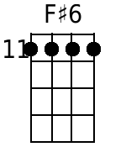

Note: Because I found the Major 5 form difficult to play, I either pluck or strum just the top 2 strings (EA or BE) or I substitute the indicated Major 6 chord.

Batman Theme
(Word and Music by Neal Hefti) – Key of C

Batman Theme, YouTube; Batman Theme, Wikipedia.

Intro C5 (7x)

| C5 | | C5 | | C5 | | C5 | |
Batman! |  | Batman!
| C5 | | C5 | | C5 | | C5 | |
Batman! |  | Batman!
| F5 | | F5 | | C5 | | C5 | |
Batman! |  | Batman!
| G5 | | F5 | | C5 | | C5 | |
Batman! | Batman! | Batman!
| G5 | | F5 | | C5 | | C5 | |
Batman! | Batman! | Batman!
Outro
| C5 | | C5 | | Cm7 | |
 |  | Bat-man!

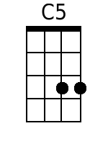 | 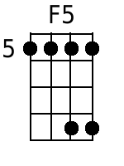 | 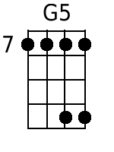 | 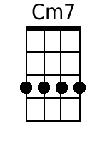 | Baritone | 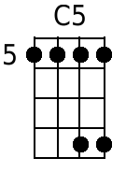 | 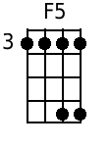 | 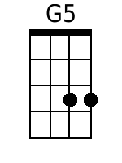 | 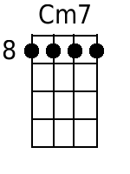
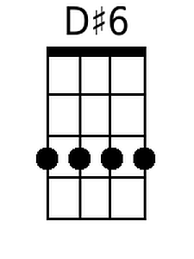 | 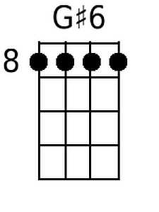 | 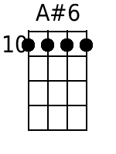 |  |  | 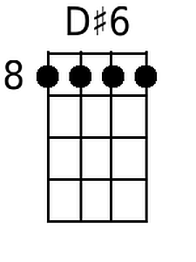 | 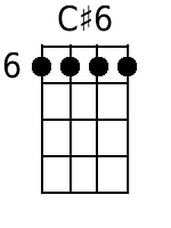 | 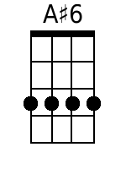

Note: Because I found the Major 5 form difficult to play, I either pluck or strum just the top 2 strings (EA or BE) or I substitute the indicated Major 6 chord.

Batman Theme
(Word and Music by Neal Hefti) – Key of G

Batman Theme, YouTube; Batman Theme, Wikipedia.

Intro G5 (7x)

| G5 | | G5 | | G5 | | G5 | |
Batman! |  | Batman!
| G5 | | G5 | | G5 | | G5 | |
Batman! |  | Batman!
| C5 | | C5 | | G5 | | G5 | |
Batman! |  | Batman!
| D5 | | C5 | | G5 | | G5 | |
Batman! | Batman! | Batman!
| D5 | | C5 | | G5 | | G5 | |
Batman! | Batman! | Batman!
Outro
| G5 | | G5 | | Gm7 | |
 |  | Bat-man!

 |  | 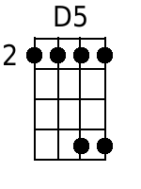 | 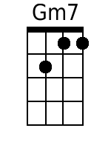 | Baritone |  |  | 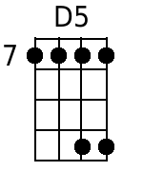 | 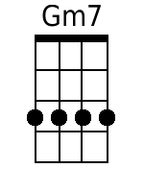
 |  | 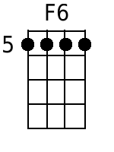 |  |  |  |  | 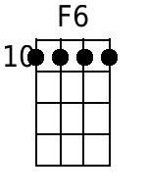

Note: Because I found the Major 5 form difficult to play, I either pluck or strum just the top 2 strings (EA or BE) or I substitute the indicated Major 6 chord.

