Baton Rouge (Guy Clark & John Charles Crowley, 1992) (C)

C G  I'm gonna leave Texarkana  F C  I'm goin' down to Louisiana  G C  I'm gonna try my luck in Baton Rouge  G  I'm gonna follow ol’ red river down  F C  Till I see the lights of town  G C  I ain't gonna get no sleep in Baton Rouge  Chorus  G  Baton Rouge Baton Rouge  F  I'm gonna get me some alligator shoes  G  Baton Rouge Baton Rouge  F G C  I'm gonna wear 'em out in Baton Rouge  C G  It was a Texas girl that broke my heart  F C  Then she tore my truck apart  G C  I guess I'll get me another in Baton Rouge  G  I like Crawfish I like rice  F C  I like girls that treat you nice  G C  I'm gonna find me one in Baton Rouge  Chorus | C G  I'm gonna learn to walk that walk  F C  I'm gonna learn to talk that talk  G C  I'm gonna learn to dance in Baton Rouge  G  Ain't life just like a cul-de-sac  F C  I'm a Texas boy and I'm goin' back  G C  Soon as I catch my breath in Baton Rouge  Chorus  G C  I'm gonna strut my stuff in Baton Rouge  G C  I'm gonna cool my heels in Baton Rouge
 |  |  | 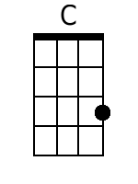 | 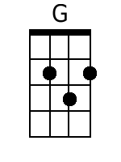 | 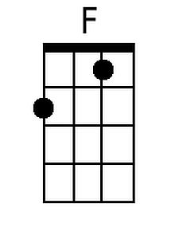
 |  |  | Bari
 |  |  | 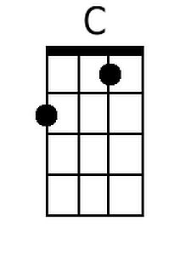 | 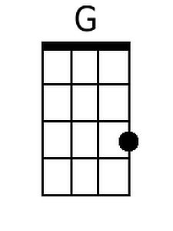 | 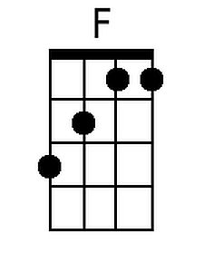


Baton Rouge (Guy Clark & John Charles Crowley, 1992) (G)

G D  I'm gonna leave Texarkana  C G  I'm goin' down to Louisiana  D G  I'm gonna try my luck in Baton Rouge  D  I'm gonna follow ol’ red river down  C G  Till I see the lights of town  D G  I ain't gonna get no sleep in Baton Rouge  Chorus  D  Baton Rouge Baton Rouge  C  I'm gonna get me some alligator shoes  D  Baton Rouge Baton Rouge  C D G  I'm gonna wear 'em out in Baton Rouge  G D  It was a Texas girl that broke my heart  C G  Then she tore my truck apart  D G  I guess I'll get me another in Baton Rouge  D  I like Crawfish I like rice  C G  I like girls that treat you nice  D G  I'm gonna find me one in Baton Rouge  Chorus | G D  I'm gonna learn to walk that walk  C G  I'm gonna learn to talk that talk  D G  I'm gonna learn to dance in Baton Rouge  D  Ain't life just like a cul-de-sac  C G  I'm a Texas boy and I'm goin' back  D G  Soon as I catch my breath in Baton Rouge  Chorus  D G  I'm gonna strut my stuff in Baton Rouge  D G  I'm gonna cool my heels in Baton Rouge
 |  |  | 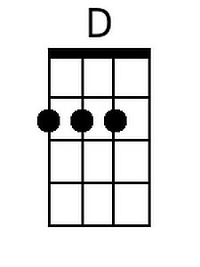
 |  | Bari
 |  |  | 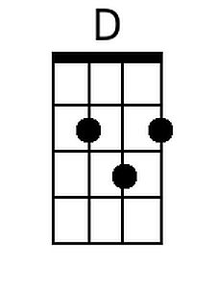

Baton Rouge (Guy Clark & John Charles Crowley, 1992) (NN)

1 5  I'm gonna leave Texarkana  4 1  I'm goin' down to Louisiana  5 1  I'm gonna try my luck in Baton Rouge  5  I'm gonna follow ol’ Red River down  4 1  Till I see the lights of town  5 1  I ain't gonna get no sleep in Baton Rouge  Chorus  5  Baton Rouge Baton Rouge  4  I'm gonna get me some alligator shoes  5  Baton Rouge Baton Rouge  4 5 G1  I'm gonna wear 'em out in Baton Rouge  1 5  It was a Texas girl that broke my heart  4 1  Then she tore my truck apart  5 1  I guess I'll get me another in Baton Rouge  5  I like Crawfish I like rice  4 1  I like girls that treat you nice  5 1  I'm gonna find me one in Baton Rouge  Chorus | 1 5  I'm gonna learn to walk that walk  4 1  I'm gonna learn to talk that talk  5 1  I'm gonna learn to dance in Baton Rouge  5  Ain't life just like a cul-de-sac  4 1  I'm a Texas boy and I'm goin' back  5 1  Soon as I catch my breath in Baton Rouge  Chorus  5 1  I'm gonna strut my stuff in Baton Rouge  5 1  I'm gonna cool my heels in Baton Rouge
 |  | 1 | 4 | 5
 |  | A | D | E
 |  | C | F | G
 |  | D | G | A
 |  | F | Bb | C
 |  | G | C | D

