Be Careful, Don't Tear The Paper
C99 C
(A series of exhortations concerning thrift)
Words by Jean Sramek, 2003; Outro by T. Miller; Music: “We Wish You A Merry Christmas”

Intro  C F D7 G7 C  (We wish you a Merry Christmas and a Happy New Year)  G7 C F D7 G7  Be careful, don't tear the paper, be careful taking the tape off  C F D7 G7 C  Be careful to save the ribbon, we can use them next year.  C G D7 G  See this gift bag, it’s not déjà vu.  C F D7 G7 C  You put my present in it, for my birthday last June  G7 C F D7 G7  It’s wrinkled but we can iron it, it’s folded but we can use it  C F D7 G7 C  It’s almost completely shredded, but it’s perfectly good  C G D7 G  Don’t throw it a-way, how wasteful of you  C F D7 G7 C  I’ve used this same paper since Ninteen Sixty Two.  G7 C F D7 G7  Just cross out the Happy Birthday, just cross out the Thinking of You  C F D7 G7 C  Just cross out On Your Re-tirement, and write Christ-mas in.  Outro  G7 C F D7 G7  We wish you a merry Christmas, we wish you a Happy Hanukkah,  C F D7 G7 C  We wish you a Joyful Kwanzaa and a Happy New Year! |  |  |  |  |  |  |  | 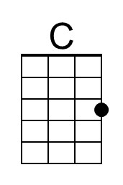
 |  |  |  |  |  |  |  | 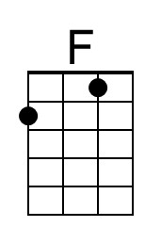
 |  |  |  |  |  |  |  | 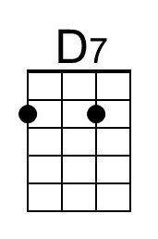
 |  |  |  |  |  |  |  | 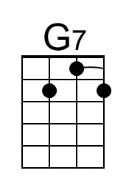
 |  |  |  |  |  |  |  | 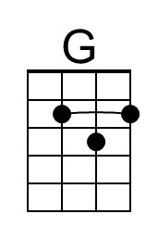
Baritone | 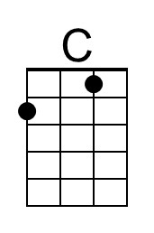 | 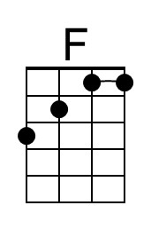 | 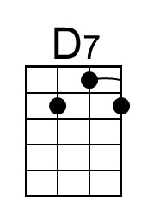 | 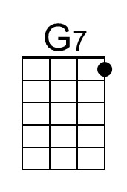 | 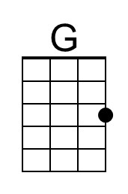


Be Careful, Don't Tear The Paper
C99 D
(A series of exhortations concerning thrift)
Words by Jean Sramek, 2003; Outro by T. Miller; Music: “We Wish You A Merry Christmas”

Intro  D G E7 A7 D  (We wish you a Merry Christmas and a Happy New Year)  A7 D G E7 A7  Be careful, don't tear the paper, be careful taking the tape off  D G E7 A7 D  Be careful to save the ribbon, we can use them next year.  D A E7 A  See this gift bag, it’s not déjà vu.  D G E7 A7 D  You put my present in it, for my birthday last June  A7 D G E7 A7  It’s wrinkled but we can iron it, it’s folded but we can use it  D G E7 A7 D  It’s almost completely shredded, but it’s perfectly good  D A E7 A  Don’t throw it a-way, how wasteful of you  D G E7 A7 D  I’ve used this same paper since Ninteen Sixty Two.  A7 D G E7 A7  Just cross out the Happy Birthday, just cross out the Thinking of You  D G E7 A7 D  Just cross out On Your Re-tirement, and write Christ-mas in.  Outro  A7 D G E7 A7  We wish you a merry Christmas, we wish you a Happy Hanukkah,  D G E7 A7 D  We wish you a Joyful Kwanzaa and a Happy New Year! |  |  |  |  |  |  |  | 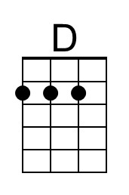
 |  |  |  |  |  |  |  | 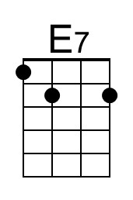
 |  |  |  |  |  |  |  | 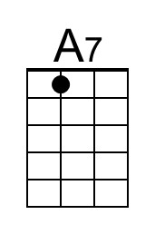
 |  |  |  |  |  |  |  | 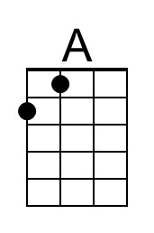
Baritone | 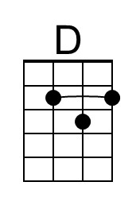 |  | 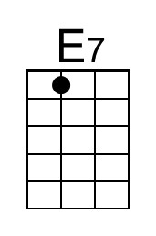 | 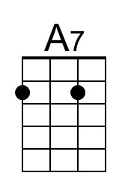 | 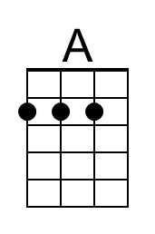

Be Careful, Don't Tear The Paper
C99 G
(A series of exhortations concerning thrift)
Words by Jean Sramek, 2003; Outro by T. Miller; Music: “We Wish You A Merry Christmas”

Intro
G C A7 D7 G
(We wish you a Merry Christmas and a Happy New Year)

D7 G C A7 D7
Be careful, don't tear the paper, be careful taking the tape off
G C A7 D7 G
Be careful to save the ribbon, we can use them next year.
G D A7 D
See this gift bag, it’s not déjà vu.
G C A7 D7 G
You put my present in it, for my birthday last June

D7 G C A7 D7
It’s wrinkled but we can iron it, it’s folded but we can use it
G C A7 D7 G
It’s almost completely shredded, but it’s perfectly good
G D A7 D
Don’t throw it a-way, how wasteful of you
G C A7 D7 G
I’ve used this same paper since Ninteen Sixty Two.

D7 G C A7 D7
Just cross out the Happy Birthday, just cross out the Thinking of You
G C A7 D7 G
Just cross out On Your Re-tirement, and write Christ-mas in.

Outro
D7 G C A7 D7
We wish you a merry Christmas, we wish you a Happy Hanukkah,
G C A7 D7 G
We wish you a Joyful Kwanzaa and a Happy New Year!

Baritone

