**Be My Baby (Phil Spector, Jeff Barry, Ellie Greenwich)**

**C Dm G7**



C

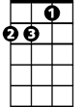

Dm

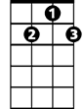

G7

F



The night we met I knew I needed you so

**C Dm G7**

And if I had the chance I'd never let you go.

**E7**

So won't you say you love me,

**A7**

E7

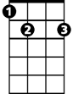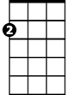

Am

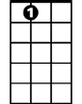

A7

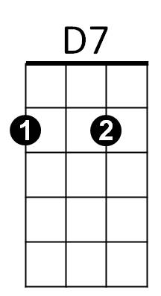I'll make you so proud of me.

**D7 G7**

We'll make 'em turn their heads every place we go.

**C**

So won't you, please,

**Chorus:**

Be my, be my baby

**Am**

Be my little baby, my one and only baby

**F**

Say you'll be my darlin', be my be my baby

**G7**

Be my baby now, Wha-oh-oh-oh.

**C Dm G7**

I'll make you happy, baby, just wait and see.

**C Dm G7**

For every kiss you give me I'll give you three.

**E7**

Oh, since the day I saw you

**A7**

I have been waiting for you.

**BARITONE**

C



Am



E7



D7



F

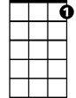

G7

**D7 G7**

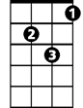

Dm

You know I will adore you 'til eternity.

**C**

So won't you, please,

**(Chorus)**

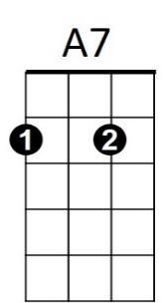

**G7 C**

So come on and, please,

**(Chorus 2x)**