Beautiful (Linda Perry) (C)
Beautiful by Christina Aguilera (Capo 1)

Intro C Bb Am Ab C C7 Am Ab  C Bb  Every day is so wonderful  Am Ab  Then sudden-ly, it's hard to breathe  C Bb  Now and then I get insecure  Am Ab  From all the pain, I'm so ashamed  F Dm  I am beautiful no matter what they say,  C Bb Am  Words can't bring me down  F Dm  I am beautiful in every single way,  C Bb Am  Yes, words can't bring me down, oh no  Dm C  So don't you bring me down today  C C7 Am Ab  C Bb  To all your friends you're de-lirious  Am Ab  So consumed in all your doom  C Bb  Trying hard to fill the emptiness  Am Ab  The pieces gone, left the puzzle un-done,  is that the way it is? |  |  |  | F Dm  You are beautiful no matter what they say,  C Bb Am  Words can't bring you down  F Dm  You am beautiful in every single way,  C Bb Am  Yes, words can't bring you down, oh no  Dm C  So don't you bring me down to-day  C Bb Am  No matter what we do, no matter what we say  Ab  We'll sing the song inside the tune,  full of beautiful mistakes  C Bb Am  And everywhere we go the sun will always shine  Ab  And tomorrow we might wake up on the other  side  F Dm  We are beautiful no matter what they say,  C Bb Am  Words won't bring us down  F Dm  We are beautiful in every single way,  C Bb Am  Yes, words can't bring us down, oh no  Dm C  So don't you bring me down today  C Bb Am Ab C Bb Am Ab C
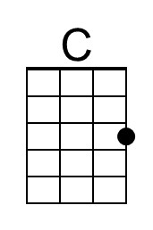 | 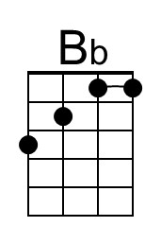 | 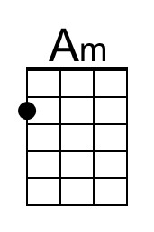 | 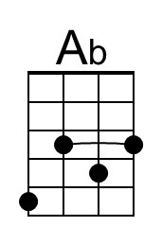 | 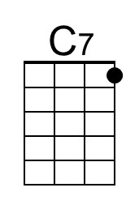 | 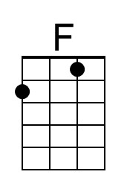 | 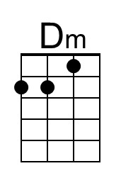
Bari | 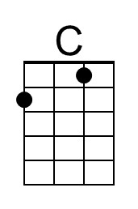 | 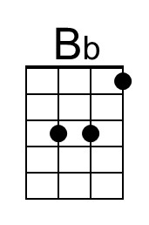 | 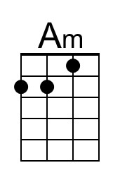 | 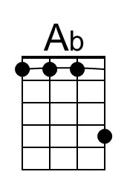 | 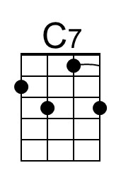 | 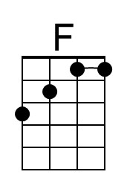 | 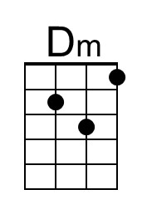

Beautiful (Linda Perry) (G)
Beautiful by Christina Aguilera

Intro G F Em Eb G G7 Em Eb  G F  Every day is so wonderful  Em Eb  Then sudden-ly, it's hard to breathe  G F  Now and then I get insecure  Em Eb  From all the pain, I'm so ashamed  C Am  I am beautiful no matter what they say,  G F Em  Words can't bring me down  C Am  I am beautiful in every single way,  G F Em  Yes, words can't bring me down, oh no  Am G  So don't you bring me down today  G G7 Em Eb  G F  To all your friends you're de-lirious  Em Eb  So consumed in all your doom  G F  Trying hard to fill the emptiness  Em Eb  The pieces gone, left the puzzle un-done,  is that the way it is? |  |  |  | C Am  You are beautiful no matter what they say,  G F Em  Words can't bring you down  C Am  You am beautiful in every single way,  G F Em  Yes, words can't bring you down, oh no  Am G  So don't you bring me down to-day  G F Em  No matter what we do, no matter what we say  Eb  We'll sing the song inside the tune,  full of beautiful mistakes  G F Em  And everywhere we go the sun will always shine  Eb  And tomorrow we might wake up on the other  side  C Am  We are beautiful no matter what they say,  G F Em  Words won't bring us down  C Am  We are beautiful in every single way,  G F Em  Yes, words can't bring us down, oh no  Am G  So don't you bring me down today  G F Em Eb G F Em Eb G
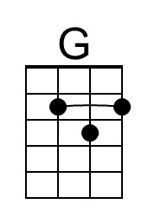 |  | 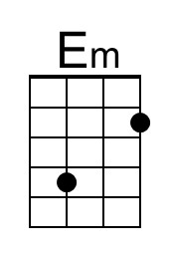 | 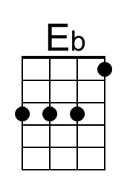 | 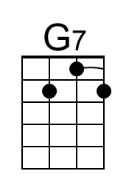
Bari | 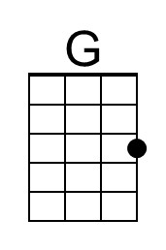 |  | 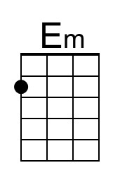 | 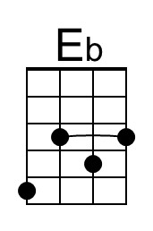 | 