**Because the Night (Bruce Springsteen / Patti Smith)**

**Dm Bb C Dm**

Take me now, baby, her e as I am.



Bb



C

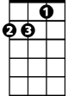

Dm

**Bb C Dm**

Pull me close try and under-stand.

**Bb C Dm**

Desire is hunger, is the fire I breathe.

**Bb C Dm**

Love is a banquet on which we feed.

**Bb C F C**

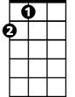

A

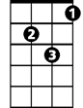

Gm

F



Come on now, try and under-stan d

**Dm Bb F C**

The way I feel when I’m in your hand.

**F Bb C**

Take my hand; come under cover.

**Gm Dm A**

They can’t hurt you now, can’t hurt you now, can’t hurt you now.

**Chorus:**

**Dm Bb C Dm**

Because the night belongs to lovers.

**Dm Bb C Dm**

Because the night belongs to lust.

**Dm Bb C Dm**

Because the night belongs to lovers.

**BARITONE**

**Dm Bb C Dm**



Dm

Because the night belongs to us.

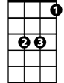

Bb

C



**Dm Bb C Dm**

Have I doubt when I’m alone?

**Dm Bb C Dm**

Love is a ring on the telephone.

**Dm Bb C Dm**

Love is an angel disguised as lust,

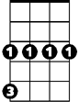

Gm

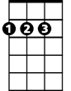

A



F

**Dm Bb C Dm**

Here in our bed until the morning comes.

**Bb C F C**

Come on now, try and under-stand

**Dm Bb F C**

The way I feel when under your com-mand.

**F Bb C**

Take my hand; as the sun descends.

**Gm Dm A**

They can’t hurt you now, can’t hurt you now, can’t hurt you now.

**(Chorus)**

**F C F C Dm C**

With love we sleep; with doubt the vicious circle turn and turns.

**F C Dm C F C**

Without you I cannot live, forgive the yearning, burning

**Bb F Bb**

I believe in time, too real to feel,

**Dm F Bb A**

So touch me now, touch me now, touch me now-ow

**(Chorus)**

**Because the Night (Bruce Springsteen / Patti Smith)**

**Bm G A Bm**



D

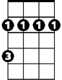

Bm



G



A

Take me now, baby, here as I am.

**G A Bm**

Pull me close try and under-stand.

**G A Bm**

Desire is hunger, is the fire I breathe.

**G A Bm**

Love is a banquet on which we feed.

**G A D A**

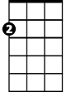

Em

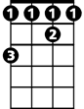

F#

Come on now, try and under-stand

**Bm G D A**

The way I feel when I’m in your hand.

**D G A**

Take my hand; come under cover.

**Em Bm F#**

They can’t hurt you now, can’t hurt you now, can’t hurt you now.

**Chorus:**

**Bm G A Bm**

Because the night belongs to lovers.

**Bm G A Bm**

Because the night belongs to lust.

**Bm G A Bm**

Because the night belongs to lovers.

**Bm G A Bm**

**BARITONE**

Because the night belongs to us.



A

Bm

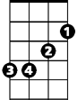

G



D

**Bm G A Bm**

Have I doubt when I’m alone?

**Bm G A Bm**

Love is a ring on the telephone.

**Bm G A Bm**

Love is an angel disguised as lust,

**Bm G A Bm**

Here in our bed until the morning comes.

Em

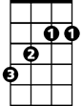

F#

**G A D A**

Come on now, try and under-stand

**Bm G D A**

The way I feel when under your com-mand.

**D G A**

Take my hand; as the sun descends.

**Em Bm F#**

They can’t hurt you now, can’t hurt you now, can’t hurt you now.

**(Chorus)**

**D A D A Bm A**

With love we sleep; with doubt the vicious circle turn and turns.

**D A Bm A D A**

Without you I cannot live, forgive the yearning, burning

**G D G**

I believe in time, too real to feel,

**Bm D G F#**

So touch me now, touch me now, touch me now-ow

**(Chorus)**