**Because (Ron Ryan)**

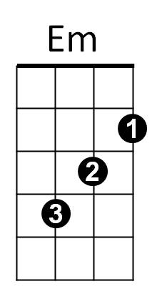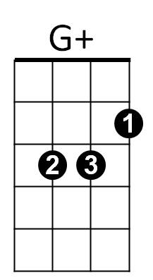**Intro: G G+ C Cm / G Am D7 G D7**



G

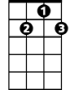

G7

**G G+ Em G7**

It’s right that I should care about you

**Am D Bb+**

And try to make you happy when you’re blue

**G G+ C Cm**

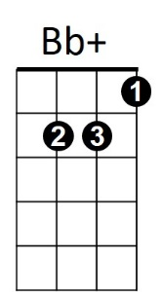It’s right, it’s right, to feel the way I do



C

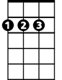

D

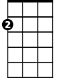

Am

**G Am D7 G**

Because, because I love you

**Bridge:**

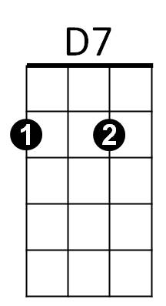 **Am D7 G Em**

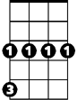

Cm

It’s wrong to say I don’t think of you

**Am D7 Am D D7**

‘Cause when you say these things, you know it makes me blue

**G G+ Em G7**

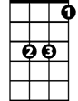

Eb

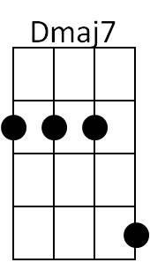Give me one kiss and I’ll be happy

**Am D Bb+**

Just, just to be with you

**G G+ C Cm**

Give me, give me, a chance to be near you,

**G Am D7 G Eb Dmaj7**

Because, because I love you

**Instrumental verse**

**D7**

**G G+ Em G7**

Give me one kiss and I’ll be happy

**Am D Bb+**

Just, just to be with you

**G G+ C Cm**

Give me, give me, a chance to be near you,

**G Am D7 G Em**

Because, because I love you

**Am D7 G**

Because, because I love you