Bennie And The Jets (Elton John & Bernie Taupin, 1973) (C)
Bennie And The Jets by Elton John (G) (1973) (Audio Release)
Bennie And The Jets by Elton John (G) (1973) (Official Music Video)

Intro Bbmaj7 ↓ | Cmaj7 ↓ ↓ ↓ ↓ | Cmaj7 ↓ ↓ ↓ ↓ | Bbmaj7 ↓ ↓ ↓ ↓ | Bbmaj7 ↓ ↓ ↓ ↓

Dm G
Hey kids, shake it loose together,
C C#dim7
The spotlight's hitting something that's been known to change the weather.
Dm G Am
__ We'll kill the fatted calf tonight, so stick a-round.
Dm Em7 F | F
You're gonna hear electric music – solid walls of sound.

Chorus
Cmaj7 Dm
Say, Candy and Ronnie, have you seen them yet? Ooh, they're so spaced out.
F
B-b-b-b-b-Bennie and the Jets.
Cmaj7 Dm
Oh, but they're weird and they're wonderful, oh, Bennie, she's really keen!
F G Am C | F
She's got electric boots, a mohair suit, you know I read it in a maga-zine, oh.
F9 F Cmaj7 | Cmaj7 | Bbmaj7 | Bbmaj7
__B-B-B-Bennie and the Jets. ( omit these chords last time through )

Dm G C C#dim7
Hey kids, plug into the faithless, maybe they're blinded, but Bennie makes them ageless.
Dm G Am
__ We shall sur-vive, lets take ourselves a-long,
Dm Em7 F
Where we fight our parents out in the streets to find who's right and who's wrong. Chorus

Instrumental Verse

Chorus

Outro (3x) [ abridged from Elton John’s 2 minute original ]
C | Bbmaj7 |
Bennie, Bennie, yeah.

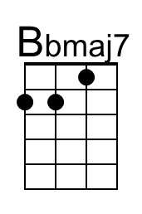 | 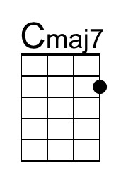 | 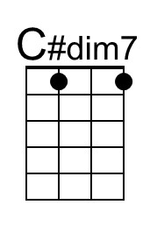 | 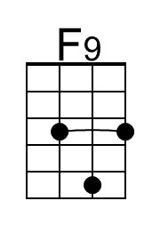 | 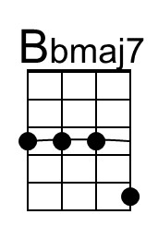 | 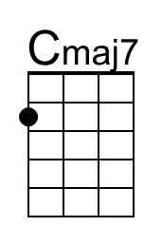 | 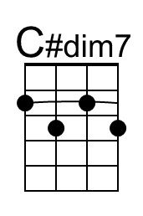 | 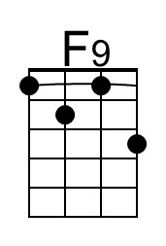

Bennie And The Jets (Elton John & Bernie Taupin, 1973) (F)
Bennie And The Jets by Elton John (G) (1973) (Audio Release)
Bennie And The Jets by Elton John (G) (1973) (Official Music Video)

Intro Ebmaj7 ↓ | Fmaj7 ↓ ↓ ↓ ↓ | Fmaj7 ↓ ↓ ↓ ↓ | Ebmaj7 ↓ ↓ ↓ ↓ | Ebmaj7 ↓ ↓ ↓ ↓

Gm C
Hey kids, shake it loose together,
F Gbdim7
The spotlight's hitting something that's been known to change the weather.
Gm C Dm
__ We'll kill the fatted calf tonight, so stick a-round.
Gm Am7 Bb | Bb
You're gonna hear electric music – solid walls of sound.

Chorus
Fmaj7 Gm
Say, Candy and Ronnie, have you seen them yet? Ooh, they're so spaced out.
Bb
B-b-b-b-b-Bennie and the Jets.
Fmaj7 Gm
Oh, but they're weird and they're wonderful, oh, Bennie, she's really keen!
Bb C Dm F | Bb
She's got electric boots, a mohair suit, you know I read it in a maga-zine, oh.
Bb9 Bb Fmaj7 | Fmaj7 | Ebmaj7 | Ebmaj7
__B-B-B-Bennie and the Jets. ( omit these chords last time through )

Gm C F Gbdim7
Hey kids, plug into the faithless, maybe they're blinded, but Bennie makes them ageless.
Gm C Dm
__ We shall sur-vive, let us take ourselves a-long,
Gm Am7 Bb
Where we fight our parents out in the streets to find who's right and who's wrong. Chorus

Instrumental Verse

Chorus

Outro (3x) [ abridged from Elton John’s 2 minute original ]
F | Ebmaj7 |
Bennie, Bennie, yeah.

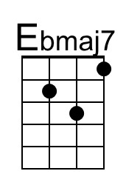 | 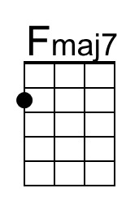 | 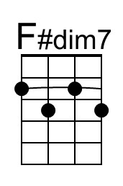 | 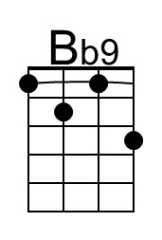 | 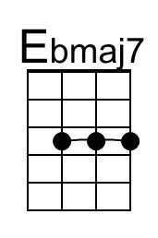 | 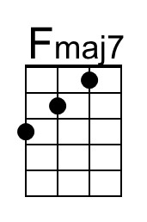 | 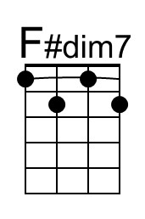 | 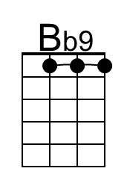

Bennie And The Jets (Elton John & Bernie Taupin, 1973) (G)
Bennie And The Jets by Elton John (G) (1973) (Audio Release)
Bennie And The Jets by Elton John (G) (1973) (Official Music Video)

Intro Fmaj7 ↓ | Gmaj7 ↓ ↓ ↓ ↓ | Gmaj7 ↓ ↓ ↓ ↓ | Fmaj7 ↓ ↓ ↓ ↓ | Fmaj7 ↓ ↓ ↓ ↓

Am D
Hey kids, shake it loose together,
G Abdim7
The spotlight's hitting something that's been known to change the weather.
Am D Em
__ We'll kill the fatted calf tonight, so stick a-round.
Am Bm7 C | C
You're gonna hear electric music – solid walls of sound.

Chorus
Gmaj7 Am
Say, Candy and Ronnie, have you seen them yet? Ooh, they're so spaced out.
C
B-b-b-b-b-Bennie and the Jets.
Gmaj7 Am
Oh, but they're weird and they're wonderful, oh, Bennie, she's really keen!
C D Em G | C
She's got electric boots, a mohair suit, you know I read it in a maga-zine, oh.
C9 C Gmaj7 | Gmaj7 | Fmaj7 | Fmaj7
__B-B-B-Bennie and the Jets. ( omit these chords last time through )

Am D G Abdim7
Hey kids, plug into the faithless, maybe they're blinded, but Bennie makes them ageless.
Am D Em
__ We shall sur-vive, let us take ourselves a-long,
Am Bm7 C
Where we fight our parents out in the streets to find who's right and who's wrong. Chorus

Instrumental Verse

Chorus

Outro (3x) [ abridged from Elton John’s 2 minute original ]
G | Fmaj7 |
Bennie, Bennie, yeah.

 | 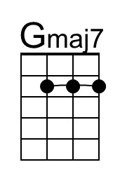 | 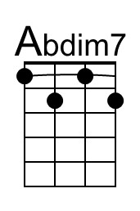 | 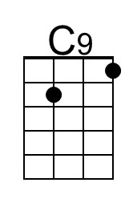 |  | 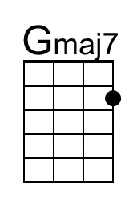 | 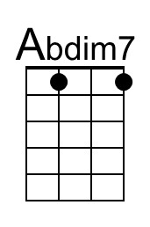 | 