Beyond the Sea (C) – C-Tuning Chords
("La Mer" by Charles Trenet & Albert Lasry, 1943, 1945; English Lyrics by Jack Lawrence, 1947)
Beyond the Sea by Bobby Darrin (1959) (Key of F)
4/4 Time – Tempo = 136 BPM

Intro C Am | F G7 | C Am | F G7  C Am F G7 C Am  Some-where . . . . beyond the sea  F G7 C E7 Am  Some-where waiting for me  G7 C Am F A7 Dm  My lover stands on golden sands  G7 Am F D7 G G7  And watches the ships that go sai . .ling.  C Am F G7 C Am  Some-where . . . be-yond the sea  F G7 C E7 Am  She's there watching for me  G7 C Am F A7 Dm  If I could fly like birds on high  G7 Am F Dm7 G7 C B7  Then straight to her arms I'd go sai . . . . . . ling.  Bridge  E C#m7 A B7 E C#m7  It's far . . . . . . . . beyond a star  F#m B7 E | E  It's near beyond the moon  D7 G Em C D7 G Em7  I know beyond a doubt  Am D7 G G7 | Em G7  My heart will lead me there, sooon.  C Am F G7 C Am  We'll meet . . . . . . beyond the shore  F G7 C E7 Am  We'll kiss just as be-fore  G7 C Am F A7 Dm  Happy we'll be be-yond the sea  G7 Am F D7 G7 C G7  And never a-gain I'll go sai . . . ling.  Repeat from top. Outro = Intro End on C |  |  | 
 |  |  | 
 |  |  | 
 |  |  | 
 |  | 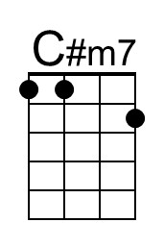 | 
 |  |  | 

Beyond the Sea (C) – G-Tuning Chords
("La Mer" by Charles Trenet & Albert Lasry, 1943, 1945; English Lyrics by Jack Lawrence, 1947)
Beyond the Sea by Bobby Darrin (1959) (Key of F)
4/4 Time – Tempo = 136 BPM

Intro C Am | F G7 | C Am | F G7  C Am F G7 C Am  Some-where . . . . beyond the sea  F G7 C E7 Am  Some-where waiting for me  G7 C Am F A7 Dm  My lover stands on golden sands  G7 Am F D7 G G7  And watches the ships that go sai . .ling.  C Am F G7 C Am  Some-where . . . be-yond the sea  F G7 C E7 Am  She's there watching for me  G7 C Am F A7 Dm  If I could fly like birds on high  G7 Am F Dm7 G7 C B7  Then straight to her arms I'd go sai . . . . . . ling.  Bridge  E C#m7 A B7 E C#m7  It's far . . . . . . . . beyond a star  F#m B7 E | E  It's near beyond the moon  D7 G Em C D7 G Em7  I know beyond a doubt  Am D7 G G7 | Em G7  My heart will lead me there, sooon.  C Am F G7 C Am  We'll meet . . . . . . beyond the shore  F G7 C E7 Am  We'll kiss just as be-fore  G7 C Am F A7 Dm  Happy we'll be be-yond the sea  G7 Am F D7 G7 C G7  And never a-gain I'll go sai . . . ling.  Repeat from top. Outro = Intro End on C |  |  | 
 |  |  | 
 |  |  | 
 |  |  | 
 |  | 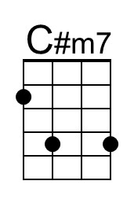 | 
 |  |  | 

Beyond the Sea (F) – C-Tuning Chords
("La Mer" by Charles Trenet & Albert Lasry, 1943, 1945;
English Lyrics by Jack Lawrence, 1947)
Beyond the Sea by Bobby Darrin (1959) (Key of F)
4/4 Time – Tempo = 136 BPM

Intro F Dm | Bb C7 | F Dm | Bb C7  F Dm Bb C7 F Dm  Some-where . . . . beyond the sea  Bb C7 F A7 Dm  Some-where waiting for me  C7 F Dm Bb D7 Gm  My lover stands on golden sands  C7 Dm Bb G7 C C7  And watches the ships that go sai . .ling.  F Dm Bb C7 F Dm  Some-where . . . beyond the sea  Bb C7 F A7 Dm  She's there watching for me  C7 F Dm Bb D7 Gm  If I could fly like birds on high  C7 Dm Bb Gm7 C7 F E7  Then straight to her arms I'd go sai . . . . . . ling.  Bridge  A F#m7 D E7 A F#m7  It's far . . . . . . . . beyond a star  Bm E7 A | A  It's near beyond the moon  G7 C Am F G7 C Am7  I know beyond a doubt  Dm G7 C C7 | Am C7  My heart will lead me there, sooon.  F Dm Bb C7 F Dm  We'll meet . . . . . . beyond the shore  Bb C7 F A7 Dm  We'll kiss just as be-fore  C7 F Dm Bb D7 Gm  Happy we'll be be-yond the sea  C7 Dm Bb G7 C7 F C7  And never a-gain I'll go sai . . . ling.  Repeat from top. Outro = Intro End on F |  |  | 
 | 
 | 
 |  | 
 |  | 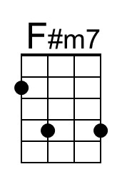
 |  |  | 

Beyond the Sea (F) – G-Tuning Chords
("La Mer" by Charles Trenet & Albert Lasry, 1943, 1945;
English Lyrics by Jack Lawrence, 1947)
Beyond the Sea by Bobby Darrin (1959) (Key of F)
4/4 Time – Tempo = 136 BPM

Intro F Dm | Bb C7 | F Dm | Bb C7  F Dm Bb C7 F Dm  Some-where . . . . beyond the sea  Bb C7 F A7 Dm  Some-where waiting for me  C7 F Dm Bb D7 Gm  My lover stands on golden sands  C7 Dm Bb G7 C C7  And watches the ships that go sai . .ling.  F Dm Bb C7 F Dm  Some-where . . . beyond the sea  Bb C7 F A7 Dm  She's there watching for me  C7 F Dm Bb D7 Gm  If I could fly like birds on high  C7 Dm Bb Gm7 C7 F E7  Then straight to her arms I'd go sai . . . . . . ling.  Bridge  A F#m7 D E7 A F#m7  It's far . . . . . . . . beyond a star  Bm E7 A | A  It's near beyond the moon  G7 C Am F G7 C Am7  I know beyond a doubt  Dm G7 C C7 | Am C7  My heart will lead me there, sooon.  F Dm Bb C7 F Dm  We'll meet . . . . . . beyond the shore  Bb C7 F A7 Dm  We'll kiss just as be-fore  C7 F Dm Bb D7 Gm  Happy we'll be be-yond the sea  C7 Dm Bb G7 C7 F C7  And never a-gain I'll go sai . . . ling.  Repeat from top. Outro = Intro End on F |  |  | 
 | 
 | 
 |  | 
 |  | 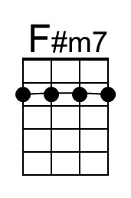
 |  | 

Beyond the Sea (G) – C-Tuning Chords
("La Mer" by Charles Trenet & Albert Lasry, 1943, 1945;
English Lyrics by Jack Lawrence, 1947)
Beyond the Sea by Bobby Darrin (1959) (Key of F)
4/4 Time – Tempo = 136 BPM

Intro G Em | C D7 | G Em | C D7

G Em C D7 G Em
Some-where . . . . beyond the sea
C D7 G B7 Em
Some-where waiting for me
D7 G Em C E7 Am
My lover stands on golden sands
D7 Em C A7 D D7
And watches the ships that go sai . .ling.

G Em C D7 G Em
Some-where . . . beyond the sea
C D7 G B7 Em
She's there watching for me
D7 G Em C E7 Am
If I could fly like birds on high
D7 Em C Am7 D7 G F#7
Then straight to her arms I'd go sai . . . . . . ling.

Bridge
B G#m7 E F#7 B G#m7
It's far . . . . . . . . beyond a star
C#m F#7 B | B
It's near beyond the moon
A7 D Bm G A7 D Bm7
I know beyond a doubt
Em A7 D D7 | Bm D7
My heart will lead me there, sooon.

G Em C D7 G Em
We'll meet . . . . . . beyond the shore
C D7 G B7 Em
We'll kiss just as be-fore
D7 G Em C E7 Am
Happy we'll be be-yond the sea
D7 Em C A7 D7 G D7
And never a-gain I'll go sai . . . ling.

Repeat from top. Outro = Intro End on G
 |  |  | 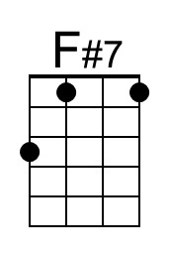
 |  | 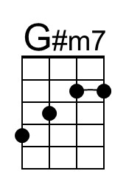
 | 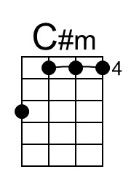 |  | 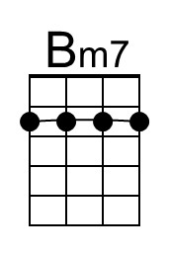

Beyond the Sea (G) – G-Tuning Chords
("La Mer" by Charles Trenet & Albert Lasry, 1943, 1945;
English Lyrics by Jack Lawrence, 1947)
Beyond the Sea by Bobby Darrin (1959) (Key of F)
4/4 Time – Tempo = 136 BPM

Intro G Em | C D7 | G Em | C D7

G Em C D7 G Em
Some-where . . . . beyond the sea
C D7 G B7 Em
Some-where waiting for me
D7 G Em C E7 Am
My lover stands on golden sands
D7 Em C A7 D D7
And watches the ships that go sai . .ling.

G Em C D7 G Em
Some-where . . . beyond the sea
C D7 G B7 Em
She's there watching for me
D7 G Em C E7 Am
If I could fly like birds on high
D7 Em C Am7 D7 G F#7
Then straight to her arms I'd go sai . . . . . . ling.

Bridge
B G#m7 E F#7 B G#m7
It's far . . . . . . . . beyond a star
C#m F#7 B | B
It's near beyond the moon
A7 D Bm G A7 D Bm7
I know beyond a doubt
Em A7 D D7 | Bm D7
My heart will lead me there, sooon.

G Em C D7 G Em
We'll meet . . . . . . beyond the shore
C D7 G B7 Em
We'll kiss just as be-fore
D7 G Em C E7 Am
Happy we'll be be-yond the sea
D7 Em C A7 D7 G D7
And never a-gain I'll go sai . . . ling.

Repeat from top. Outro = Intro End on G
 |  |  | 
 |  | 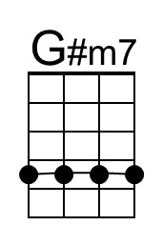
 | 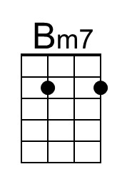 | 

