Beyond the Sea (C) – C-Tuning Chords
("La Mer" by Charles Trenet & Albert Lasry, 1943, 1945; English Lyrics by Jack Lawrence, 1947)
Beyond the Sea by Bobby Darrin (1959) (Key of F)
4/4 Time – Tempo = 136 BPM

Intro C Am | F G7 | C Am | F G7  C Am F G7 C Am  Some-where . . . . beyond the sea  F G7 C E7 Am  Some-where waiting for me  G7 C Am F A7 Dm  My lover stands on golden sands  G7 Am F D7 G G7  And watches the ships that go sai . .ling.  C Am F G7 C Am  Some-where . . . be-yond the sea  F G7 C E7 Am  She's there watching for me  G7 C Am F A7 Dm  If I could fly like birds on high  G7 Am F Dm7 G7 C B7  Then straight to her arms I'd go sai . . . . . . ling.  Bridge  E C#m7 A B7 E C#m7  It's far . . . . . . . . beyond a star  F#m B7 E | E  It's near beyond the moon  D7 G Em C D7 G Em7  I know beyond a doubt  Am D7 G G7 | Em G7  My heart will lead me there, sooon.  C Am F G7 C Am  We'll meet . . . . . . beyond the shore  F G7 C E7 Am  We'll kiss just as be-fore  G7 C Am F A7 Dm  Happy we'll be be-yond the sea  G7 Am F D7 G7 C G7  And never a-gain I'll go sai . . . ling.  Repeat from top. Outro = Intro End on C | 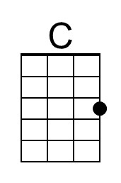 | 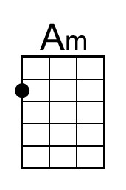 | 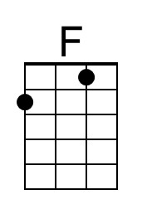
 | 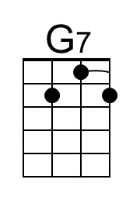 | 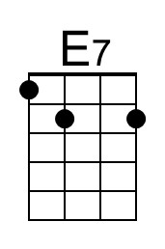 | 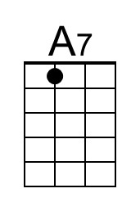
 | 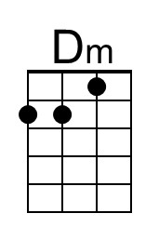 | 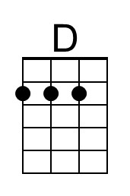 | 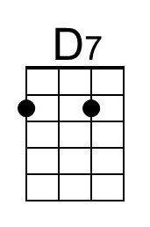
 | 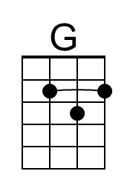 | 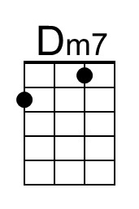 | 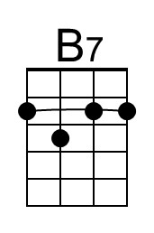
 | 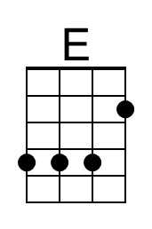 | 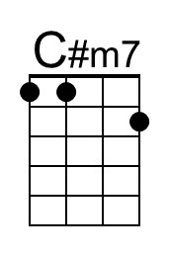 | 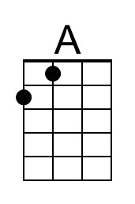
 | 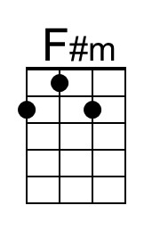 | 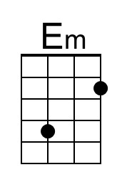 | 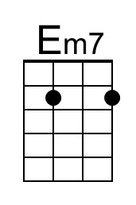
 | To perform as Bobby Darren, play an instrumental verse after the third verse, and then instrumental the first two lines of bridge. Begin singing at the third line of the Bridge (“I know . . . “), and finish with the third verse and Outro.

Beyond the Sea (C) – G-Tuning Chords
("La Mer" by Charles Trenet & Albert Lasry, 1943, 1945; English Lyrics by Jack Lawrence, 1947)
Beyond the Sea by Bobby Darrin (1959) (Key of F)
4/4 Time – Tempo = 136 BPM

Intro C Am | F G7 | C Am | F G7  C Am F G7 C Am  Some-where . . . . beyond the sea  F G7 C E7 Am  Some-where waiting for me  G7 C Am F A7 Dm  My lover stands on golden sands  G7 Am F D7 G G7  And watches the ships that go sai . .ling.  C Am F G7 C Am  Some-where . . . be-yond the sea  F G7 C E7 Am  She's there watching for me  G7 C Am F A7 Dm  If I could fly like birds on high  G7 Am F Dm7 G7 C B7  Then straight to her arms I'd go sai . . . . . . ling.  Bridge  E C#m7 A B7 E C#m7  It's far . . . . . . . . beyond a star  F#m B7 E | E  It's near beyond the moon  D7 G Em C D7 G Em7  I know beyond a doubt  Am D7 G G7 | Em G7  My heart will lead me there, sooon.  C Am F G7 C Am  We'll meet . . . . . . beyond the shore  F G7 C E7 Am  We'll kiss just as be-fore  G7 C Am F A7 Dm  Happy we'll be be-yond the sea  G7 Am F D7 G7 C G7  And never a-gain I'll go sai . . . ling.  Repeat from top. Outro = Intro End on C | 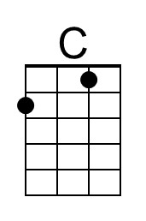 | 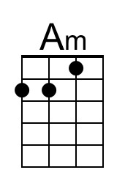 | 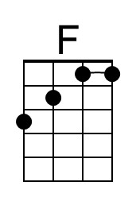
 | 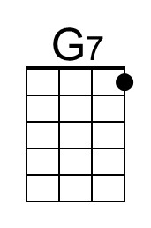 | 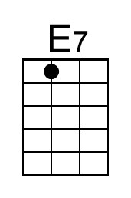 | 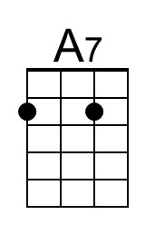
 | 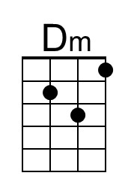 | 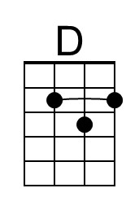 | 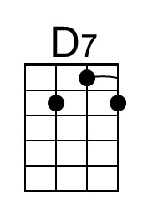
 | 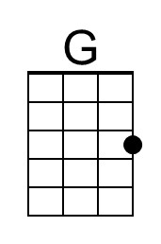 | 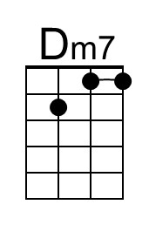 | 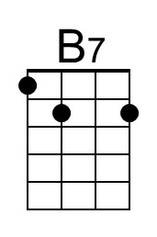
 | 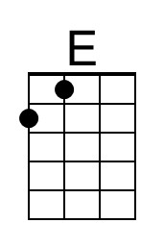 | 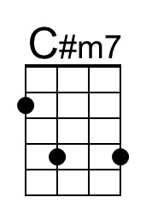 | 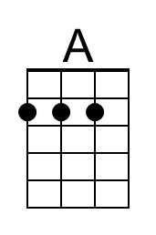
 | 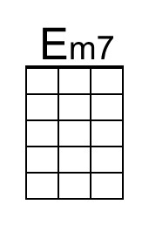 | 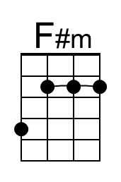 | 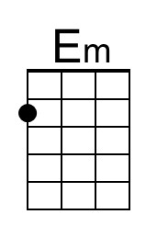
 | To perform as Bobby Darren, play an instrumental verse after the third verse, and then instrumental the first two lines of bridge. Begin singing at the third line of the Bridge (“I know . . . “), and finish with the third verse and Outro.

Beyond the Sea (F) – C-Tuning Chords
("La Mer" by Charles Trenet & Albert Lasry, 1943, 1945; English Lyrics by Jack Lawrence, 1947)
Beyond the Sea by Bobby Darrin (1959) (Key of F)
4/4 Time – Tempo = 136 BPM

Intro F Dm | Bb C7 | F Dm | Bb C7  F Dm Bb C7 F Dm  Some-where . . . . beyond the sea  Bb C7 F A7 Dm  Some-where waiting for me  C7 F Dm Bb D7 Gm  My lover stands on golden sands  C7 Dm Bb G7 C C7  And watches the ships that go sai . .ling.  F Dm Bb C7 F Dm  Some-where . . . beyond the sea  Bb C7 F A7 Dm  She's there watching for me  C7 F Dm Bb D7 Gm  If I could fly like birds on high  C7 Dm Bb Gm7 C7 F E7  Then straight to her arms I'd go sai . . . . . . ling.  Bridge  A F#m7 D E7 A F#m7  It's far . . . . . . . . beyond a star  Bm E7 A | A  It's near beyond the moon  G7 C Am F G7 C Am7  I know beyond a doubt  Dm G7 C C7 | Am C7  My heart will lead me there, sooon.  F Dm Bb C7 F Dm  We'll meet . . . . . . beyond the shore  Bb C7 F A7 Dm  We'll kiss just as be-fore  C7 F Dm Bb D7 Gm  Happy we'll be be-yond the sea  C7 Dm Bb G7 C7 F C7  And never a-gain I'll go sai . . . ling.  Repeat from top. Outro = Intro End on F |  |  | 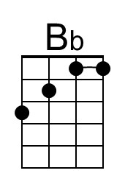
 | 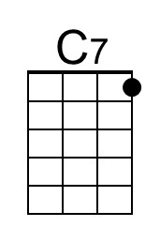
 | 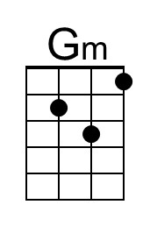
 |  | 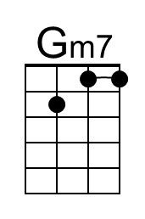
 |  | 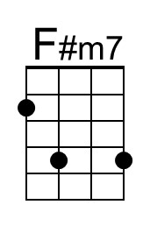
 | 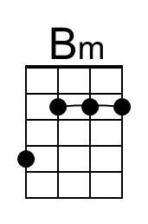 |  | 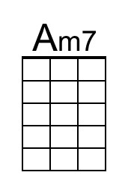
 | To perform as Bobby Darren, play an instrumental verse after the third verse, and then instrumental the first two lines of bridge. Begin singing at the third line of the Bridge (“I know . . . “), and finish with the third verse and Outro.

Beyond the Sea (F) – G-Tuning Chords
("La Mer" by Charles Trenet & Albert Lasry, 1943, 1945; English Lyrics by Jack Lawrence, 1947)
Beyond the Sea by Bobby Darrin (1959) (Key of F)
4/4 Time – Tempo = 136 BPM

Intro F Dm | Bb C7 | F Dm | Bb C7  F Dm Bb C7 F Dm  Some-where . . . . beyond the sea  Bb C7 F A7 Dm  Some-where waiting for me  C7 F Dm Bb D7 Gm  My lover stands on golden sands  C7 Dm Bb G7 C C7  And watches the ships that go sai . .ling.  F Dm Bb C7 F Dm  Some-where . . . beyond the sea  Bb C7 F A7 Dm  She's there watching for me  C7 F Dm Bb D7 Gm  If I could fly like birds on high  C7 Dm Bb Gm7 C7 F E7  Then straight to her arms I'd go sai . . . . . . ling.  Bridge  A F#m7 D E7 A F#m7  It's far . . . . . . . . beyond a star  Bm E7 A | A  It's near beyond the moon  G7 C Am F G7 C Am7  I know beyond a doubt  Dm G7 C C7 | Am C7  My heart will lead me there, sooon.  F Dm Bb C7 F Dm  We'll meet . . . . . . beyond the shore  Bb C7 F A7 Dm  We'll kiss just as be-fore  C7 F Dm Bb D7 Gm  Happy we'll be be-yond the sea  C7 Dm Bb G7 C7 F C7  And never a-gain I'll go sai . . . ling.  Repeat from top. Outro = Intro End on F |  |  | 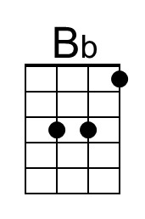
 | 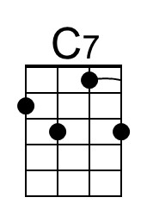
 | 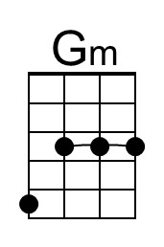
 |  | 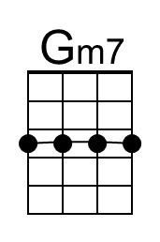
 |  | 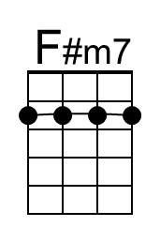
 | 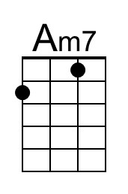 | 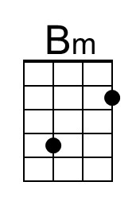
 | To perform as Bobby Darren, play an instrumental verse after the third verse, and then instrumental the first two lines of bridge. Begin singing at the third line of the Bridge (“I know . . . “), and finish with the third verse and Outro.

Beyond the Sea (G) – C-Tuning Chords
("La Mer" by Charles Trenet & Albert Lasry, 1943, 1945; English Lyrics by Jack Lawrence, 1947)
Beyond the Sea by Bobby Darrin (1959) (Key of F)
4/4 Time – Tempo = 136 BPM

Intro G Em | C D7 | G Em | C D7

G Em C D7 G Em
Some-where . . . . beyond the sea
C D7 G B7 Em
Some-where waiting for me
D7 G Em C E7 Am
My lover stands on golden sands
D7 Em C A7 D D7
And watches the ships that go sai . .ling.

G Em C D7 G Em
Some-where . . . beyond the sea
C D7 G B7 Em
She's there watching for me
D7 G Em C E7 Am
If I could fly like birds on high
D7 Em C Am7 D7 G F#7
Then straight to her arms I'd go sai . . . . . . ling.

Bridge
B G#m7 E F#7 B G#m7
It's far . . . . . . . . beyond a star
C#m F#7 B | B
It's near beyond the moon
A7 D Bm G A7 D Bm7
I know beyond a doubt
Em A7 D D7 | Bm D7
My heart will lead me there, sooon.

G Em C D7 G Em
We'll meet . . . . . . beyond the shore
C D7 G B7 Em
We'll kiss just as be-fore
D7 G Em C E7 Am
Happy we'll be be-yond the sea
D7 Em C A7 D7 G D7
And never a-gain I'll go sai . . . ling.

Repeat from top. Outro = Intro End on G
 |  |  | 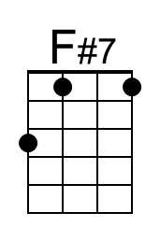
 | 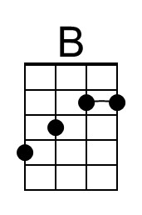 | 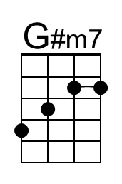
 | 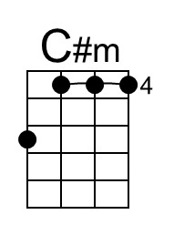 |  | 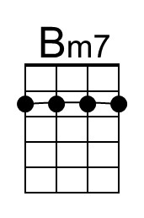
 | To perform as Bobby Darren, play an instrumental verse after the third verse, and then instrumental the first two lines of bridge. Begin singing at the third line of the Bridge (“I know . . . “), and finish with the third verse and Outro.

Beyond the Sea (G) – G-Tuning Chords
("La Mer" by Charles Trenet & Albert Lasry, 1943, 1945; English Lyrics by Jack Lawrence, 1947)
Beyond the Sea by Bobby Darrin (1959) (Key of F)
4/4 Time – Tempo = 136 BPM

Intro G Em | C D7 | G Em | C D7

G Em C D7 G Em
Some-where . . . . beyond the sea
C D7 G B7 Em
Some-where waiting for me
D7 G Em C E7 Am
My lover stands on golden sands
D7 Em C A7 D D7
And watches the ships that go sai . .ling.

G Em C D7 G Em
Some-where . . . beyond the sea
C D7 G B7 Em
She's there watching for me
D7 G Em C E7 Am
If I could fly like birds on high
D7 Em C Am7 D7 G F#7
Then straight to her arms I'd go sai . . . . . . ling.

Bridge
B G#m7 E F#7 B G#m7
It's far . . . . . . . . beyond a star
C#m F#7 B | B
It's near beyond the moon
A7 D Bm G A7 D Bm7
I know beyond a doubt
Em A7 D D7 | Bm D7
My heart will lead me there, sooon.

G Em C D7 G Em
We'll meet . . . . . . beyond the shore
C D7 G B7 Em
We'll kiss just as be-fore
D7 G Em C E7 Am
Happy we'll be be-yond the sea
D7 Em C A7 D7 G D7
And never a-gain I'll go sai . . . ling.

Repeat from top. Outro = Intro End on G
 |  |  | 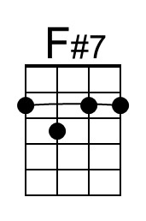
 | 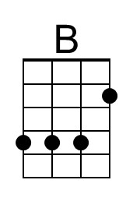 | 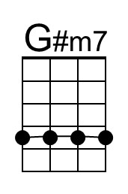
 | 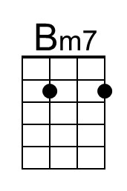 | 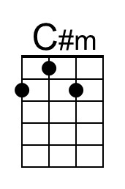
 | To perform as Bobby Darren, play an instrumental verse after the third verse, and then instrumental the first two lines of bridge. Begin singing at the third line of the Bridge (“I know . . . “), and finish with the third verse and Outro.

