Beyond the Sea (C)
("La Mer" by Charles Trenet & Albert Lasry, 1943, 1945; English Lyrics by Jack Lawrence, 1947)
Beyond the Sea by Bobby Darrin (1959) (Key of F)
4/4 Time – Tempo = 136 BPM
C-Tuning Chords
Intro C Am | F G7 | C Am | F G7  C Am F G7 C Am  Some-where . . . . beyond the sea,  F G7 C E7 | Am  Some-where waiting for me,  G7 C Am F A7 | Dm  My lover stands on golden sands  G7 Am F D7 | G G7  And watches the ships that go sai . . .ling.  C Am F G7 C Am  Some-where . . . . . beyond the sea,  F G7 C E7 | Am  She's there watching for me.  G7 C Am F A7 | Dm  If I could fly like birds on high,  G7 Am F Dm7 G7 C B7  Then straight to her arms I'd go sai . . . . . . . ling.  Bridge  E C#m7 A B7 E C#m7  It's far . . . . . . . . beyond a star;  F#m B7 E | E D7  It's near beyond the moon.  G Em C D7 G Em7  I know beyond a doubt,  Am D7 G G7 | Em G7  My heart will lead me there, sooon.  C Am F G7 C Am  We'll meet . . . . . . beyond the shore;  F G7 C E7 | Am  We'll kiss just as be-fore.  G7 C Am F A7 | Dm  Happy we'll be be-yond the sea,  G7 Am F D7 G7 C G7  And never a-gain I'll go sai . . . . . ling.  Repeat from top. Outro = Intro End on C | 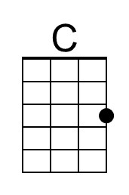 | 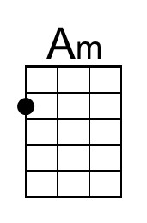 | 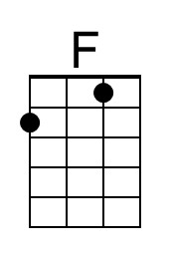
 | 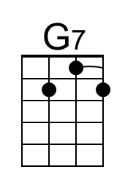 | 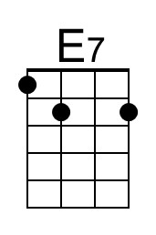 | 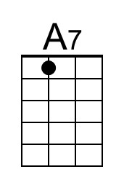
 | 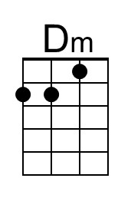 | 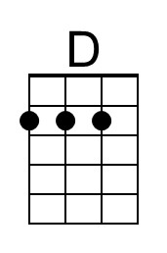 | 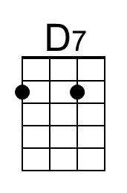
 | 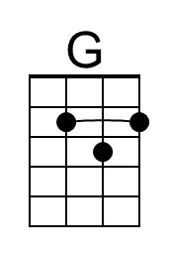 | 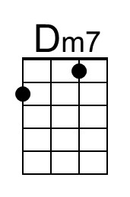 | 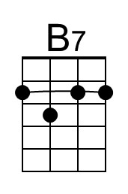
 | 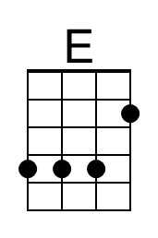 | 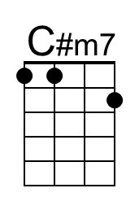 | 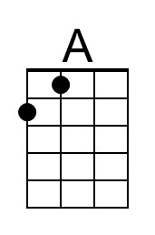
 | 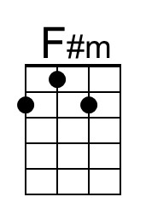 | 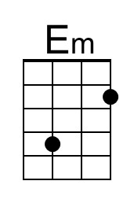 | 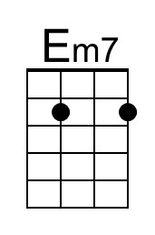
 | To perform as Bobby Darren, play an instrumental verse after the third verse, and then instrumental the first two lines of bridge. Begin singing at the third line of the Bridge (“I know . . . “), and finish with the third verse and Outro.

Beyond the Sea (C)
("La Mer" by Charles Trenet & Albert Lasry, 1943, 1945; English Lyrics by Jack Lawrence, 1947)
Beyond the Sea by Bobby Darrin (1959) (Key of F)
4/4 Time – Tempo = 136 BPM
G-Tuning Chords
Intro C Am | F G7 | C Am | F G7  C Am F G7 C Am  Some-where . . . . beyond the sea,  F G7 C E7 | Am  Some-where waiting for me,  G7 C Am F A7 | Dm  My lover stands on golden sands  G7 Am F D7 | G G7  And watches the ships that go sai . . .ling.  C Am F G7 C Am  Some-where . . . . . beyond the sea,  F G7 C E7 | Am  She's there watching for me.  G7 C Am F A7 | Dm  If I could fly like birds on high,  G7 Am F Dm7 G7 C B7  Then straight to her arms I'd go sai . . . . . . . ling.  Bridge  E C#m7 A B7 E C#m7  It's far . . . . . . . . beyond a star;  F#m B7 E | E D7  It's near beyond the moon.  G Em C D7 G Em7  I know beyond a doubt,  Am D7 G G7 | Em G7  My heart will lead me there, sooon.  C Am F G7 C Am  We'll meet . . . . . . beyond the shore;  F G7 C E7 | Am  We'll kiss just as be-fore.  G7 C Am F A7 | Dm  Happy we'll be be-yond the sea,  G7 Am F D7 G7 C G7  And never a-gain I'll go sai . . . . . ling.  Repeat from top. Outro = Intro End on C | 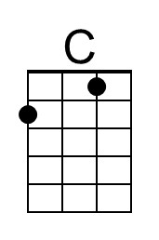 | 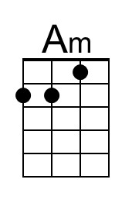 | 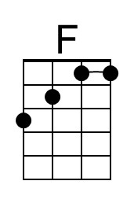
 | 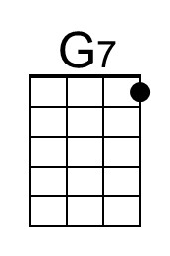 | 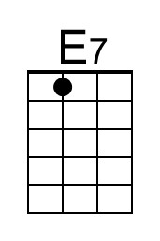 | 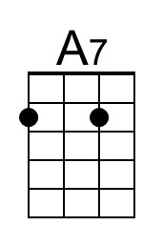
 | 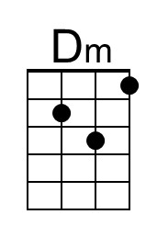 | 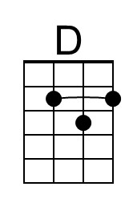 | 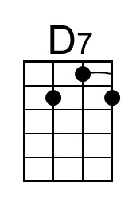
 | 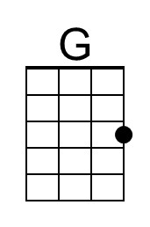 | 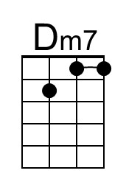 | 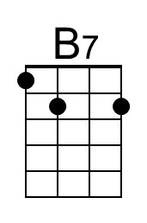
 | 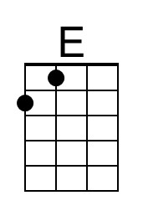 | 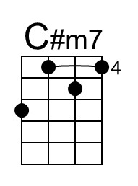 | 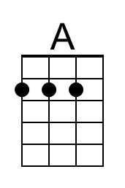
 | 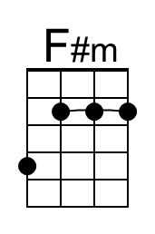 | 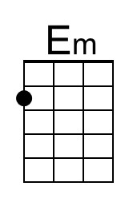 | 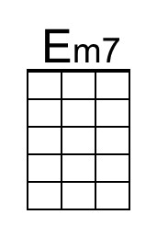
 |  | 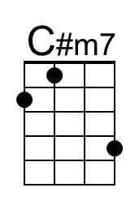 | 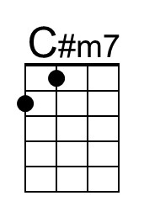

Beyond the Sea (F)
("La Mer" by Charles Trenet & Albert Lasry, 1943, 1945; English Lyrics by Jack Lawrence, 1947)
Beyond the Sea by Bobby Darrin (1959) (Key of F)
4/4 Time – Tempo = 136 BPM
C-Tuning Chords
Intro F Dm | Bb C7 | F Dm | Bb C7  F Dm Bb C7 F Dm  Some-where . . . . beyond the sea,  Bb C7 F A7 | Dm  Some-where waiting for me,  C7 F Dm Bb D7 | Gm  My lover stands on golden sands  C7 Dm Bb G7 | C C7  And watches the ships that go sai . . .ling.  F Dm Bb C7 F Dm  Some-where . . . . . beyond the sea,  Bb C7 F A7 | Dm  She's there watching for me.  C7 F Dm Bb D7 | Gm  If I could fly like birds on high,  C7 Dm Bb Gm7 C7 F E7  Then straight to her arms I'd go sai . . . . . . ling.  Bridge  A F#m7 D E7 A F#m7  It's far . . . . . . . . beyond a star;  Bm E7 A | A G7  It's near beyond the moon.  C Am F G7 C Am7  I know beyond a doubt,  Dm G7 C C7 | Am C7  My heart will lead me there, sooon.  F Dm Bb C7 F Dm  We'll meet . . . . . . beyond the shore;  Bb C7 F A7 | Dm  We'll kiss just as be-fore.  C7 F Dm Bb D7 | Gm  Happy we'll be be-yond the sea,  C7 Dm Bb G7 C7 F C7  And never a-gain I'll go sai . . . . . ling.  Repeat from top. Outro = Intro End on F |  |  | 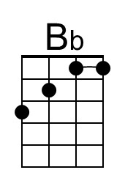
 | 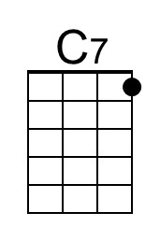
 | 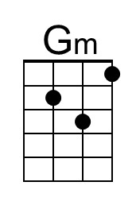
 |  | 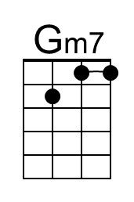
 |  | 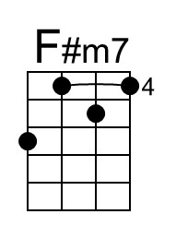
 | 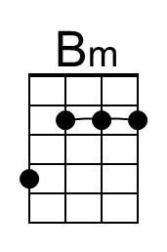 |  | 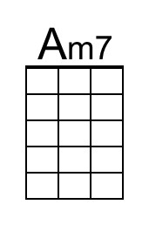
 |  | 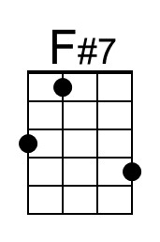 | 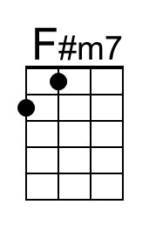

Beyond the Sea (F)
("La Mer" by Charles Trenet & Albert Lasry, 1943, 1945; English Lyrics by Jack Lawrence, 1947)
Beyond the Sea by Bobby Darrin (1959) (Key of F)
4/4 Time – Tempo = 136 BPM
G-Tuning Chords
Intro F Dm | Bb C7 | F Dm | Bb C7  F Dm Bb C7 F Dm  Some-where . . . . beyond the sea,  Bb C7 F A7 | Dm  Some-where waiting for me,  C7 F Dm Bb D7 | Gm  My lover stands on golden sands  C7 Dm Bb G7 | C C7  And watches the ships that go sai . . .ling.  F Dm Bb C7 F Dm  Some-where . . . . . beyond the sea,  Bb C7 F A7 | Dm  She's there watching for me.  C7 F Dm Bb D7 | Gm  If I could fly like birds on high,  C7 Dm Bb Gm7 C7 F E7  Then straight to her arms I'd go sai . . . . . . ling.  Bridge  A F#m7 D E7 A F#m7  It's far . . . . . . . . beyond a star;  Bm E7 A | A G7  It's near beyond the moon.  C Am F G7 C Am7  I know beyond a doubt,  Dm G7 C C7 | Am C7  My heart will lead me there, sooon.  F Dm Bb C7 F Dm  We'll meet . . . . . . beyond the shore;  Bb C7 F A7 | Dm  We'll kiss just as be-fore.  C7 F Dm Bb D7 | Gm  Happy we'll be be-yond the sea,  C7 Dm Bb G7 C7 F C7  And never a-gain I'll go sai . . . . . ling.  Repeat from top. Outro = Intro End on F |  |  | 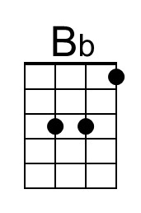
 | 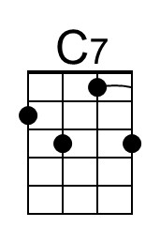
 | 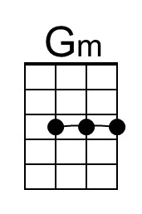
 |  | 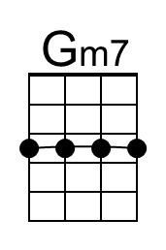
 |  | 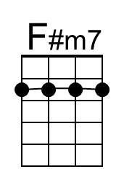
 | 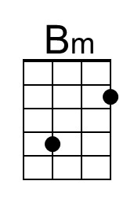 |  | 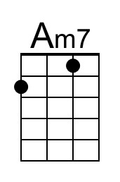
 | To perform as Bobby Darren, play an instrumental verse after the third verse, and then instrumental the first two lines of bridge. Begin singing at the third line of the Bridge (“I know . . . “), and finish with the third verse and Outro.

