**Bitter Green (Gordon Lightfoot) Key C**

**Intro: C F G F G C G7 (Melody for last 2 lines of chorus)**

F



G



C

**C G**

Upon the bitter green she walked, the hills above the town,

**Em Dm**

Echoed to her footsteps as soft as Eider down.

**Em Dm**

Waiting for her master to kiss away her tears,

**G7**

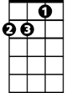

Dm

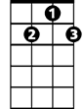

G7

Em

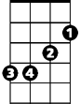

Waiting through the years.

**CHORUS:**

**C F G**

Bitter Green they called her, walking in the sun,

**F G C G7**

Loving everyone that she met.

**C F G**

**BARITONE**

Bitter Green they called her, waiting in the sun,

C



G



F

**F G C G7**

Waiting for someone to take her home.

**C G**

Some say he was a sailor who died away at sea,

**Em Dm**

Some say he was a prisoner who never was set free.

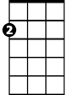

Em

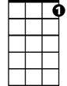

G7

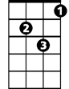

Dm

**Em Dm**

Lost upon the ocean he died there in the mist,

**G7**

Dreaming of her kiss.

**(CHORUS)**

**C G**

But now the bitter green is gone, the hills have turned to rust,

**Em Dm**

There comes a weary stranger, his tears fall in the dust,

**Em Dm**

Kneeling by the churchyard in the autumn mist,

**G7**

Dreaming of a kiss.

**(CHORUS)**

**F G C**

Waiting for someone to take her home.

**Bitter Green (Gordon Lightfoot) Key D**

**Intro: D G A G A D A7 (Melody for last 2 lines of chorus)**

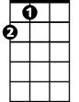

A



G

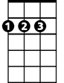

D

**D A**

Upon the bitter green she walked, the hills above the town,

**F#m Em**

Echoed to her footsteps as soft as Eider down.

**F#m Em**

Waiting for her master to kiss away her tears,

**A7**

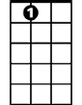

A7

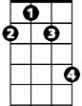

F#m

Em



Waiting through the years.

**CHORUS:**

**D G A**

Bitter Green they called her, walking in the sun,

**G A D A7**

Loving everyone that she met.

**D G A**

Bitter Green they called her, waiting in the sun,

**BARITONE**

**G A D A7**



A



G



D

Waiting for someone to take her home.

**D A**

Some say he was a sailor who died away at sea,

**F#m Em**

Some say he was a prisoner who never was set free.

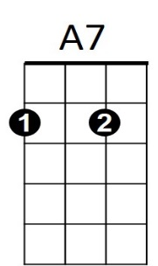**F#m Em**



Em

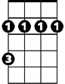

F#m

Lost upon the ocean he died there in the mist,

**A7**

Dreaming of her kiss.

**(CHORUS)**

**D A**

But now the bitter green is gone, the hills have turned to rust,

**F#m Em**

There comes a weary stranger, his tears fall in the dust,

**F#m Em**

Kneeling by the churchyard in the autumn mist,

**A7**

Dreaming of a kiss.

**(CHORUS)**

**G A D**

Waiting for someone to take her home.

**Bitter Green (Gordon Lightfoot) Key G**

**Intro: G C D C D G D7 (Melody for last 2 lines of chorus)**



G



D



C

**G D**

Upon the bitter green she walked, the hills above the town,

**Bm Am**

Echoed to her footsteps as soft as Eider down.

**Bm Am**

Waiting for her master to kiss away her tears,

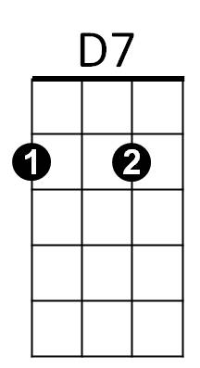 **D7**



Bm



Am

Waiting through the years.

**CHORUS:**

**G C D**

Bitter Green they called her, walking in the sun,

**C D G D7**

Loving everyone that she met.

**G C D**

Bitter Green they called her, waiting in the sun,

**BARITONE**

**C D G D7**



G



D

C



Waiting for someone to take her home.

**G D**

Some say he was a sailor who died away at sea,

**Bm Am**

Some say he was a prisoner who never was set free.



D7



Am

Bm



**Bm Am**

Lost upon the ocean he died there in the mist,

**D7**

Dreaming of her kiss.

**(CHORUS)**

**G D**

But now the bitter green is gone, the hills have turned to rust,

**Bm Am**

There comes a weary stranger, his tears fall in the dust,

**Bm Am**

Kneeling by the churchyard in the autumn mist,

**D7**

Dreaming of a kiss.

**(CHORUS)**

**C D G**

Waiting for someone to take her home.