Black Velvet Band (Traditional, Adapted by Will Millar)
Key of C; 12/8 Time, a quick-time variant of ¾ time.
Black Velvet Band, The Irish Rovers (45 rpm version, 1967)

Intro (Last Two Lines of Chorus): C Am Dm G C  Chorus:  C  Her eyes they shone like the diamonds.  C D G  You'd think she was Queen of the Land.  C Am  And her hair hung over her shoulders,  Dm G C  Tied up with a Black Velvet Band. | 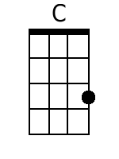 | 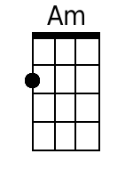 | 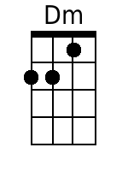
 | 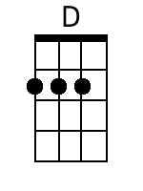 | 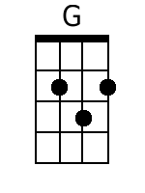

C
1. In a neat little town they call Belfast,
C Dm G
Ap-prenticed to trade I was bound.
C Am
And many’s an hour sweet happiness,
Dm G C
I spent in that neat little town.
C
Till bad misfortune came o’er me
C Dm G
That caused me to stray from the land.
C Am
Far a-way from me friends and re-lations
Dm G C
To follow the Black Velvet Band. Chorus.

C
2. Well, I was out strolling one evening,
C Dm G
Not meaning to go very far.
C Am
When I met with a frolicsome damsel
Dm G C
A-selling her trade in the bar.
C
When a watch she took from a customer,
C Dm G
And slipped it right into my hand.
C Am
Then the law came and put me in prison,
Dm G C
Bad luck to her Black Velvet Band. Chorus.

C
3. Next mornin' before judge and jury,
C Dm G
Her trial I had to ap-pear.
C Am
And the judge he says, 'Me young fellow,
Dm G C
The case against you is quite clear.
C
And seven long years is your sentence,
C G
You're going to Van Diemen’s Land.*
C Am
Far a-way from your friends and re-lations
Dm G C
To follow the Black Velvet Band.' Chorus.

C
4. So, come all ye jolly young fellows,
C Dm G
I'll have you take warnin' by me.
C Am
And when-ever you're into the liquor, me lads,
Dm G C
Be-ware of the pretty Colleen.
C
For they'll fill you with whiskey and porter,
C Dm G
Til you are not able to stand.
C Am
And the very next thing that you know, me lads,
Dm G C
You've landed in Van Diemen’s Land. Chorus (2x)

Bari: | 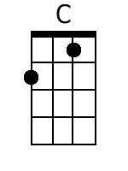 | 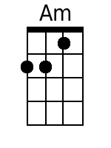 | 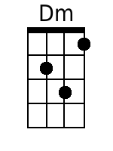 | 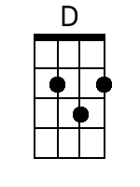 | 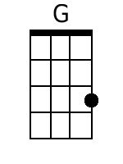

Black Velvet Band (Traditional, Adapted by Will Millar)
Key of G; 12/8 Time, a quick-time variant of ¾ time.
Black Velvet Band, The Irish Rovers (45 rpm version, 1967)

Intro (Last Two Lines of Chorus): G Em Am D G  Chorus:  G  Her eyes they shone like the diamonds.  G A D  You'd think she was Queen of the Land.  G Em  And her hair hung over her shoulders,  Am D G  Tied up with a Black Velvet Band. |  | 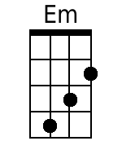
 |  | 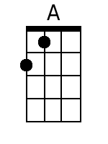

G
1. In a neat little town they call Belfast,
G Am D
Ap-prenticed to trade I was bound.
G Em
And many’s an hour sweet happiness,
Am D G
I spent in that neat little town.
G
Till bad misfortune came o’er me
G Am D
That caused me to stray from the land.
G Em
Far a-way from me friends and re-lations
Am D G
To follow the Black Velvet Band. Chorus.

G
2. Well, I was out strolling one evening,
G Am D
Not meaning to go very far.
G Em
When I met with a frolicsome damsel
Am D G
A-selling her trade in the bar.
G
When a watch she took from a customer,
G Am D
And slipped it right into my hand.
G Em
Then the law came and put me in prison,
Am D G
Bad luck to her Black Velvet Band. Chorus.

G
3. Next mornin' before judge and jury,
G Am D
Her trial I had to ap-pear.
G Em
And the judge he says, 'Me young fellow,
Am D G
The case against you is quite clear.
G
And seven long years is your sentence,
G D
You're going to Van Diemen’s Land.
G Em
Far a-way from your friends and re-lations
Am D G
To follow the Black Velvet Band.' Chorus.

G
4. So, come all ye jolly young fellows,
G Am D
I'll have you take warnin' by me.
G Em
And when-ever you're into the liquor, me lads,
Am D G
Be-ware of the pretty Colleen.
G
For they'll fill you with whiskey and porter,
G Am D
Til you are not able to stand.
G Em
And the very next thing that you know, me lads,
Am D G
You've landed in Van Diemen’s Land. Chorus (2x)

Bari |  | 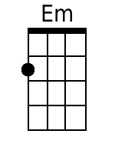 |  |  | 