**Black is Black (Anthony Hayes / Michelle Grainger / Steve Wadey)**

**Intro: Dm C (4x)**

**Dm C**



C



G

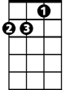

Dm

Black is black, I want my baby back

**Dm G G7 C**

It's gray, it's gray, since she went away, woh woh

**C Dm G C**

What can I do, 'cause I - I - I - I -I, I'm feelin' blue

F

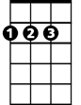

D

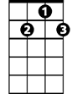

G7

**Dm C**

If I had my way, she'd be back today

**Dm G G7 C**

But she don’t intend, to see me again, oh oh

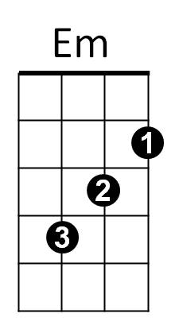**C Dm G C**

What can I do, 'cause I - I - I - I -I, I'm feelin' blue

**Reprise:**

**Dm Em**

I can't choose, it's too much to lose

**F**

When our love's too strong

**BARITONE**

**D**



G

C

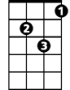

Dm

Whoooo- Maybe if she would come back to me,

**G Em G7 (PAUSE)**

Then it can't go wrong

**Dm C**

Bad is bad, that I feel so sad

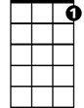

G7



F



D

**Dm G G7 C**

It's time, it's time, that I found peace of mind, oh oh

**C Dm G C**

What can I do, 'cause I - I - I - I -I, I'm feelin' blue

**(Reprise)**

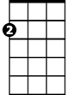

Em

**Dm C**

Black is black, I want my baby back

**Dm G G7 C**

It's gray, it's gray, since she went away, woh woh

**C Dm G C**

What can I do, 'cause I - I - I – I - I, I'm feelin' blue

**Dm G C C F G C**

'Cause I - I - I - I -I, I'm feelin' blue,