Black is Black (Anthony Hayes / Michelle Grainger / Steve Wadey)
Intro: Dm C (4x)



Dm C
C
Dm
G
Black is black, I want my baby back
Dm G G7 C
It's gray, it's gray, since she went away, woh woh
C Dm G C



What can I do, 'cause I - I - I - I -I, I'm feelin' blue
F
D
G7

Dm C
If I had my way, she'd be back today
Dm G G7 C
But she don’t intend, to see me again, oh oh
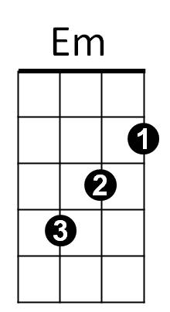
C Dm G C
What can I do, 'cause I - I - I - I -I, I'm feelin' blue

Reprise:
Dm Em
I can't choose, it's too much to lose
F
When our love's too strong
BARITONE

D
C
G
Dm
Whoooo- Maybe if she would come back to me,
G Em G7 (PAUSE)
Then it can't go wrong

Dm C


Bad is bad, that I feel so sad
F
G7
D
Dm G G7 C
It's time, it's time, that I found peace of mind, oh oh
C Dm G C
What can I do, 'cause I - I - I - I -I, I'm feelin' blue


(Reprise)
Em

Dm C
Black is black, I want my baby back
Dm G G7 C
It's gray, it's gray, since she went away, woh woh
C Dm G C
What can I do, 'cause I - I - I – I - I, I'm feelin' blue
Dm G C C F G C
'Cause I - I - I - I -I, I'm feelin' blue,

