**Black is Black (Anthony Hayes / Michelle Grainger / Steve Wadey)**

**Intro: Dm C (4x)**



G



C

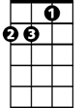

Dm

**Dm C**

Black is black, I want my baby back

**Dm G G7 C**

It's gray, it's gray, since she went away, woh woh

**C Dm G C**

What can I do, 'cause I - I - I - I -I, I'm feelin' blue

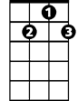

G7

F



Em

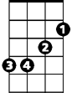

**Dm C**

If I had my way, she'd be back today

**Dm G G7 C**

But she don’t intend, to see me again, oh oh

**C Dm G C**

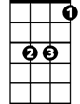

Eb

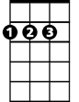

D

What can I do, 'cause I - I - I - I -I, I'm feelin' blue

**Reprise:**

**Dm Em**

I can't choose, it's too much to lose

**F**

When our love's too strong

**D**

Whoooo- Maybe if she would come back to me,

**G Em G7 (PAUSE)**

**BARITONE**

Then it can't go wrong

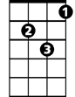

Dm



G

C



F

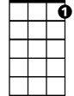

G7

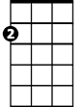

Em

**Dm C**

Bad is bad, that I feel so sad

**Dm G G7 C**

It's time, it's time, that I found peace of mind, oh oh

**C Dm G C**

What can I do, 'cause I - I - I - I -I, I'm feelin' blue

**(Reprise)**

**Dm C**

Black is black, I want my baby back

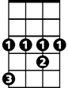

Eb



D

**Dm G G7 C**

It's gray, it's gray, since she went away, woh woh

**C Dm G C**

What can I do, 'cause I - I - I – I - I, I'm feelin' blue

**Dm G C C Eb F C**

'Cause I - I - I - I -I, I'm feelin' blue,