Blame It on the Ukulele
Barry Mann & Cynthia Weil
Blame It on the Ukulele (Barry Mann & Cynthia Weil) (C)

Intro C | G7 | C  Tacet C G7  I was on my own, feeling sad and blue.  C  When I met a friend who knew just what to do  C7 F  On her little uke, she began to play  C G7 C  And then I knew, I’d buy a uke that day (Pause)  Tacet G7 C  Blame it on the Uku-lele, with its magic spell  G7 C C7  Blame it on the Ukulele, that she played so well  F  Oh, it all began with just one little chord  C  But soon it soon it was a sound we all adored  G7 C  Blame it on the Ukulele, the sound of love (Pause)  Bridge  Tacet G7  Is it a guitar? (No, no the ukulele)  C  Or a mandolin? (No, no the ukulele)  G7 C  So it was the sound? (Yes, yes, the ukulele)  F C  The sound of love! (Pause)  Tacet C G7  Now I’m glad to say, I have a family  C  Soprano, tenor, bari – every uku-lele  C7 F  All my friends play ukes and I’m never blue  C G7 C  So join our band and you can play one, too! (Pause)  G7 C  Come and play the Uku-lele, with its magic spell  G7 C C7  Come and play the Uku-lele, makes you feel so swell  F  Oh, it all began with just one little chord  C  But soon it soon it was a sound we all adored  G7 C  Blame it on the Ukulele, the sound of love. Bridge | 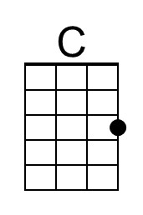 | 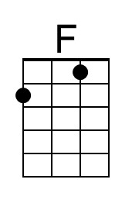
 | 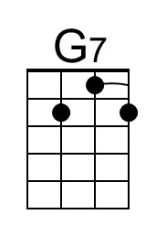 | 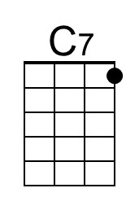
 | Bari
 | 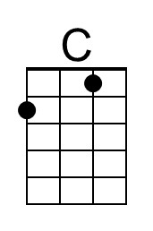 | 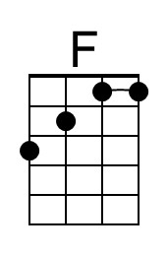
 | 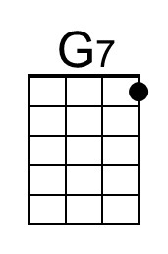 | 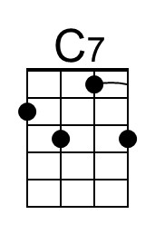

Blame It on the Ukulele (Barry Mann & Cynthia Weil) (G)

Intro G | D7 | G  Tacet G D7  I was on my own, feeling sad and blue.  G  When I met a friend who knew just what to do  G7 C  On her little uke, she began to play  G D7 G  And then I knew, I’d buy a uke that day (Pause)  Tacet D7 G  Blame it on the Uku-lele, with its magic spell  D7 G G7  Blame it on the Ukulele, that she played so well  C  Oh, it all began with just one little chord  G  But soon it soon it was a sound we all adored  D7 G  Blame it on the Ukulele, the sound of love. (Pause)  Bridge  Tacet D7  Is it a guitar? (No, no the ukulele)  G  Or a mandolin? (No, no the ukulele)  D7 G  So it was the sound? (Yes, yes, the ukulele)  C G  The sound of love! (Pause)  Tacet G D7  Now I’m glad to say, I have a family  G  Soprano, tenor, bari – every uku-lele  G7 C  All my friends play ukes and I’m never blue  G D7 G  So join our band and you can play one, too! (Pause)  D7 G  Come and play the Uku-lele, with its magic spell Tacet  D7 G G7  Come and play the Uku-lele, makes you feel so swell  C  Oh, it all began with just one little chord  G  But soon it soon it was a sound we all adored  D7 G  Blame it on the Ukulele, the sound of love. Bridge | 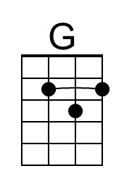
 | 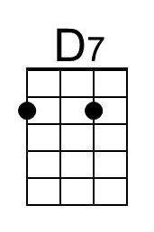
 | Bari
 |  | 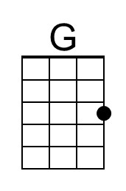
 |  | 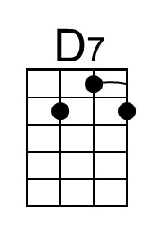

Blame It on the Ukulele (Barry Mann & Cynthia Weil) (F)

Intro F | C7 | F

Tacet F C7
I was on my own, feeling sad and blue.
F
When I met a friend who knew just what to do
F7 Bb
On her little uke, she began to play
F C7 F
And then I knew, I’d buy a uke that day (Pause)
Tacet C7 F
Blame it on the Uku-lele, with its magic spell
C7 F F7
Blame it on the Ukulele, that she played so well
Bb
Oh, it all began with just one little chord
F
But soon it soon it was a sound we all adored
C7 F
Blame it on the Ukulele, the sound of love (Pause)

Bridge
Tacet C7
Is it a guitar? (No, no the ukulele)
F
Or a mandolin? (No, no the ukulele)
C7 F
So it was the sound? (Yes, yes, the ukulele)
Bb F
The sound of love! (Pause)

Tacet F C7
Now I’m glad to say, I have a fami-ly
F
Soprano, tenor, bari – every uku-lele
F7 Bb
All my friends play ukes and I’m never blue
F C7 F
So join our band and you can play one, too! (Pause)
Tacet C7 F
Come and play the Uku-lele, with its magic spell
C7 F F7
Come and play the Uku-lele, makes you feel so swell
Bb
Oh, it all began with just one little chord
F
But soon it soon it was a sound we all adored
C7 F
Blame it on the Ukulele, the sound of love. Bridge
 | 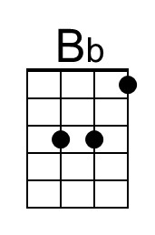 | 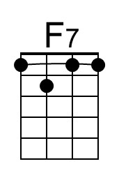
 | Bari

Blame It on the Ukulele (Barry Mann & Cynthia Weil) (C)

Intro C | G7 | C

Tacet C G7
I was on my own, feeling sad and blue.
C
When I met a friend who knew just what to do
C7 F
On her little uke, she began to play
C G7 C
And then I knew, I’d buy a uke that day (Pause)
Tacet G7 C
Blame it on the Uku-lele, with its magic spell
G7 C C7
Blame it on the Ukulele, that she played so well
F
Oh, it all began with just one little chord
C
But soon it soon it was a sound we all adored
G7 C
Blame it on the Ukulele, the sound of love (Pause)

Bridge
Tacet G7
Is it a guitar? (No, no the ukulele)
C
Or a mandolin? (No, no the ukulele)
G7 C
So it was the sound? (Yes, yes, the ukulele)
F C
The sound of love! (Pause)

Tacet C G7
Now I’m glad to say, I have a family
C
Soprano, tenor, bari – every uku-lele
C7 F
All my friends play ukes and I’m never blue
C G7 C
So join our band and you can play one, too! (Pause)
G7 C
Come and play the Uku-lele, with its magic spell
G7 C C7
Come and play the Uku-lele, makes you feel so swell
F
Oh, it all began with just one little chord
C
But soon it soon it was a sound we all adored
G7 C
Blame it on the Ukulele, the sound of love. Bridge
Bari

This page is intentionally blank.

