**Blowin’ in the Wind (Bob Dylan)**

**Intro: Chords for last line of verse**

**C F C Am C F C**

How many roads must a man walk down before you call him a man?

**C F C Am C F G**

How many seas must a white dove sail before she can sleep in the sand?

**C F C Am C F G**

How many times must the cannon balls fly before they are forever banned?

**F G C Am**

The answer my friend, is blowin' in the wind.

**F G C**

The answer is blowin' in the wind.

**C F C Am C F C**

How many years can a mountain exist, before it's washed to the sea?

**C F C Am C F G**

How many years can some people exist, before they're allowed to be free?

**C F C Am C F G**

How many times can a man turn his head and pretend that he just doesn't see?

**F G C Am**

The answer my friend, is blowin' in the wind.

**F G C**

The answer is blowin' in the wind.

**C F C Am C F C**

How many times must a man look up before he can see the sky?

**C F C Am C F G**

How many ears must one man have before he can hear people cry?

**C F C Am C F G**

How many deaths will it take till he knows that too many people have died?

**F G C Am**

The answer my friend, is blowin' in the wind.

**F G C**

The answer is blowin' in the wind.

**F G C**

The answer is blowin' in the wind

**BARITONE**

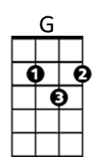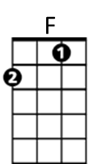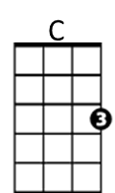

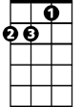

Am



G

C



F

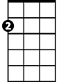

Am