Blowin' in the Wind (Bob Dylan) (G)

Intro: Chords for last line of verse

G C G Em G C G
How many roads must a man walk down before you call him a man?
G C G Em G C D
How many seas must a white dove sail before she can sleep in the sand?
G C G Em G C D
How many times must the cannon balls fly before they are forever banned?
C D G Em
The answer my friend, is blowin' in the wind.
C D G
The answer is blowin' in the wind.

G C G Em G C G
How many years can a mountain exist, before it's washed to the sea?
G C G Em G C D
How many years can some people exist, before they're allowed to be free?
G C G Em G C D
How many times can a man turn his head and pretend that he just doesn't see?
C D G Em
The answer my friend, is blowin' in the wind.
C D G
The answer is blowin' in the wind.

G C G Em G C G
How many times must a man look up before he can see the sky?
G C G Em G C D
How many ears must one man have before he can hear people cry?
G C G Em G C D
How many deaths will it take till he knows that too many people have died?
C D G Em
The answer my friend, is blowin' in the wind.
C D G
The answer is blowin' in the wind.
C D G
The answer is blowin' in the wind.

 |  |  |  | Bari
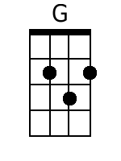 | 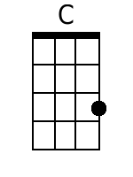 | 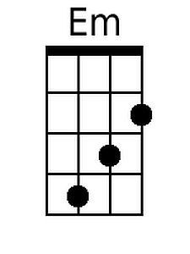 | 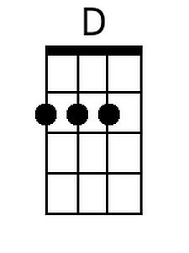 | 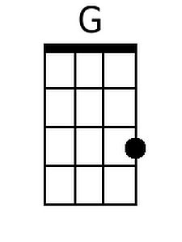 | 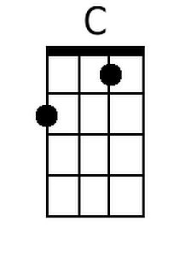 | 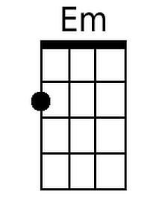 | 