Blue Bayou (Roy Orbison & Joe Melson, 1961)
As performed by Roy Orbison

Intro (4 Measures): C  C G  I feel so bad I've got a worried mind, I'm so lonesome __ all the time  C  Since I left my baby behind on Blue Bayou.  C G  Saving nickels, saving dimes, __ working 'till the sun don't shine.  C (Hold)  Looking forward to happier times on Blue Bayou.  Chorus 1  C G7  I'm going back some day come what may to Blue Bayou  C  Where you sleep all day and the catfish play on Blue Bayou  C7 F - Fm  All those fishing boats with their sails afloat if I could only see  C G7 C  That fa-miliar sunrise through sleepy eyes, how happy I'd be.  C G  Go to see my baby again, __ And to be with some of my friends  C  Maybe I'd be happy then on Blue Bayou.  Chorus 2  C G7  I'm going back some day, gonna stay on Blue Bayou  C  Where the folks are fine and the world is mine on Blue Bayou  C7 F Fm  Oh, that girl of mine __ by my side the silver moon and the evening tide  C G7 C  Oh, some sweet day gonna take away this hurtin' inside  Outro  G7 C  I'll never be blue, my dreams come true on Blue . . . Ba . . . you |  |  |  |  |  |  |  | 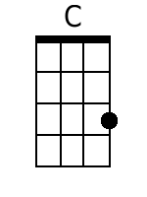
 |  |  |  |  |  |  |  | 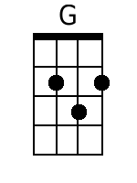
 |  |  |  |  |  |  |  | 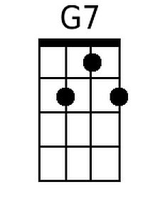
 |  |  |  |  |  |  |  | 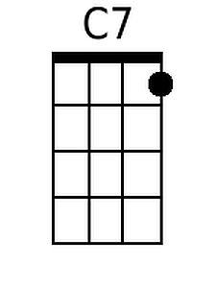
 |  |  |  |  |  |  |  | 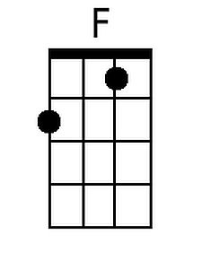
 |  |  |  |  |  |  |  | 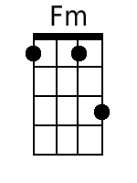
Bari | 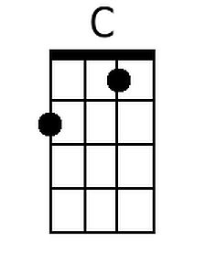 | 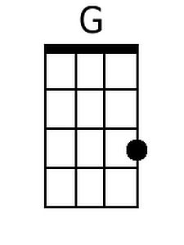 | 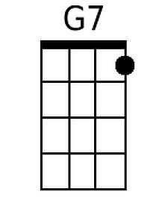 | 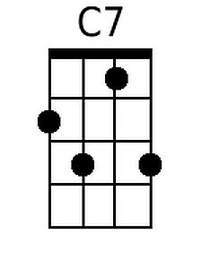 | 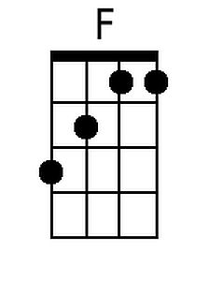 | 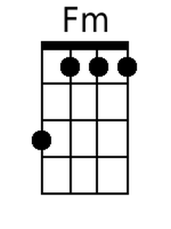

Blue Bayou (Roy Orbison & Joe Melson, 1961)
As performed by Roy Orbison

Intro (4 Measures): G

G D
I feel so bad I've got a worried mind, I'm so lonesome __ all the time
G
Since I left my baby behind on Blue Bayou

G D
Saving nickels, saving dimes, __ working 'till the sun don't shine
G
Looking forward to happier times on Blue Bayou

Chorus 1
G D7
I'm going back some day come what may to Blue Bayou
G
Where you sleep all day and the catfish play on Blue Bayou
G7 C - Cm
All those fishing boats with their sails afloat if I could only see
G D7 G
That fa-miliar sunrise through sleepy eyes, how happy I'd be

G D
Go to see my baby again, __ And to be with some of my friends
G
Maybe I'd be happy then on Blue Bayou.

Chorus 2
G D7
I'm going back some day, gonna stay on Blue Bayou
G
Where the folks are fine and the world is mine on Blue Bayou
G7 C Cm
Oh, that girl of mine by my side the silver moon and the evening tide
G D7 G
Oh, some sweet day gonna take away this hurtin' inside

Outro
D7 G
I'll never be blue, my dreams come true on Blue Ba-you

 |  |  |  |  |  |  |  | 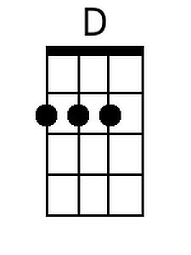
 |  |  |  |  |  |  |  | 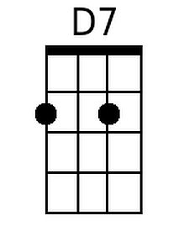
 |  |  |  |  |  |  |  | 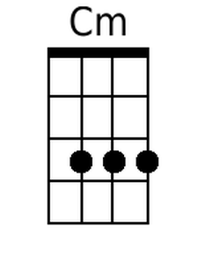
Bari |  | 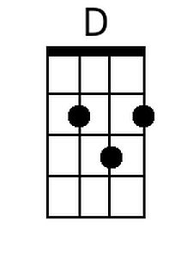 | 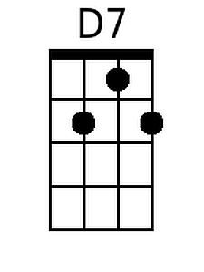 |  |  | 