Blue Bayou (Roy Orbison & Joe Melson, 1961)
As performed by Roy Orbison – Version 2

Intro: C G7 C  C CΔ7 Am7 G7 G9  I feel so bad I've got a worried mind, I'm so lonesome all the time  G7 G9 C  Since I left my baby be-hind on Blue Bayou.  C CΔ7 Am7 G7 G9  Saving nickels, saving dimes, working 'till the sun don't shine.  G7 G9 C | Bb C |  Looking forward to happier times on Blue Bayou.  Chorus 1  C CΔ7 C CΔ7 G7  I'm going back some-day, come what may, to Blue Bayou.  C  Where you sleep all day and the catfish play on Blue Bayou.  C7 F Fm  All those fishing boats with their sails afloat if I could only see  C G7 C  That fa-miliar sunrise through sleepy eyes, how happy I'd be.  C CΔ7 Am7 G7 G9  Go to see my baby again, and to be with some of my friends;  G7 G9 C  Maybe I'd be happy then on Blue Bayou.  Chorus 2  C CΔ7 C CΔ7 G7  I'm going back some day, gonna stay on Blue Bayou.  C  Where the folks are fine and the world is mine on Blue Bayou.  C C7 F Fm  Ah, that (boy/gal) of mine by my side the silver moon and the evening  C G7 C  Oh, some sweet day, gonna take away this hurtin' inside.  Outro  G7 G9 G7 F G7 C | C  I'll never be blue, my dreams come true, on Blue . . . Ba . . . you.  (3 measures, end C) |  |  |  |  |  |  |  | 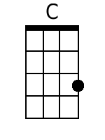 |  | 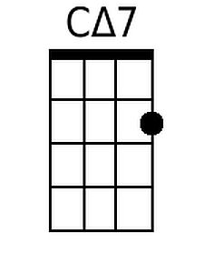
 |  |  |  |  |  |  |  | 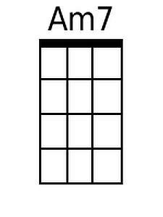 |  | 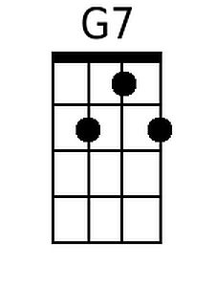
 |  |  |  |  |  |  |  | 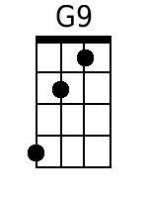 |  | 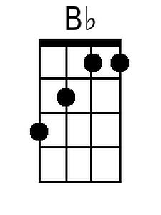
 |  |  |  |  |  |  |  | 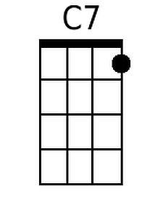 |  | 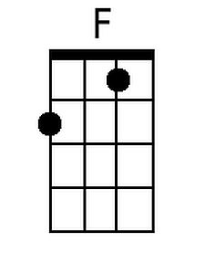
 |  |  |  |  |  |  |  | 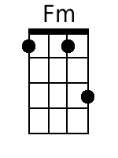
 |  |  |  |  |  |  |  | tide
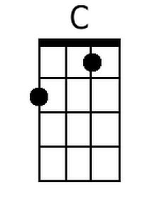 | 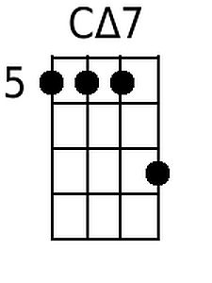 | 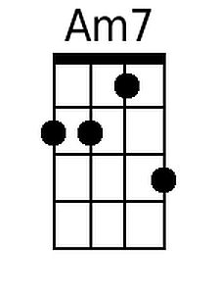 | 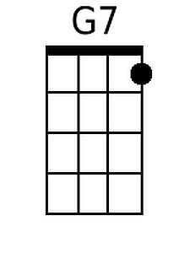 | 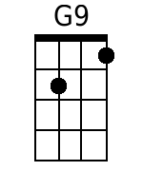 | 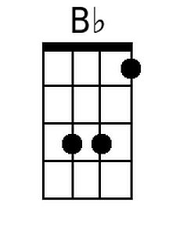 | 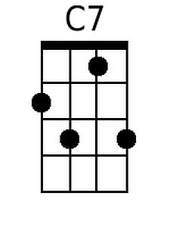 | 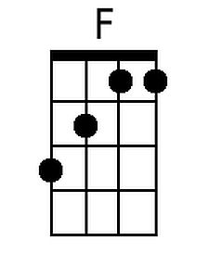 |  | 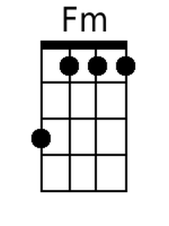

Blue Bayou (Roy Orbison & Joe Melson, 1961)
As performed by Roy Orbison – Version 2

Intro: G D7 G  G GΔ7 Em7 D7 D9  I feel so bad I've got a worried mind, I'm so lonesome all the time  D7 D9 G | F G |  Since I left my baby be-hind on Blue Bayou.  G GΔ7 Em7 D7 D9  Saving nickels, saving dimes, working 'till the sun don't shine.  D7 D9 G | F G |  Looking forward to happier times on Blue Bayou.  Chorus 1  G GΔ7 G GΔ7 D7  I'm going back some-day, come what may, to Blue Bayou.  G  Where you sleep all day and the catfish play on Blue Bayou.  G7 C Cm  All those fishing boats with their sails afloat if I could only see  G D7 G  That fa-miliar sunrise through sleepy eyes, how happy I'd be.  G GΔ7 Em7 D7 D9  Go to see my baby again, and to be with some of my friends;  D7 D9 G  Maybe I'd be happy then on Blue Bayou.  Chorus 2  G GΔ7 G GΔ7 D7  I'm going back some day, gonna stay on Blue Bayou.  G  Where the folks are fine and the world is mine on Blue Bayou.  G G7 C Cm  Ah, that (boy/gal) of mine by my side the silver moon and the evening  G D7 G  Oh, some sweet day, gonna take away this hurtin' inside.  Outro  D7 D9 D7 C D7 G | G  I'll never be blue, my dreams come true on Blue . . . Ba . . . you.  (3 measures, end C) |  |  |  |  |  |  |  | 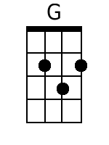 |  | 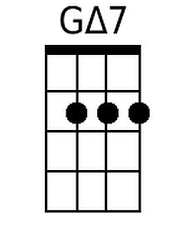
 |  |  |  |  |  |  |  | 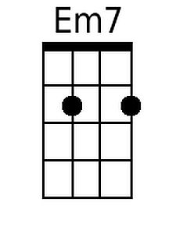 |  | 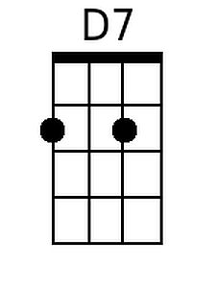
 |  |  |  |  |  |  |  | 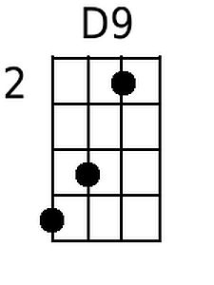
 |  |  |  |  |  |  |  | 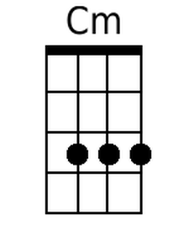
 |  |  |  |  |  |  |  | tide
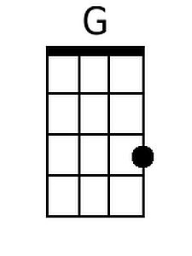 | 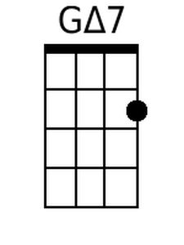 | 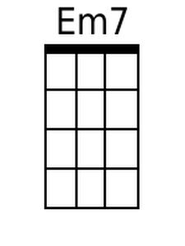 | 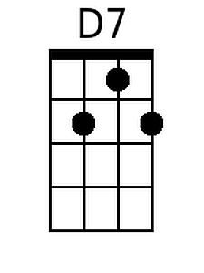 | 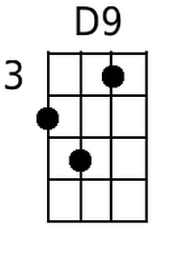 |  |  |  |  | 