Blue Bayou (Roy Orbison & Joe Melson, 1961) (C)
As performed by Linda Ronstadt (1977)
Tempo: 95 bpm
Intro: C | G7 | C  C G7  1. I feel so bad, I’ve got a worried mind; I'm so lonesome __ all the time,  C  Since I left my baby behind on Blue Bayou.  C G7  2. Saving nickels, saving dimes; __ working till the sun don't shine;  C | Bb C  Looking forward to happier times on Blue Bayou.  Chorus  C G7  I'm going back someday, come what may to Blue Bayou.  C  Where the folks are fine and the world is mine on Blue Bayou.  C C7 F Fm  Where those fishing boats with their sails a-float, if I could only see,  C G7 C  That fa-miliar sunrise through sleepy eyes how happy I'd be.  C G7  3. Gonna see my baby again, gonna be with some of my friends;  C  Maybe I'll feel better again on Blue Bayou.  Repeat Verse 2 and Chorus.  Instrumental Interlude: C | C | G7 | G7 | G7 | G7 | C | C  Outro  C C7 F Fm  Oh that boy of mine by my side, the silver moon and the evening tide,  C G7 C  Oh some sweet day, gonna take away this hurting inside.  G7 C | C | C | C  Well I'll never be blue, my dreams come true, on Blue Ba-you. (Hold) |  |  |  |  |  |  |  | 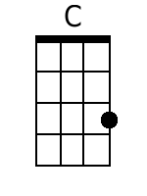
 |  |  |  |  |  |  |  | 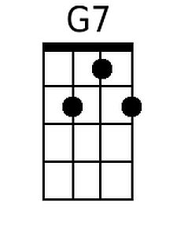
 |  |  |  |  |  |  |  | 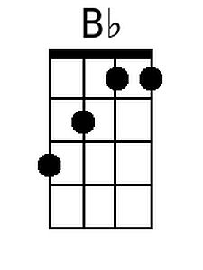
 |  |  |  |  |  |  |  | 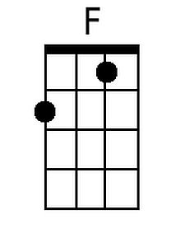
 |  |  |  |  |  |  |  | 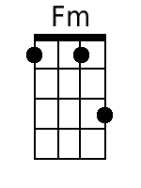
 |  |  | Bari | 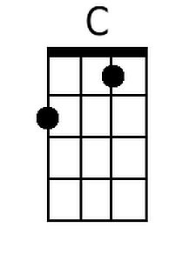 | 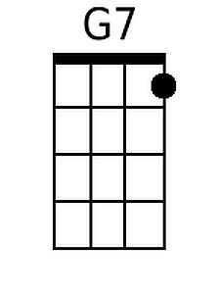 | 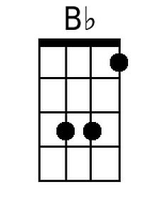 | 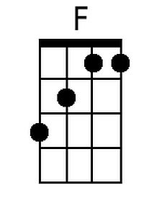 |  | 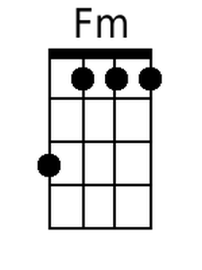

Blue Bayou (Roy Orbison & Joe Melson, 1961) (G)
As performed by Linda Ronstadt (1977)
Tempo: 95 bpm
Intro: G | D7 | G  G D7  1. I feel so bad, I’ve got a worried mind; I'm so lonesome __ all the time,  G  Since I left my baby behind on Blue Bayou.  G D7  2. Saving nickels, saving dimes; __ working till the sun don't shine;  G | F | G  Looking forward to happier times on Blue Bayou.  Chorus  G D7  I'm going back someday, come what may to Blue Bayou.  G  Where the folks are fine and the world is mine on Blue Bayou.  G G7 C Cm  Where those fishing boats with their sails a-float, if I could only see,  G D7 G  That fa-miliar sunrise through sleepy eyes how happy I'd be.  G D7  3. Gonna see my baby again, gonna be with some of my friends;  G  Maybe I'll feel better again on Blue Bayou.  Repeat Verse 2 and Chorus.  Instrumental Interlude: G | G | D7 | D7 | D7 | D7 | G | G  Outro  G G7 C Cm  Oh that boy of mine by my side, the silver moon and the evening tide  G D7 G  Oh some sweet day, gonna take away this hurting inside.  D G | G | G | G  Well I'll never be blue, my dreams come true, on Blue Ba-you. (Hold) |  |  |  |  |  |  |  | 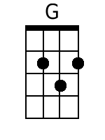
 |  |  |  |  |  |  |  | 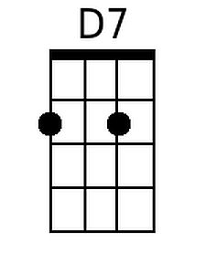
 |  |  |  |  |  |  |  | 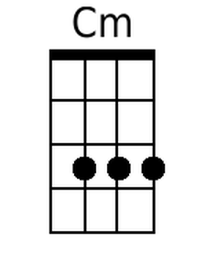
 |  |  | Bari | 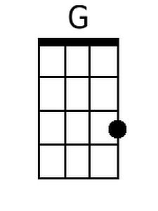 | 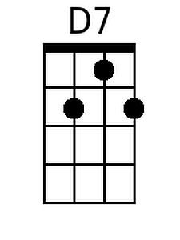 |  |  |  | 