**Blue Bayou (Roy Orbison & Joe Melson, 1961) (C) Tempo: 95 bpm**

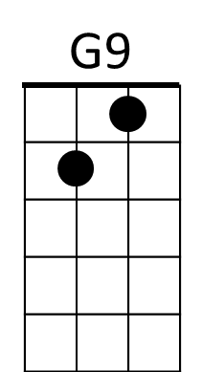**Intro: C | G7 | C**

**C Cmaj7 Am7**

I feel so bad, I’ve got a worried mind -

**G7 G9**

I'm so lonesome all the time,

**G7 G9 C**

Since I left my baby behind on Blue Bayou.

**C Cmaj7 Am7 G7**

Saving nickels, saving dimes;

**G9**

Working till the sun don't shine;

**G7 G9 C**

Looking forward to happier times on Blue Bayou.

**Bb C**

**C Cmaj7**

I'm going back someday,

**C Cmaj7 G7**

Come what may to Blue Bayou.

Where the folks are fine

**C**

And the world is mine on Blue Bayou.

Where those fishing boats

**C7**

With their sails a-float,

**F Fm**

If I could only see,

**C G7**

That fa-miliar sunrise through sleepy eyes

**C**

How happy I'd be.

**C Cmaj7 Am7**

Gonna see my baby again,

**G7 G9**

Gonna be with some of my friends;

**G7 G9 C**

Maybe I'll feel better again on Blue Bayou.

**C Cmaj7 Am7 G7**

Saving nickels, saving dimes;

**G9**

Working till the sun don't shine;

**G7 G9 C**

Looking forward to happier times on Blue Bayou.

**Bb C**

**C Cmaj7**

I'm going back someday,

**C Cmaj7 G7**

Come what may to Blue Bayou.

Where you sleep all day

**C**

And the catfish play on Blue Bayou.

Where those fishing boats

**C7**

With their sails a-float,

**F Fm**

If I could only see,

**C G7**

That fa-miliar sunrise through sleepy eyes

**C**

How happy I'd be.

**C Cmaj7 Am7**

Gonna see my baby again,

**G7 G9**

And to be with some of my friends;

**G7 G9 C**

Maybe I’d be happy then on Blue Bayou.

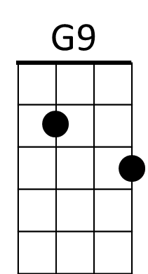

**C Cmaj7**

I'm going back someday,

**C Cmaj7 G7**

Gonna stay on Blue Bayou.

Where the folks are fine

**C**

And the world is mine on Blue Bayou.

**C C7**

Oh that (boy/gal) of mine by my side,

**F Fm**

The silver moon and the evening tide,

**C G7**

Oh some sweet day, gonna take away

**C**

This hurting inside.

**G7 G9 G7**

Well I'll never be blue, my dreams come true,

**F G7 C C (3 measures, end C)**

On Blue - Ba - you.