**Blue Eyes Crying In The Rain (Fred Rose) Key C**

**Intro: G G7 C (melody for last line of verse)**

**C**

In the twilight glow I see her

**G G7 C**

Blue eyes crying in the rain

**C**

When we kissed good-bye and parted

**G7 C C7**

I knew we'd never meet again

F

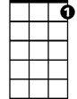

C7



C



G

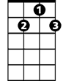

G7

**F**

Love is like a dying ember

**C G7**

Only memories remain

**C**

Through the ages I'll remember

**G G7 C**

Blue eyes crying in the rain

**C**

Now my hair has turned to silver

**G7 C**

All my life I've love in vain

**C**

I can see her star in heaven

**G G7 C C7**

Blue eyes crying in the rain

**F**

Someday when we meet up yonder

**C G7**

We'll stroll hand in hand again

**BARITONE**

**C**



G



F



G7

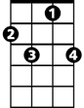

C7

C



In the land that knows no parting

**G G7 C**

Blue eyes crying in the rain

**G G7 C F C**

Blue eyes crying in the rain

**Blue Eyes Crying In The Rain (Fred Rose) Key D**

**Intro: A A7 D (melody for last line of verse)**

**D**

In the twilight glow I see her

**A A7 D**

Blue eyes crying in the rain

**D**

As when we kissed good-bye and parted

**A7 D D7**

I knew we'd never meet again

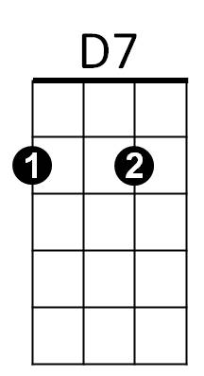



G

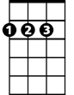

D

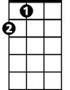

A

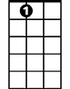

A7

**G**

Love is like a dying ember

**D A7**

Only memories remain

**D**

Through the ages I'll remember

**A A7 D**

Blue eyes crying in the rain

**D**

Now my hair has turned to silver

**A7 D**

All my life I've love in vain

**D**

I can see her star in heaven

**A A7 D D7**

Blue eyes crying in the rain

**G**

Someday when we meet up yonder

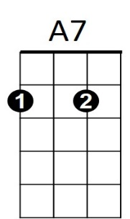**D A7**



A



D7



D

**BARITONE**



G

We'll stroll hand in hand again

**D**

In the land that knows no parting

**A A7 D**

Blue eyes crying in the rain

**A A7 D G D**

Blue eyes crying in the rain

**Blue Eyes Crying In The Rain (Fred Rose) Key G**

**Intro: D D7 G (melody for last line of verse)**

**G**

In the twilight glow I see her

**D D7 G**

Blue eyes crying in the rain

**G**

As when we kissed good-bye and parted

**D7 G G7**

****I knew we'd never meet again



C



G7



D



G

**C**

Love is like a dying ember

**G D7**

Only memories remain

**G**

Through the ages I'll remember

**D D7 G**

Blue eyes crying in the rain

**G**

Now my hair has turned to silver

**D7 G**

All my life I've love in vain

**G**

I can see her star in heaven

**D D7 G G7**

Blue eyes crying in the rain

**C**

Someday when we meet up yonder

**G D7**



G



D



G7

C



**BARITONE**



D7

We'll stroll hand in hand again

**G**

In the land that knows no parting

**D D7 G**

Blue eyes crying in the rain

**D D7 G C G**

Blue eyes crying in the rain