**Blue Hawaii (Leo Rabin / Ralph Rainger) Key C**

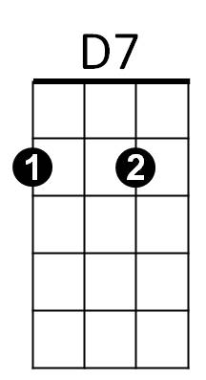**INTRO: A7 D7 G7 C Fm C**

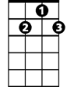

G7



C

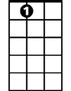

A7

**C F C**

Night and you and Blue Hawaii

**A7 D7 G7**

The night is hea venly

**C G7**

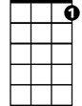

C7

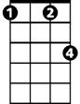

Fm



G

F



And you are heaven to me

**C F C**

Lovely you and Blue Hawaii

**A7 D7 G7**

With all this loveliness

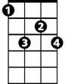

G# 7

**C F C C7**

There should be l – o - ve

**Chorus:**

**F C**

Come with me – whi-le the moon is on the sea

**D7 G G7 G#7 G7**

The night is young and so are we, so are we

**C F C**

**BARITONE**

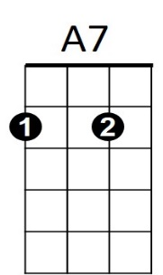 Dreams come true in Blue Hawaii

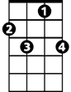

C7



F

C



G7

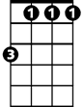

Fm



D7

**A7 D7 G7**

And mine could all come true

**C F C C7**

This magic night of nights with you

**(Chorus)**



G

**C F C**

Dreams come true in Blue Hawaii

**A7 D7 G7**

And mine could all come true

**C Fm C (hold)**

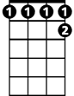

G#7

This magic night – of nights with you

**Blue Hawaii (Leo Rabin / Ralph Rainger) Key G**

**INTRO: E7 A7 D7 G Cm G**

E7

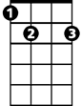

A7



G

**BARITONE**

**G C G**

Night and you and Blue Hawaii

**E7 A7 D7**

The night is heavenly

**G D7**

And you are heaven to me

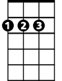

D



G7



C

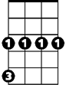

Cm

**G C G**

Lovely you and Blue Hawaii

**E7 A7 D7**

With all this loveliness

**G C G G7**

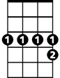

D#7

There should be l – o - ve

**Chorus:**

**C G**

Come with me – whi-le the moon is on the sea

**A7 D D7 D#7 D7**

The night is young and so are we, so are we

**G C G**

Dreams come true in Blue Hawaii

**E7 A7 D7**



E7



D7



G

And mine could all come true

**G C G G7**

This magic night of nights with you

**(Chorus)**



D



G7

C



Cm

**G C G**

Dreams come true in Blue Hawaii

**E7 A7 D7**

And mine could all come true

**G Cm G (hold)**

This magic night – of nights with you



D#7