Blue Hawaiian Moonlight (Ray Muffs & Myron A. Muffs) Key C

D7 G7 C Hawaiian Vamp - 2x  C F C D7  Blue Hawaiian moonlight, shining over the sea  G7 C F C  Take me to your island, where I'm longing to be  TACET F C D7  Blue Hawaiian moonlight, find the one I adore  G7 C F C  Spread your magic love light, guide my ship to your shore  Chorus:  C7 F C G7 C  When the night is falling, I'm in deep rever-ie  D7 G7 Dm G7  I can hear you calling, "Oh, please come back to me"  TACET F C D7  You know how I'm yearning, make my dreams all come true  G7 C F C  Blue Hawaiian moonlight, I'm depending on you  (REPEAT FROM CHORUS)  Ending:  D7 G7 C F C  Blue Hawaiian moonlight, I'm depending on you |  |  |  |  |  | 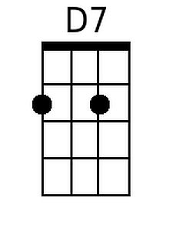
 |  |  |  |  |  | 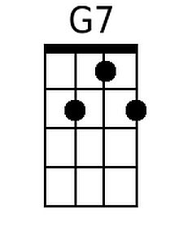
 |  |  |  |  |  | 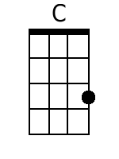
 |  |  |  |  |  | 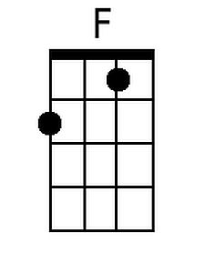
 |  |  |  |  |  | 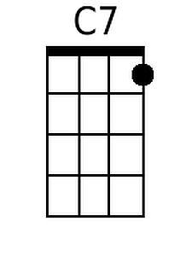
 |  |  |  |  |  | 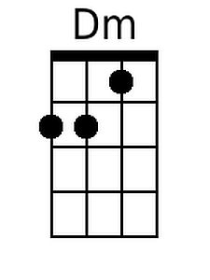
Baritone
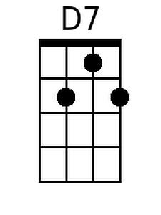 | 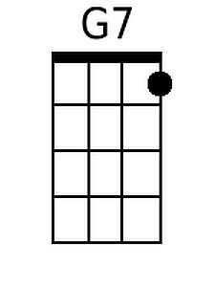 | 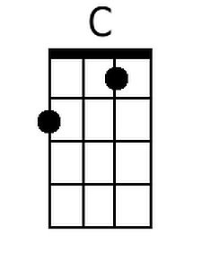 | 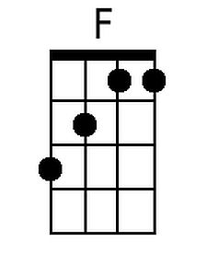 | 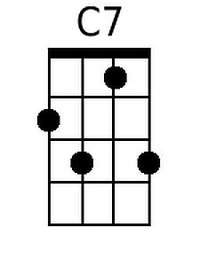 | 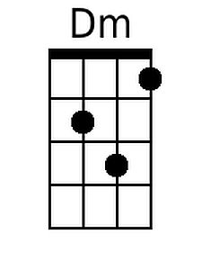

Blue Hawaiian Moonlight (Ray Muffs & Myron A. Muffs) Key F

G7 C7 F Hawaiian Vamp - 2x

F Bb F G7
Blue Hawaiian moonlight, shining over the sea
C7 F Bb F
Take me to your island, where I'm longing to be

TACET F C D7
Blue Hawaiian moonlight, find the one I adore
C7 F Bb F
Spread your magic love light, guide my ship to your shore

Chorus:
F7 Bb F C7 F
When the night is falling, I'm in deep rever-ie
G7 C7 Gm C7
I can hear you calling, "Oh, please come back to me"

TACET F C D7
You know how I'm yearning, make my dreams all come true
C7 F Bb F
Blue Hawaiian moonlight, I'm depending on you

(REPEAT FROM CHORUS)

Ending:

G7 C7 F Bb F
Blue Hawaiian moonlight, I'm depending on you
 |  |  |  |  |  | 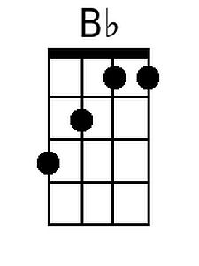
 |  |  |  |  |  | 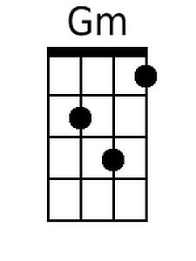
Baritone
 |  |  | 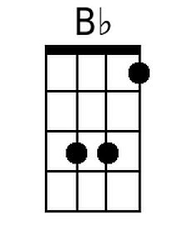 |  | 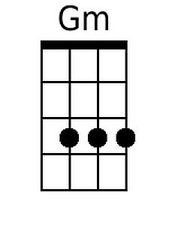

Blue Hawaiian Moonlight (Ray Muffs & Myron A. Muffs) Key G

A7 D7 G Hawaiian Vamp - 2x  G C G A7  Blue Hawaiian moonlight, shining over the sea  D7 G C G  Take me to your island, where I'm longing to be  TACET F C D7  Blue Hawaiian moonlight, find the one I adore  D7 G C G  Spread your magic love light, guide my ship to your shore  Chorus:  G7 C G D7 G  When the night is falling, I'm in deep rever-ie  A7 D7 Am D7  I can hear you calling, "Oh, please come back to me"  TACET F C D7  You know how I'm yearning, make my dreams all come true  D7 G C G  Blue Hawaiian moonlight, I'm depending on you  (REPEAT FROM CHORUS)  Ending:  A7 D7 G C G  Blue Hawaiian moonlight, I'm depending on you |  |  |  |  |  | 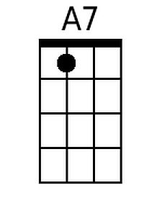
 |  |  |  |  |  | 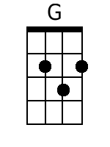
 |  |  |  |  |  | 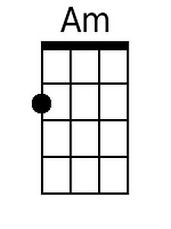
Baritone
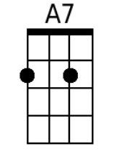 |  | 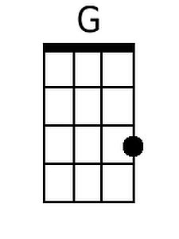 |  |  | 