Blue Moon (Richard Rodgers & Lorenz Hart, 1934) (C)
Blue Moon by The Marcels (1961) (G / 128 BPM) – By Frank Sinatra (C# - 114 BPM)

Intro C | Am | F | G7  C Am F G7 C Am F  Blue moon, You saw me standing alone.  G7 C Am F  Without a dream in my heart,  G7 C Am F G7  Without a love of my own.  C Am F G7 C Am F  Blue moon, You knew just what I was there for,  G7 C Am F  You heard me saying a prayer for,  G7 C F C C7  Someone I really care for.  Chorus  Dm G7 C - Am  And then there suddenly ap-peared be-fore me.  Dm G7 C  The only one my heart could ever hold.  Am7 Bm7 Em  I heard some-body whisper, please a-dore me.  C D7 G G7  And when I looked, the moon had turned to gold.  C Am F G7 C Am F  Blue moon, Now I'm no longer alone.  G7 C Am F G7 C Am F G7  Without a dream in my heart, Without a love of my own. Chorus  C Am F G7 C Am F  Blue moon, You saw me standing alone.  G7 C Am F  Without a dream in my heart,  G7 C F C Gm C  Without a love of my own. Blue.............Moon. |  |  |  |  |  | 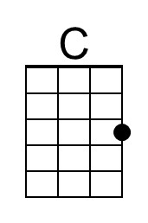 | 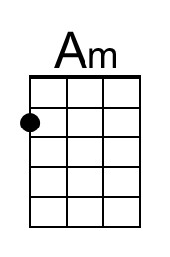
 |  |  |  |  |  | 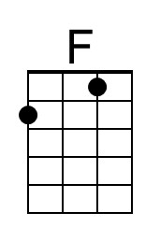 | 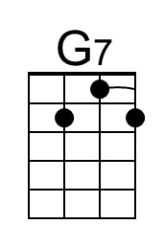
 |  |  |  |  |  | 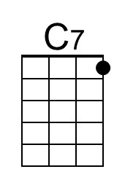 | 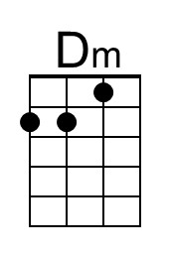
 |  |  |  |  |  | 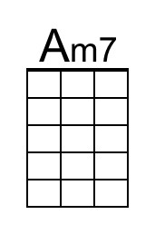 | 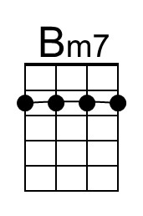
 |  |  |  |  |  | 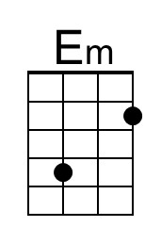 | 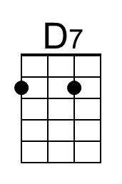
 |  |  |  |  |  | 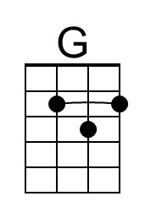 | 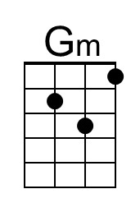
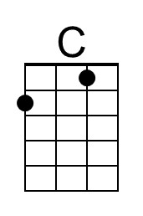 | 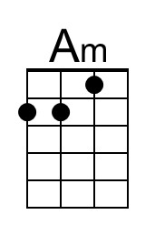 | 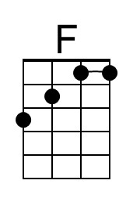 | 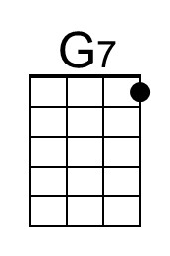 | 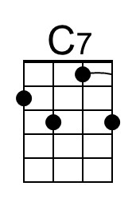 | 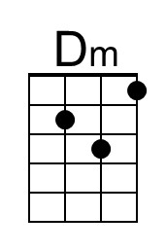
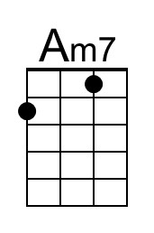 | 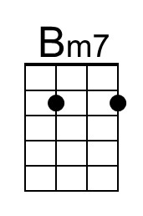 | 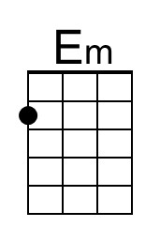 | 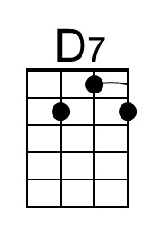 | 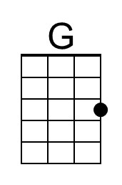 | 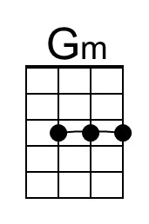

Blue Moon (Richard Rodgers & Lorenz Hart, 1934) (G)
Blue Moon by The Marcels (1961) (G / 128 BPM) – By Frank Sinatra (C# - 114 BPM)

Intro G | Em | C | D7

G Em C D7 G Em C
Blue moon, You saw me standing alone.
D7 G Em C
Without a dream in my heart,
D7 G Em C D7
Without a love of my own.
G Em C D7 G Em C
Blue moon, You knew just what I was there for,
D7 G Em C
You heard me saying a prayer for,
D7 G C G G7
Someone I really care for.

Chorus
Am D7 G - Em
And then there suddenly ap-peared be-fore me.
Am D7 G
The only one my heart could ever hold.
Em7 F#m7 Bm
I heard some-body whisper, please a-dore me.
G A7 D D7
And when I looked, the moon had turned to gold.

G Em C D7 G Em C
Blue moon, Now I'm no longer alone.
D7 G Em C D7 G Em C D7
Without a dream in my heart, Without a love of my own. Chorus

G Em C D7 G Em C
Blue moon, You saw me standing alone.
D7 G Em C
Without a dream in my heart,
D7 G C G Dm G
Without a love of my own. Blue.............Moon.

 |  |  |  |  |  | 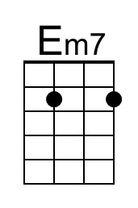 | 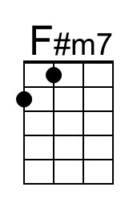
 |  |  |  |  |  | 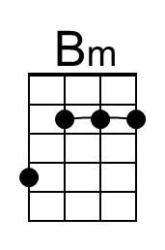 | 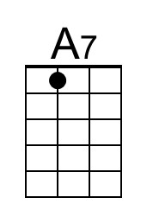
 |  |  |  |  |  | 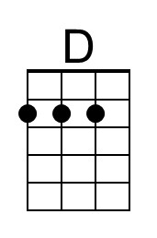
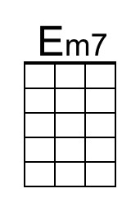 | 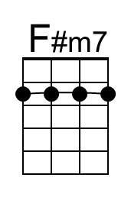 | 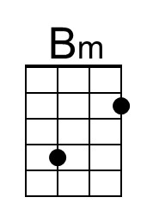 | 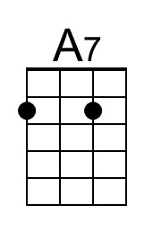 | 