Blue Moon of Kentucky (Bill Monroe) Key C

C C7 F / C G C  C C7 F  Blue moon of Kentucky keep on shining  C C7 G  Shine on the one that's gone and proved untrue  C C7 F  Blue moon of Kentucky keep on shining  C G C  Shine on the one that's gone and left me blue  F C  It was on a moonlight night the stars were shining bright  F C G  When they whispered from on high your love has said good-bye  C C7 F  Blue moon of Kentucky keep on shining  C G C  Shine on the one that's gone and said good-bye  C C7 F / C C7 G / C C7 F / C G C  Repeat song |  |  |  |  |  |  | 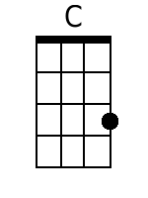
 |  |  |  |  |  |  | 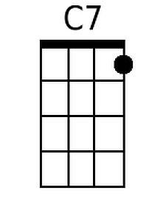
 |  |  |  |  |  |  | 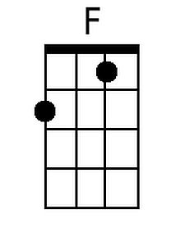
 |  |  |  |  |  |  | 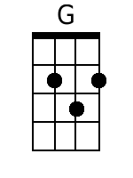
Bari
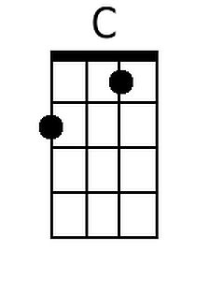 | 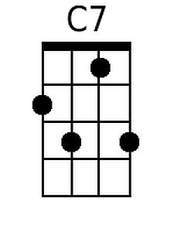 | 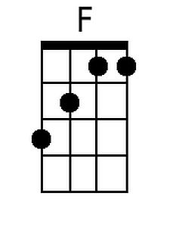 | 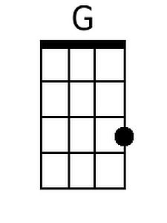

Blue Moon of Kentucky (Bill Monroe) Key G

G G7 C / G D G

G G7 C
Blue moon of Kentucky keep on shining
G G7 D
Shine on the one that's gone and proved untrue
G G7 C
Blue moon of Kentucky keep on shining
G D G
Shine on the one that's gone and left me blue

C G
It was on a moonlight night the stars were shining bright
C G D
When they whispered from on high your love has said good-bye
G G7 C
Blue moon of Kentucky keep on shining
G D G
Shine on the one that's gone and said good-bye

G G7 C / G G7 D / G G7 C / G D G

Repeat song

 |  |  |  |  |  |  | 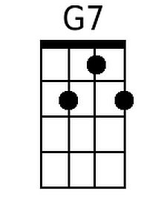
 |  |  |  |  |  |  | 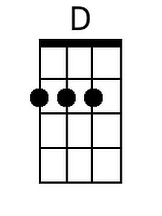
Bari
 | 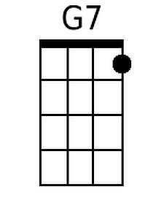 |  | 