Blue Moon of Kentucky (Bill Monroe) Key G

G G7 C / G D G  G G7 C  Blue moon of Kentucky keep on shining  G G7 D  Shine on the one that's gone and proved untrue  G G7 C  Blue moon of Kentucky keep on shining  G D G  Shine on the one that's gone and left me blue  C G  It was on a moonlight night the stars were shining bright  C G D  When they whispered from on high your love has said good-bye  G G7 C  Blue moon of Kentucky keep on shining  G D G  Shine on the one that's gone and said good-bye  G G7 C / G G7 D / G G7 C / G D G  Repeat song |  |  |  |  |  |  | 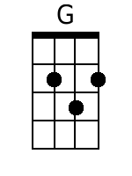
 |  |  |  |  |  |  | 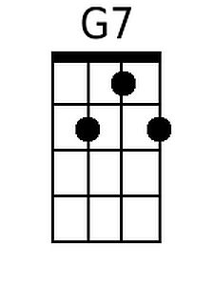
 |  |  |  |  |  |  | 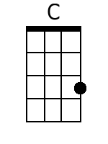
 |  |  |  |  |  |  | 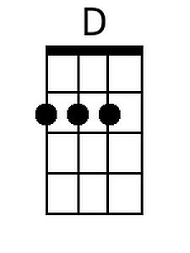
Bari
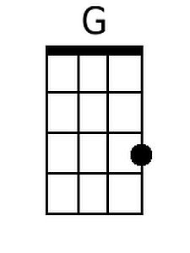 | 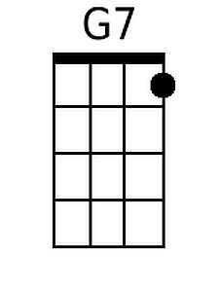 | 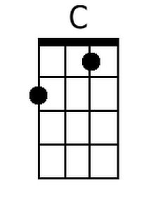 | 