Blue Moon by Lorenz Hart & Richard Rodgers
      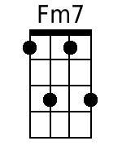  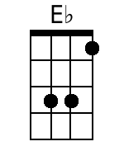 |     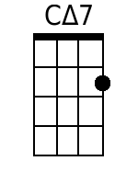  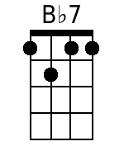   | Verse 1:  [G7] Blue [C] moon, [Am] [F]  You saw me [G7] standing a- [C] lone [Am] [F]  Without a [D7] dream in my [CM7] heart, [Am] [F]  Without a [F] love of my [C] own. [Am] [F]  Verse 2:  [G7] Blue [C] moon, [Am] [F]  You knew just [G7] what I was [C] there for, [Am] [F]  You heard me [D7] saying a [CM7] prayer for [Am] [F]  [F] Someone I [G] really could [C] care for. [F] [Fm] [C]  Bridge:  And then there [F] suddenly ap- [G7] peared be- [C] fore me  The only [F] one my heart could [G7] ever [C] hold;  I heard some- [Fm7] body whisper, "[Bb7] Please a- [Eb] dore me."  And when I [G] looked, the moon had [D7] turned to [G] gold. [D7] [G7]  Verse 3:  [G7] Blue [C] moon, [Am] [F]  Now I'm no [G7] longer a- [C] lone [Am] [F]  Without a [F] dream in my [C] heart, [Am] [F]  Without a [F] love of my [C] own. [Am] [F]

