**Blue Moon (Lorenz Hart / Richard Rodgers)**

**C Am F**

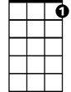

C7

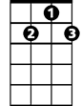

G7

F

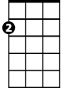

Am



C

Blue moon,

**G7 C Am F**

You saw me standing alone.

**G7 C Am F**

Without a drea m in my heart,

**G7 C Am F G7**

Without a love of my own.

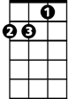

Dm

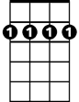

Bm7

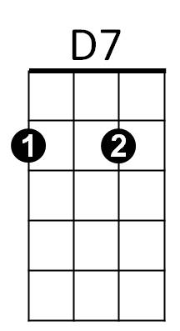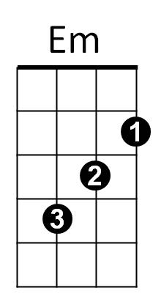 **C Am F**

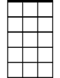

Am7

Blue moon,

**G7 C Am F**

You knew just what I was there for,

**G7 C Am F**

You heard me saying a prayer for,

**G7 C F C C7**

Someone I really care for.

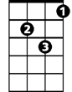

Gm



G

**Chorus:**

**Dm G7 C Am**

And then there suddenly appeared before me.

**Dm G7 C**

The only one my heart could ever hold.

**Am7 Bm7 Em**

I heard s omebody whisper, please adore me.

**C D7 G G7**

And when I looked, the moon had turned to gold.

**C Am F**

Blue moon,



Dm

**BARITONE**

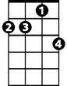

Am7

Bm7

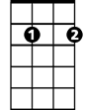

D7

C



Am



F



G7

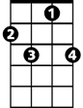

C7



G



Em

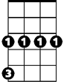

Gm

**G7 C Am F**

Now I'm no longer alone.

**G7 C Am F**

Without a dream in my heart,

**G7 C Am F G7**

Without a love of my own.

**(Chorus)**

**C Am F**

Blue moon,

**G7 C Am F**

You saw me standing alone.

**G7 C Am F**

Without a dream in my heart,

**G7 C F C**

Without a love of my own.

**Gm C**

Blue.............Moon