Blue Skies (Willie Nelson) – Chord Charts

Key of Am

C-Tuned Ukes

Am | AmM7 | Am7 | Am6 | C#7
Bbm | BbmM7 | Bbm7 | Bbm6 | C# | G#7 | D#m7

Blue Skies (Willie Nelson) – Chord Charts

Key of Am

G-Tuned Ukes

 | 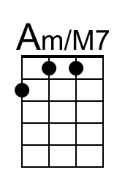 |  | 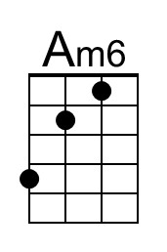 | 
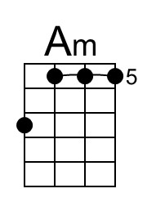 | 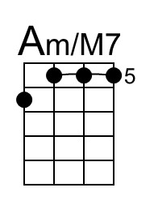 | 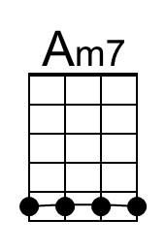 | 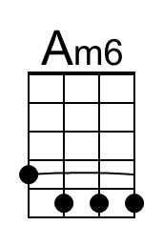
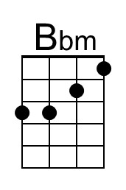 | 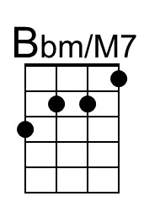 | 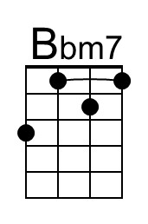 | 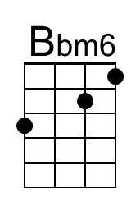 |  | 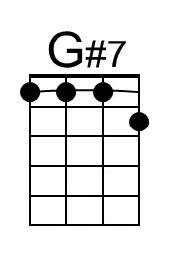 | 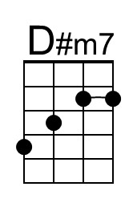
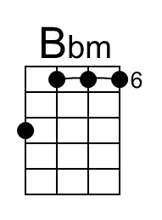 | 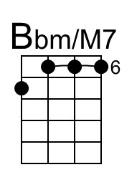 | 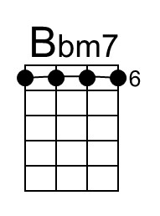 | 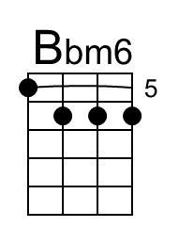 | 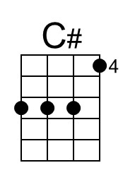 | 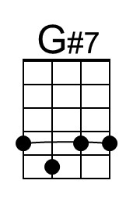 | 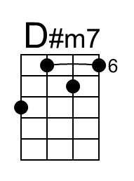

Blue Skies (Willie Nelson) – Chord Charts

Key of Bm

C-Tuned Ukes

Bm | BmM7 | Bm7 | Bm6 | D#7
Cm | CmM7 | Cm7 | Cm6 | D# | A#7 | Fm7

Blue Skies (Willie Nelson) – Chord Charts

Key of Bm

G-Tuned Ukes

Bm | BmM7 | Bm7 | Bm6 | D#7
Cm | CmM7 | Cm7 | Cm6 | D# | A#7 | Fm7

Blue Skies (Willie Nelson) – Chord Charts

Key of Dm

C-Tuned Ukes

Dm | DmM7 | Dm7 | Dm6 | Gb7
Ebm | EbmM7 | Ebm7 | Ebm6 | Gb | Db7 | Abm7

Blue Skies (Willie Nelson) – Chord Charts

Key of Dm

G-Tuned Ukes

Dm | DmM7 | Dm7 | Dm6 | Gb7
Ebm | EbmM7 | Ebm7 | Ebm6 | Gb | Db7 | Abm7

= = = = = = = = = =

Blue Skies (Willie Nelson) – Chord Charts

Key of Em

C-Tuned Ukes

Em | EmM7 | Em7 | Em6 | G#7
Fm | FmM7 | Fm7 | Fm6 | G# | D#7 | A#m7

Blue Skies (Willie Nelson) – Chord Charts

Key of Em

G-Tuned Ukes

Em | EmM7 | Em7 | Em6 | G#7
Fm | FmM7 | Fm7 | Fm6 | G# | D#7 | A#m7

