**Blue Spanish Eyes (Charles Singleton, Bert Kaempfert & Eddie Snyder) Key of C**

**Intro: Chords for ending**

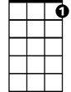

C7



C

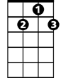

G7

**C**

Blue Spanish eyes

**G7**

Teardrops are falling from your Spanish eyes

Please, please don't cry

**C**

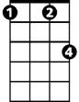

Fm

F



This is just adios and not good bye

Soon, I'll return

**C7 F**

Bringing you all the love your heart can hold

**Fm C**

Please, say si si

**G7 C F C**

Say you and your Spanish eyes will wait for me.

**C**

Blue Spanish eyes

**G7**

Prettiest eyes in all of Mexico

**BARITONE**

True Spanish eyes

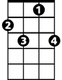

C7

C



G7

**C**

Please smile for me once more before I go

Soon, I'll return

**C7 F**

Bringing you all the love your heart can hold

**Fm C**

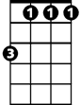

Fm



F

Please, say si si

**G7 C F C**

Say you and your Spanish eyes will wait for me.

**ending:**

**G7 C F C**

Say you and your Spanish eyes will wait for me.

**Blue Spanish Eyes (Charles Singleton, Bert Kaempfert & Eddie Snyder) Key of G**

**Intro: Chords for ending**

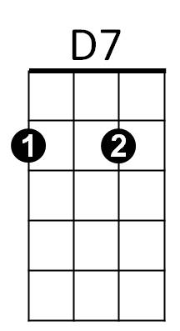



G7



G

**G**

Blue Spanish eyes

**D7**

Teardrops are falling from your Spanish eyes

Please, please don't cry

**G**

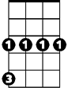

Cm



C

This is just adios and not good bye

Soon, I'll return

**G7 C**

Bringing you all the love your heart can hold

**Cm G**

Please, say si si

**D7 G C G**

Say you and your Spanish eyes will wait for me.

**G**

Blue Spanish eyes

**D7**

Prettiest eyes in all of Mexico

True Spanish eyes

**BARITONE**

**G**



D7



G



G7

Please smile for me once more before I go

Soon, I'll return

**G7 C**

Bringing you all the love your heart can hold

**Cm G**

C



Please, say si si



Cm

**D7 G C G**

Say you and your Spanish eyes will wait for me.

**ending:**

**D7 G C G**

Say you and your Spanish eyes will wait for me.