**Blue Suede Shoes (Carl Perkins)**

**C/ C/**

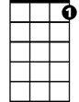

C7

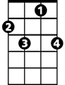

F7



C

Well it's one for the money, two for the show

**C/ C7**

Three to get ready, now go cat go

**F7 C**

But don't you, step on my blue suede shoes

**G7 F C**

You can do anything but lay off of my blue suede shoes

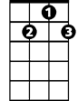

G7

F



**C**

But you can knoc k me down, step in my face

Slander my name all over the place

And do anything that you want to do

**C7**

But uh uh honey lay off of my shoes

**F7 C**

But don't you, step on my blue suede shoes

**G7 F C**

You can do anything but lay off of my blue suede shoes

**C**

But you can burn my house, steal my car

**BARITONE**

Drink my liquor from an old fruit jar

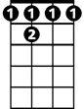

F 7



C7

C



Do anything that you want to do

**C7**

But uh uh honey lay off of them shoes

**F7 C**

But don't you, step on my blue suede shoes

**G7 F C**



F



G7

You can do anything but lay off of my blue suede shoes

**C/ C/**

Well it's one for the money, two for the show

**C/ C7**

Three to get ready, now go cat go

**F7 C**

But don't you, step on my blue suede shoes

**G7 F C**

You can do anything but lay off of my blue suede shoes

**C**

Well it's blue, blue, blue suede shoes

Blue, blue, blue suede shoes yeah

**F**

Blue, blue, blue suede shoes baby

**C**

Blue, blue, blue suede shoes

**G7 F C**

You can do anything but lay off of my blue suede shoes