**Blue Velvet (Bernie Wayne & Lee Morris) Key of G**

**Intro: Chords for first verse**

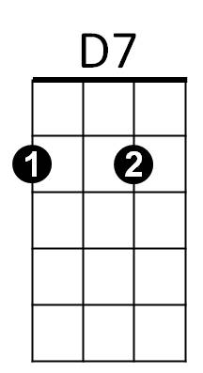**D7 G Bm**

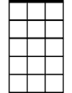

Am7

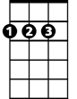

D

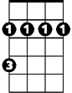

Bm



G

She wore blue velvet

**Am7 D Gmaj7**

Bluer than velvet was the night

**Am7 D7**

Softer than satin was the light,

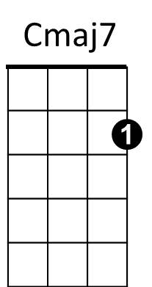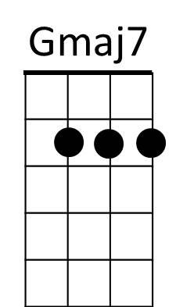 **Gmaj7 Am7**

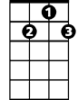

G7

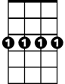

Cm7

From the stars.

**D7 G Bm**

She wore blue ve lvet

**Am7 D Gmaj7**

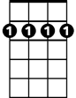

Bm7

Bluer than Velvet were her eyes,

Em7

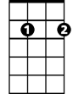

**Am7 D7**

Warmer than May her tender sighs,

**G9**

Love was ours.

**Cmaj7 Cm7**

Ours, a love I held tightly,

**Gmaj7 G G7**

Feeling the rapture grow,

**BARITONE**

**Cmaj7 Cm7**



D

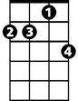

Am7

Bm

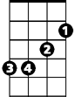

G



D7

Like a flame burning brightly,

**Bm7 Em7**

But when she left,

**Am7 D7**

Gone was the glow

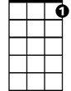

G7

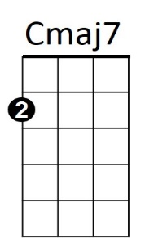 **G Bm**

Cm7

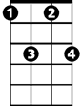

Of Blue velvet

**Am7 D Gmaj7**

But in my heart there'll always be,

**Am7 D7**

Precious and warm, a memory



Em7

Bm7



**G9**

Through the years

**Cmaj7 Cm7**

And I still can see blue velvet

**D7 G**

Through my tears