Book of Love (A)
(Warren Davis, George Malone and Charles Patrick, 1957)
Book of Love by The Monotones (Bb)
2/2 – 100 BPM

Chorus  A D A  I wonder, wonder who-oo-ooh, who. Who wrote the book of love?  A F#m Bm7 E7  Tell me, tell me, tell me, oh, who wrote the Book Of Love?  A F#m Bm7 E7  I've got to know the answer, someone from a-bove? Chorus  A F#m Bm7 E7  I love you darlin', baby, you know I do.  A F#m Bm7 E7  But I've got to see this book of love, find out why it's true. Chorus  Bridge  D A  Chapter One says to love her, love her with all your heart.  D  Chapter Two you tell her, you're  E7  Never, never, never, never, never gonna part.  A F#m Bm7 E7  In Chapter Three re-member, the meaning of ro-mance.  A F#m  In Chapter Four you break up,  A F#m  But you give her just one more chance. Oh, Chorus  A F#m Bm7 E7  Baby, baby, baby, I love you, yes I do.  A F#m Bm7 E7  Well it says so in this book of love, ours is the one that's true. Chorus  Repeat from Bridge.  A D A  I wonder who . . . who wrote the Book of Love? Outro |  |  |  |  |  |  | 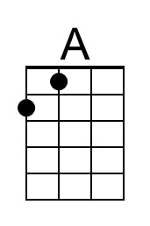
 |  |  |  |  |  |  | 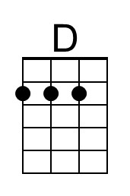
 |  |  |  |  |  |  | 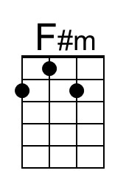
 |  |  |  |  |  |  | 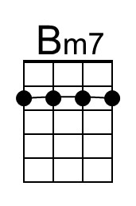
 |  |  |  |  |  |  | 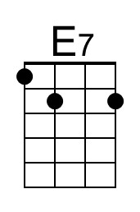
Bari | 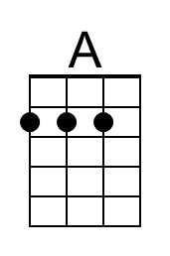 | 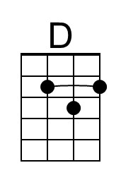 | 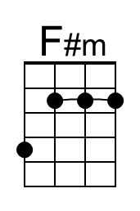 | 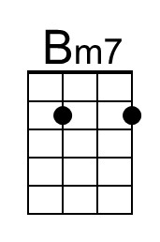 | 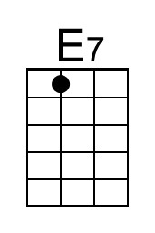

Book of Love (C)
(Warren Davis, George Malone and Charles Patrick, 1957)
Book of Love by The Monotones (Bb)
2/2 – 100 BPM

Chorus  C F C  I wonder, wonder who-oo-ooh, who. Who wrote the book of love?  C Am Dm7 G7  Tell me, tell me, tell me, oh, who wrote the Book Of Love?  C Am Dm7 G7  I've got to know the answer, someone from a-bove? Chorus  C Am Dm7 G7  I love you darlin', baby, you know I do.  C Am Dm7 G7  But I've got to see this book of love, find out why it's true. Chorus  Bridge  F C  Chapter One says to love her, love her with all your heart.  F  Chapter Two you tell her, you're  G7  Never, never, never, never, never gonna part.  C Am Dm7 G7  In Chapter Three re-member, the meaning of ro-mance.  C Am  In Chapter Four you break up,  C Am  But you give her just one more chance. Oh, Chorus  C Am Dm7 G7  Baby, baby, baby, I love you, yes I do.  C Am Dm7 G7  Well it says so in this book of love, ours is the one that's true. Chorus  Repeat from Bridge.  C F C  I wonder who . . . who wrote the Book of Love? Outro |  |  |  |  |  |  | 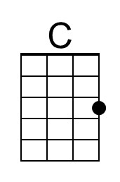
 |  |  |  |  |  |  | 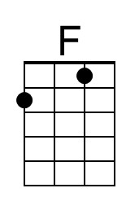
 |  |  |  |  |  |  | 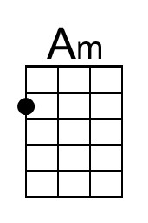
 |  |  |  |  |  |  | 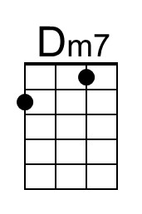
 |  |  |  |  |  |  | 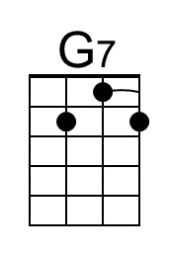
Bari | 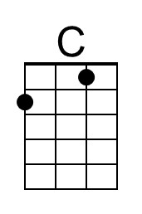 | 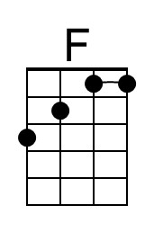 | 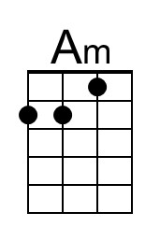 | 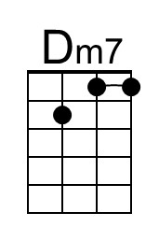 | 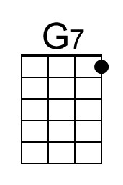

Book of Love (F)
(Warren Davis, George Malone and Charles Patrick, 1957)
Book of Love by The Monotones (Bb)
2/2 – 100 BPM

Chorus
F Bb F
I wonder, wonder who-oo-ooh, who. Who wrote the book of love?

F Dm Gm7 C7
Tell me, tell me, tell me, oh, who wrote the Book Of Love?
F Dm Gm7 C7
I've got to know the answer, someone from a-bove? Chorus

F Dm Gm7 C7
I love you darlin', baby, you know I do.
F Dm Gm7 C7
But I've got to see this book of love, find out why it's true. Chorus

Bridge
Bb F
Chapter One says to love her, love her with all your heart.
Bb
Chapter Two you tell her, you're
C7
Never, never, never, never, never gonna part.
F Dm Gm7 C7
In Chapter Three re-member, the meaning of ro-mance.
F Dm
In Chapter Four you break up,
F Dm
But you give her just one more chance. Oh, Chorus

F Dm Gm7 C7
Baby, baby, baby, I love you, yes I do.
F Dm Gm7 C7
Well it says so in this book of love, ours is the one that's true. Chorus

Repeat from Bridge.

F Bb F
I wonder who . . . who wrote the Book of Love? Outro

 |  |  |  |  |  |  | 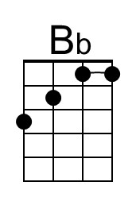
 |  |  |  |  |  |  | 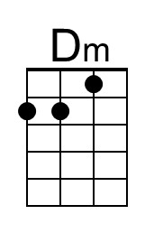
 |  |  |  |  |  |  | 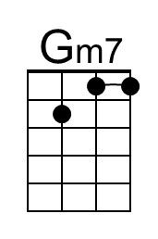
 |  |  |  |  |  |  | 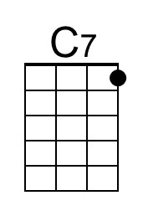
Bari |  | 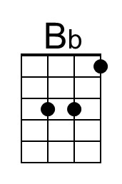 | 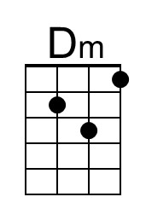 | 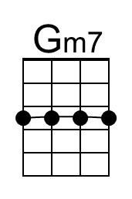 | 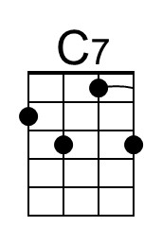

Book of Love (G)
(Warren Davis, George Malone and Charles Patrick, 1957)
Book of Love by The Monotones (Bb)
2/2 – 100 BPM

Chorus  G C G  I wonder, wonder who-oo-ooh, who. Who wrote the book of love?  G Em Am7 D7  Tell me, tell me, tell me, oh, who wrote the Book Of Love?  G Em Am7 D7  I've got to know the answer, someone from a-bove? Chorus  G Em Am7 D7  I love you darlin', baby, you know I do.  G Em Am7 D7  But I've got to see this book of love, find out why it's true. Chorus  C G  Chapter One says to love her, love her with all your heart. Bridge  C  Chapter Two you tell her, you're  D7  Never, never, never, never, never gonna part.  G Em Am7 D7  In Chapter Three re-member, the meaning of ro-mance.  G Em  In Chapter Four you break up,  G Em  But you give her just one more chance. Oh, Chorus  G Em Am7 D7  Baby, baby, baby, I love you, yes I do.  G Em Am7 D7  Well it says so in this book of love, ours is the one that's true. Chorus  G C G  I wonder who . . . who wrote the Book of Love? Outro  Repeat from Bridge. |  |  |  |  |  |  | 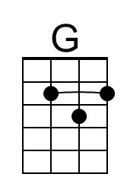
 |  |  |  |  |  |  | 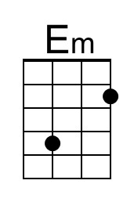
 |  |  |  |  |  |  | 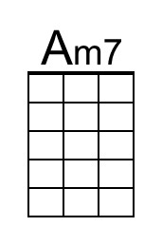
 |  |  |  |  |  |  | 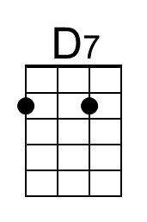
Bari | 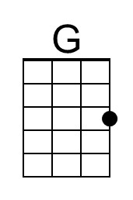 |  | 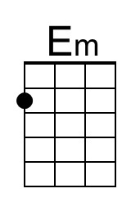 | 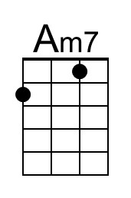 | 