Boris the Spider (John Entwhistle, 1966)
Boris the Spider by The Who

C5 Eb Gm7 F - C C5 Eb Gm7 F - C  Look, he's crawling up my wa-all, Black and hairy, very sma-all  C5 Eb Gm7 F - C7 C Eb Gm7 F - C  Now he's up a - bove my head Hanging by a little thread  Chorus (growly voice)  C Eb Gm7 C7 C Eb Gm7 C7  Bor - is the spi - der, Bor - is the spi - der  C5 Eb Gm7 F - C C5 Eb Gm7 F - C  Now he's dropped on to the floor, Heading for the bedroom door  C Eb Gm7 F- C7 C5 Eb Gm7 F - C  Maybe he's as scared as me, Where's he gone now, I can't see. Chorus  Bridge. (Tabs - E string)  2, 3 , 2, 3, 2, 3, 2, 3,  Creep-y, crawl-y, Creep-y, crawl-y  (speeds up)  2 - 3 2 - 3 2 - 3 2 - 3 2 - 3 2 - 3 2 - 3 2 - 3  Creep-y, creep-y, crawl-y, crawl-y, Creep-y, creep-y, crawl-y, crawl-y.  C5 Eb Gm7 F - C C5 Eb Gm7 F - C  There he is wrapped in a ball, Doesn't seem to move at all.  C5 Eb Gm7 F - C7 C5 Eb Gm7 F - C  Per-haps he's dead, I'll just make sure Pick this book up off the floor. Chorus Bridge  C5 Eb Gm7 F - C C5 Eb Gm7 F - C  He's come to a sticky end, Don't think he will ever mend  C5 Eb Gm7 F - C7 C5 Eb Gm7 F- C  Never more will he crawl 'round, He's em-bedded in the ground. Chorus |  |  |  |  |  |  | 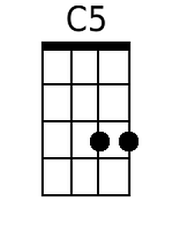
 |  |  |  |  |  |  | 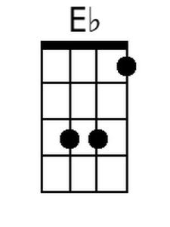
 |  |  |  |  |  |  | 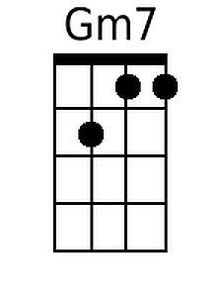
 |  |  |  |  |  |  | 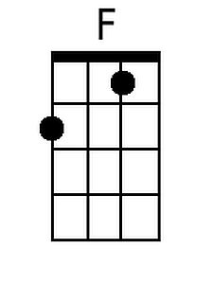
 |  |  |  |  |  |  | 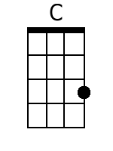
 |  |  |  |  |  |  | 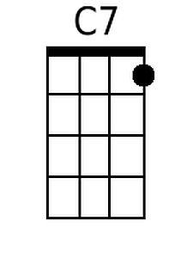
Baritone
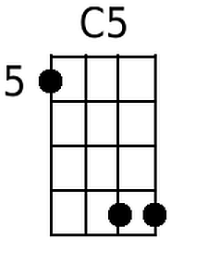 | 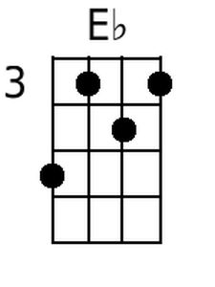 | 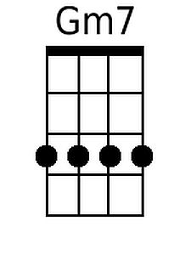 | 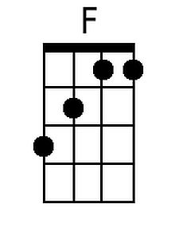 | 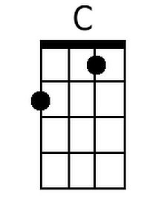 | 