Both Sides Now (Joni Mitchell) (C)
Both Sides Now by Judy Collins

C F C  Bows and flows of angel hair,  Em F C  And ice cream castles in the air,  F Dm  And feather canyons everywhere;  G  I've looked at clouds that way.  C Dm F C  But now they only block the sun,  Em F C  They rain and snow on every-one,  F Dm  So many things I would have done,  G  But clouds got in the way.  C F C  I've looked at clouds from both sides now,  F C F C  From up and down, and still some-how  Em F C  It's cloud's il-lusions I recall  F G G7 G C - Dm C G  I really don't know clouds __ at all.  C F C  Moons and Junes and Ferris wheels,  Em F C  The dizzy dancing way you feel  F Dm  When every fairy tale comes real;  G  I've looked at love that way.  C Dm F C  But now it's just a-nother show,  Em F C  You leave them laughing when you go,  F Dm  And if you care don't let them know,  G  Don't give yourself a-way. |  |  |  | C F C  I've looked at love from both sides now,  F C F C  From give and take, and still some-how  Em F C  It's love's il-lusions I recall  F G G7 G C - Dm C G  I really don't know love __ at all.  C F C  Tears and fears and feeling proud,  Em F C  To say "I love you" right out loud;  F Dm  Dreams and schemes and circus crowds;  G  I've looked at life that way.  C Dm F C  But now old friends are acting strange,  Em F C  They shake their heads; they say I've changed  F Dm  But something's lost and something's gained  G  In living every day  C F C  I've looked at life from both sides now,  F C F C  From win and lose, and still some-how  Em F C  It's life's il-lusions I recall  F C Dm G G7 C  I really don't know life __ at all.
 |  |  |  | 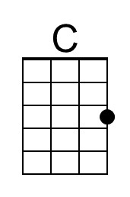 | 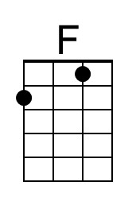 | 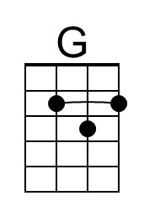  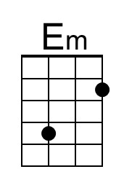 | 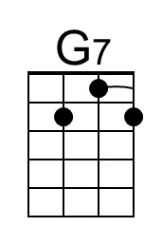  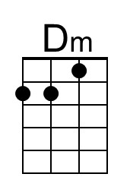
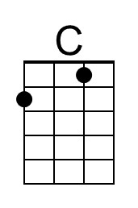 | 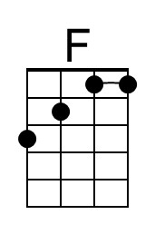 | 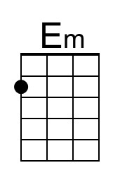 | 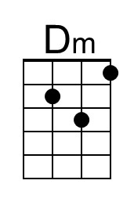 | 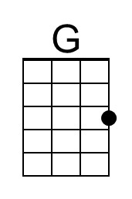 | 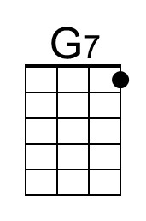

Both Sides Now (Joni Mitchell) (G)
Both Sides Now by Judy Collins

G C G  Bows and flows of angel hair,  Bm C G  And ice cream castles in the air,  C Am  And feather canyons everywhere;  D  I've looked at clouds that way.  G Am C G  But now they only block the sun,  Bm C G  They rain and snow on every-one,  C Am  So many things I would have done,  D  But clouds got in the way.  G C G  I've looked at clouds from both sides now,  C G C G  From up and down, and still some-how  Bm C G  It's cloud's il-lusions I recall  C D D7 D G - Am G D  I really don't know clouds __ at all.  G C G  Moons and Junes and Ferris wheels,  Bm C G  The dizzy dancing way you feel  C Am  When every fairy tale comes real;  D  I've looked at love that way.  G Am C G  But now it's just a-nother show,  Bm C G  You leave them laughing when you go,  C Am  And if you care don't let them know,  D  Don't give yourself a-way. |  |  |  | G C G  I've looked at love from both sides now,  C G C G  From give and take, and still some-how  Bm C G  It's love's il-lusions I recall  C D D7 D G - Am G D  I really don't know love __ at all.  G C G  Tears and fears and feeling proud,  Bm C G  To say "I love you" right out loud;  C Am  Dreams and schemes and circus crowds;  D  I've looked at life that way.  G Am C G  But now old friends are acting strange,  Bm C G  They shake their heads; they say I've changed  C Am  But something's lost and something's gained  D  In living every day  G C G  I've looked at life from both sides now,  C G C G  From win and lose, and still some-how  Bm C G  It's life's il-lusions I recall  C G Am D D7 G  I really don't know life __ at all.
 |  |  |  |  |  | 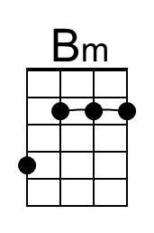  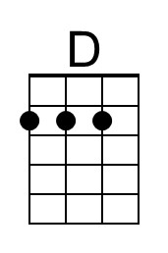 | 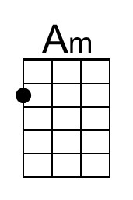  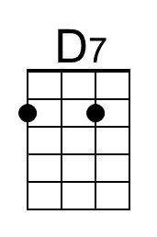
 |  | 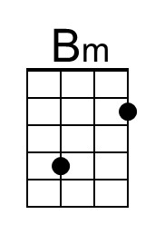 | 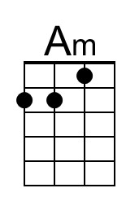 | 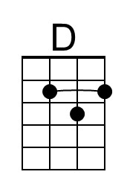 | 